Biology: Life on Earth with Physiology, 10e (Audesirk)
Chapter 1 An Introduction to Life on Earth

1.1 Multiple Choice Questions

1) Scientific inquiry is based on
A) natural selection.
B) stories that are passed down through generations.
C) natural causes.
D) information found in a gossip magazine.
Answer: C
Diff: 1
Section: 1.1
Skill: Knowledge/Comprehension

2) Which of the following is an example a natural cause?
A) Mice arise from discarded garbage.
B) Maggots appear spontaneously on rotting meat.
C) Epilepsy is a disease caused by uncontrolled firing of nerve cells in the brain.
D) If you sneeze you will die.
Answer: C
Diff: 1
Section: 1.1
Skill: Application/Analysis

3) Science cannot answer certain faith-based questions because
A) scientists are not able to study human behavior.
B) faith-based beliefs are impossible to either prove or disprove.
C) faith requires deductive reasoning.
D) there aren't enough variables.
Answer: B
Diff: 2
Section: 1.1
Skill: Application/Analysis

4) Which of the following is FALSE about scientific theories?
A) They have been thoroughly tested.
B) They are developed by inductive reasoning.
C) They are used to support observations using deductive reasoning.
D) They can be either supported or modified by new observations.
E) They are firmly established and cannot be refuted.
Answer: E
Diff: 1
Section: 1.1
Skill: Knowledge/Comprehension
5) Which of these is NOT scientific?
A) A study determines differences in the species composition in two parks.
B) People are immunized with different vaccines to determine their relative effectiveness against the flu virus.
C) NASA sends tadpoles up in the space shuttle to see how gravity affects their development.
D) Consumers are asked which tomato variety produces the best-tasting spaghetti sauce.
E) A company uses different advertising methods for a product to determine which one produces the most sales.
Answer: D
Diff: 3
Section: 1.1
Skill: Application/Analysis

6) The scientific method includes all of the following EXCEPT:
A) experimentation.
B) a testable theory.
C) an observation.
D) a hypothesis.
E) conclusions.
Answer: B
Diff: 2
Section: 1.1
Skill: Knowledge/Comprehension

7) We use the scientific method every day. Imagine that your car doesn't start one morning before school. Which of these is a reasonable hypothesis regarding the problem?
A) I'm going to be late.
B) I'm out of gas.
C) I should check whether the lights were left on and drained the battery.
D) I should change the battery or the starter.
E) I should add a quart of oil.
Answer: B
Diff: 2
Section: 1.1
Skill: Application/Analysis

8) A scientific theory
A) is a general explanation for natural phenomena.
B) is an educated guess.
C) is less reliable than a hypothesis.
D) will never be changed.
Answer: A
Diff: 2
Section: 1.1
Skill: Knowledge/Comprehension
9) A scientific explanation that is tentative and requires more investigation is called a(n)
A) theory.
B) fact.
C) control.
D) hypothesis.
E) observation.
Answer: D
Diff: 2
Section: 1.1
Skill: Knowledge/Comprehension

10) A carefully formulated scientific explanation that is based on extensive observations and is in accord with scientific principles is called a
A) hypothesis.
B) theory.
C) fact.
D) control.
E) postulate.
Answer: B
Diff: 2
Section: 1.1
Skill: Knowledge/Comprehension

11) All the following are features of the scientific method EXCEPT:
A) hypothesis formulation.
B) observation and experimentation.
C) supernatural causes.
D) inductive reasoning.
E) repeatable by other scientists.
Answer: C
Diff: 2
Section: 1.1
Skill: Knowledge/Comprehension

12) Suppose you are testing a treatment for AIDS patients and find that 75% respond very well whereas 25% show no improvement or a decline in health. You should:
A) conclude that you have proven the effectiveness of the drug.
B) conclude that only 75% of AIDS patients should be treated.
C) review the results, modify the drug or the dosage, and repeat the experiment.
D) discontinue experimentation with this treatment because 25% of patients did not improve.
E) begin work on developing a new drug.
Answer: C
Diff: 3
Section: 1.1
Skill: Application/Analysis
13) Alexander Fleming observed a colony of mold that inhibited the growth of nearby bacteria. Which of the following was his hypothesis?
A) The mold used all of the nutrients so that the bacteria couldn't grow.
B) The mold produced a substance that killed nearby bacteria.
C) The bacteria changed their DNA when growing near the mold.
D) The mold was dead.
Answer: B
Diff: 2
Section: 1.1
Skill: Synthesis/Evaluation

14) Imagine that 1 milliliter of an experimental drug diluted in a saline solution is injected into 20 pregnant mice to determine possible side effects. Which of the following is a suitable control for this experiment?
A) 20 male mice injected with 1 milliliter of saline
B) 20 male mice injected with 1 milliliter of the drug
C) 20 pregnant mice injected with 2 milliliters of the drug
D) 20 nonpregnant mice injected with 1 milliliter of the drug
E) 20 pregnant mice injected with 1 milliliter of saline
Answer: E
Diff: 2
Section: 1.1
Skill: Application/Analysis

15) Which of the following statements is a hypothesis rather than a theory?
A) Matter is composed of atoms.
B) Living things are made of cells.
C) Modern organisms descended from preexisting life-forms.
D) Female birds prefer to mate with male birds that have longer tails.
Answer: D
Diff: 2
Section: 1.1
Skill: Application/Analysis

16) Which of the following is true regarding faith-based beliefs and scientific theories?
A) Both faith-based beliefs and scientific theories can be proven.
B) Any and all faith-based beliefs can be disproven, but scientific theories cannot.
C) Any and all scientific theories can be disproven, but faith-based beliefs cannot.
D) Scientific theories are not modifiable, but faith-based beliefs are.
E) Faith-based beliefs can become scientific theories.
Answer: C
Diff: 1
Section: 1.1
Skill: Knowledge/Comprehension
17) Which is the correct sequence of increasing organization?
A) Molecule, cell, organelle, organ
B) Organelle, tissue, cell, organ
C) Atom, molecule, tissue, cell
D) Organ, tissue, cell, molecule
E) Cell, tissue, organ, organ system
Answer: E
Diff: 1
Section: 1.1
Skill: Knowledge/Comprehension

18) Which of the following levels of organization is the most inclusive (that is, includes the most life-forms)?
A) Organ system
B) Population
C) Biosphere
D) Community
E) Ecosystem
Answer: C
Diff: 1
Section: 1.1
Skill: Knowledge/Comprehension

19) The smallest units that still retain the characteristics of an element are called
A) molecules.
B) cells.
C) atoms.
D) tissues.
E) organic molecules.
Answer: C
Diff: 1
Section: 1.1
Skill: Knowledge/Comprehension

20) Which of the following is an example of deductive reasoning?
A) All objects on Earth will fall down when dropped, and none will "fall up."
B) Living objects are composed of cells.
C) Atoms make up molecules, which make up cells, which make up tissues.
D) If an object exhibits all the characteristics of life, it must be living.
Answer: D
Diff: 1
Section: 1.1
Skill: Application/Analysis
21) The experiments of Francesco Redi
A) disproved that maggots and flies were related.
B) disproved the idea of spontaneous generation.
C) disproved the scientific method.
D) used the scientific method to prove the idea of spontaneous generation.
E) determined that flies come from maggots.
Answer: B
Diff: 2
Section: 1.1
Skill: Knowledge/Comprehension

22) Francesco Redi designed an experiment to test the notion of spontaneous generation. He left the first jar of meat open to the air and covered the second jar. The first jar would be called the ________ jar.
A) experimental
B) control
C) conclusive
D) hypothetical
Answer: B
Diff: 2
Section: 1.1
Skill: Application/Analysis

23) To test the effect of vitamin D on growth, two groups of rats were raised under identical conditions and fed the same diet. One of the groups received daily injections of vitamin D. The other group received injections of saline, which did not contain vitamin D. All the rats were weighed weekly for 2 months. In this experiment, the control was the
A) group receiving vitamin D.
B) group receiving saline.
C) average weight gain of the rats.
D) 2-month period of time.
Answer: B
Diff: 2
Section: 1.1
Skill: Application/Analysis

24) Evolution is sometimes described as the change from preexisting life-forms to modern-day organisms. What actually changes, in every case of evolution, is the
A) rate of reproduction.
B) ability of organisms to respond to external stimuli.
C) energy and nutritional demands of the organism.
D) genetic makeup of the species.
E) species' physical appearance.
Answer: D
Diff: 2
Section: 1.2
Skill: Synthesis/Evaluation
25) All of the following are important to the theory of evolution EXCEPT:
A) environmental change.
B) variation in traits within a population.
C) mutations.
D) inheritance of traits.
E) changes in individuals within their lifetimes.
Answer: E
Diff: 2
Section: 1.2
Skill: Knowledge/Comprehension

26) Which is NOT an example of evolution?
A) The development of antibiotic-resistant bacteria
B) Flightless birds living on islands without predators
C) Annual changes in the flu virus
D) A dog learning how to open the cabinet where its food is kept
E) The 2- to 3-year effectiveness of most commercial pesticides
Answer: D
Diff: 3
Section: 1.2
Skill: Application/Analysis

27) A mutation can be the cause for
A) environmental change.
B) natural selection.
C) sexual reproduction.
D) growth and development.
E) sperm and egg formation.
Answer: B
Diff: 2
Section: 1.2
Skill: Application/Analysis

28) A mutation is a
A) physical deformity, such as the loss of a limb.
B) change in the DNA sequence.
C) dose of radiation.
D) defective egg or sperm cell.
Answer: B
Diff: 1
Section: 1.2
Skill: Knowledge/Comprehension

29) In a word, "evolution" means
A) selection.
B) improvement.
C) nature.
D) change.
Answer: D
Diff: 1
Section: 1.2
Skill: Application/Analysis
30) The concept of evolution is based on
A) any type of genetic variation within a population.
B) inheritance of variations by offspring of parents with the variations.
C) survival and successful reproduction in organisms with favorable variations.
D) all genetic variation in a population being equally successful in the same environment.
Answer: C
Diff: 2
Section: 1.2
Skill: Knowledge/Comprehension

31) All of the following are examples of adaptations EXCEPT:
A) mice learning a maze to get food.
B) larger teeth in beavers for gnawing wood.
C) different beak shapes for birds that eat seeds or insects.
D) insects that resemble twigs.
E) flower coloration that attracts pollinators.
Answer: A
Diff: 2
Section: 1.2
Skill: Application/Analysis

32) Suppose an organism has an enzyme that repairs changes in its DNA. The result is a decrease in mutations. This trait would definitely influence the organism's ability to
A) obtain energy.
B) evolve.
C) move.
D) maintain homeostasis.
Answer: B
Diff: 3
Section: 1.2
Skill: Application/Analysis

33) The variation among individuals, on which natural selection acts, describes
A) physical training and exercise.
B) genetic differences.
C) random occurrences in the lifetimes of individuals.
D) nutritional differences.
Answer: B
Diff: 1
Section: 1.2
Skill: Application/Analysis

34) Chromosomes are made of
A) cells.
B) carbohydrates
C) organelles.
D) deoxyribonucleic acid.
Answer: D
Diff: 1
Section: 1.2
Skill: Knowledge/Comprehension
35) A change in the genetic makeup of a species over time is called
A) adaptation.
B) evolution.
C) mutation.
D) natural causality.
Answer: B
Diff: 2
Section: 1.2
Skill: Knowledge/Comprehension

36) Adaptations include all of the following EXCEPT:
A) inborn migratory behavior of young birds born in the Arctic.
B) reduced heart rate and oxygen consumption in seals that dive deep for long periods of time.
C) larger body size in male gorillas, which fight over females.
D) teaching a pet parrot to talk.
Answer: D
Diff: 1
Section: 1.2
Skill: Synthesis/Evaluation

37) Dinosaurs are not alive today because they
A) evolved too quickly in response to a changing environment.
B) evolved adaptations that were beneficial in their constant, unchanging environment.
C) did not evolve fast enough to keep up with rapid environmental change.
D) did not possess the genetic material that beneficial mutations act on.
Answer: C
Diff: 1
Section: 1.2
Skill: Application/Analysis

38) Which of the following is a characteristic of living organisms?
A) Ability to produce energy
B) Eat other organisms
C) Maintenance of precise internal conditions
D) Have a nucleus
E) Have membrane-bound organelles
Answer: C
Diff: 2
Section: 1.3
Skill: Knowledge/Comprehension

39) All of the following are true of all living organisms EXCEPT that they
A) are made of cells.
B) can grow.
C) can reproduce themselves.
D) respond to stimuli.
E) possess either DNA or RNA.
Answer: E
Diff: 2
Section: 1.3
Skill: Knowledge/Comprehension
40) After you drink a glass of acidic lemonade, your body's pH does not change. This is an example of how humans and other organisms
A) maintain precise internal conditions.
B) maintain cellular organization.
C) evolve in response to the environment.
D) are immune to weak acids.
Answer: A
Diff: 2
Section: 1.3
Skill: Application/Analysis

41) Humans born without sweat glands usually do not survive. Why not?
A) Sweating is an important mechanism for maintaining the correct body temperature.
B) Sweat glands create openings in the skin where gas exchange occurs.
C) Sweating is the only way the body eliminates excess water.
D) Sweating is important for eliminating impurities from the body.
Answer: A
Diff: 2
Section: 1.3
Skill: Application/Analysis

42) An organism's ability to perceive stimuli from either the internal or external environment is called
A) natural selection.
B) mutation.
C) responsiveness.
D) DNA.
E) evolution.
Answer: C
Diff: 1
Section: 1.3
Skill: Knowledge/Comprehension

43) You observe a plant on your windowsill that is growing at an angle toward the outside. This is an example of a living thing
A) maintaining precise internal conditions.
B) responding to stimuli.
C) reproducing.
D) evolving.
Answer: B
Diff: 1
Section: 1.3
Skill: Application/Analysis
44) Using its antennae, the male moth finds female moths by following a trail of airborne chemicals, called pheromones, upwind from the female producing them. This is an example of how living things
A) acquire nutrients.
B) grow.
C) reproduce.
D) respond to stimuli.
E) maintain precise internal conditions.
Answer: D
Diff: 2
Section: 1.3
Skill: Application/Analysis

45) An organism in the domain Eukarya is characterized by all of the following EXCEPT:
A) being composed of prokaryotic cells.
B) ingestion of organic matter to acquire nutrients.
C) the potential to grow and reproduce.
D) the innate ability to maintain precise internal conditions.
Answer: A
Diff: 2
Section: 1.4
Skill: Application/Analysis

46) Why do heterotrophs require "food" for survival?
A) Food is an alternative source of energy for heterotrophs when sunlight is unavailable.
B) Food provides the organic chemicals needed by heterotrophs.
C) Food provides at least half of the water required by heterotrophs.
D) Heterotrophs cannot photosynthesize without the chemicals provided by food.
Answer: B
Diff: 2
Section: 1.4
Skill: Synthesis/Evaluation

47) The main difference between an autotroph and a heterotroph is
A) how they reproduce.
B) how they respond to stimuli.
C) their ability to move.
D) how they obtain energy.
Answer: D
Diff: 1
Section: 1.4
Skill: Knowledge/Comprehension
For the following question(s), choose the characteristic of a living organism that best corresponds to each statement. Selections may be used once, more than once, or not at all.
A. Growth
B. Reproduction
C. Maintaining precise internal conditions
D. Evolution
E. Response to stimuli

48) A sunflower follows the sun as it move across the sky during the day.
Answer: E
Diff: 2
Section: 1.3
Skill: Application/Analysis

49) A puppy is born weighing 5 pounds and eventually becomes a 75-pound golden retriever.
Answer: A
Diff: 2
Section: 1.3
Skill: Application/Analysis

50) At the beginning of the week a plant is 3 inches tall, and at the end of the week it is 4 inches tall.
Answer: A
Diff: 2
Section: 1.3
Skill: Application/Analysis

51) A paramecium moves from direct light toward the dark.
Answer: E
Diff: 2
Section: 1.3
Skill: Application/Analysis

52) A bacterium divides into two bacteria that are identical to, but smaller than, the original bacterium.
Answer: B
Diff: 2
Section: 1.3
Skill: Application/Analysis

53) Over time, the average neck length of giraffes has increased. Only those giraffes with longer necks survived by eating the leaves high up on the trees, and they were able to reproduce and pass those long-neck genes on to the next generation.
Answer: D
Diff: 2
Section: 1.3
Skill: Application/Analysis
54) Of the following levels of organization, Archaea have
A) atoms only.
B) molecules only.
C) organs only.
D) atoms and molecules.
E) atoms, molecules, and organs.
Answer: D
Diff: 2
Section: 1.4
Skill: Application/Analysis

55) In evolutionary terms, which of the following cells is considered to be the most primitive?
A) eukaryote
B) prokaryote
C) autotroph
D) heterotroph
Answer: B
Diff: 2
Section: 1.4
Skill: Knowledge/Comprehension

56) In which kingdom does a multicellular, eukaryotic, photosynthetic organism belong?
A) Protists
B) Fungi
C) Plantae
D) Animalia
Answer: C
Diff: 2
Section: 1.4
Skill: Knowledge/Comprehension

57) A basic difference between a prokaryotic cell and a eukaryotic cell is that the prokaryotic cell
A) possesses membrane-bound organelles.
B) lacks DNA.
C) lacks a nucleus.
D) is considerably larger.
E) is structurally more complex.
Answer: C
Diff: 2
Section: 1.4
Skill: Knowledge/Comprehension

58) Which of the following statements about the Bacteria and Eukarya domains is true?
A) All members of Bacteria are single-celled and all members of Eukarya are multicellular.
B) All members of Bacteria acquire nutrients via ingestion and all members of Eukarya acquire nutrients by photosynthesis.
C) Only members of Eukarya have the ability to grow and reproduce.
D) All members of Bacteria are prokaryotic cells and all members of Eukarya are eukaryotic cells.
Answer: D
Diff: 2
Section: 1.4
Skill: Knowledge/Comprehension
59) Which group has prokaryotic individuals?
A) Protist kingdoms
B) Kingdom Fungi
C) Kingdom Plantae
D) Kingdom Animalia
E) Domain Archaea
Answer: E
Diff: 2
Section: 1.4
Skill: Knowledge/Comprehension

60) Which kingdom possesses unicellular animal-like species and unicellular plantlike species?
A) Fungi
B) Animalia
C) Protist kingdoms
D) Plantae
Answer: C
Diff: 2
Section: 1.4
Skill: Knowledge/Comprehension

61) A cell that lacks organelles is a(n)
A) member of the Kingdom Plantae.
B) animal cell.
C) prokaryotic cell.
D) eukaryotic cell.
Answer: C
Diff: 2
Section: 1.4
Skill: Knowledge/Comprehension

1.2 True/False Questions

1) Scientific theories are the same regardless of when or where one is. True or False?
Answer: FALSE
Diff: 1
Section: 1.1
Skill: Knowledge/Comprehension

2) Scientific experimentation generally leads to more questions. True or False?
Answer: TRUE
Diff: 1
Section: 1.1
Skill: Knowledge/Comprehension

3) A good experiment should include as many variables as possible at the same time. True or False?
Answer: FALSE
Diff: 2
Section: 1.1
Skill: Application/Analysis
4) A hypothesis is always an "If...then" statement. True or False?
Answer: FALSE
Diff: 2
Section: 1.1
Skill: Application/Analysis

5) Variation among organisms is due to adaptation. True or False?
Answer: FALSE
Diff: 2
Section: 1.2
Skill: Knowledge/Comprehension

6) Adaptations aid in the survival and reproduction of an organism in a particular environment. True or False?
Answer: TRUE
Diff: 1
Section: 1.2
Skill: Knowledge/Comprehension

7) The energy that sustains life ultimately comes from sunlight. True or False?
Answer: TRUE
Diff: 1
Section: 1.3
Skill: Knowledge/Comprehension

8) Photosynthetic bacteria are examples of autotrophs. True or False?
Answer: TRUE
Diff: 2
Section: 1.4
Skill: Knowledge/Comprehension

9) Prokaryotic cells are distinguishable from eukaryotic cells by having a nucleus True or False?
Answer: FALSE
Diff: 1
Section: 1.4
Skill: Knowledge/Comprehension

10) Biodiversity is the total number of organisms in an ecosystem. True or False?
Answer: FALSE
Diff: 1
Section: 1.4
Skill: Knowledge/Comprehension

1.3 Fill-in-the-Blank Questions

1) All scientific study begins with ________ and the formation of testable hypotheses.
Answer: observations
Diff: 2
Section: 1.1
Skill: Application/Analysis
2) A group of individuals who are able to interbreed, regardless of their geographical location, is defined as a(n) ________.
Answer: species
Diff: 1
Section: 1.1
Skill: Knowledge/Comprehension

3) A group of similar, interbreeding individuals that live in the same area is a(n) ________.
Answer: population
Diff: 1
Section: 1.1
Skill: Knowledge/Comprehension

4) The basic unit of life is the ________.
Answer: cell
Diff: 1
Section: 1.1
Skill: Knowledge/Comprehension

5) Errors or changes in the DNA of an organism are called ________.
Answer: mutations
Diff: 2
Section: 1.2
Skill: Knowledge/Comprehension

6) The three natural processes that underlie evolution are genetic variation, inheritance, and ________.
Answer: natural selection
Diff: 1
Section: 1.2
Skill: Knowledge/Comprehension

7) Single-celled organisms that lack a nucleus belong to the domains Bacteria and ________.
Answer: Archaea
Diff: 2
Section: 1.4
Skill: Knowledge/Comprehension

8) Cells that contain a nucleus are eukaryotic, and cells without a nucleus are ________.
Answer: prokaryotic
Diff: 2
Section: 1.4
Skill: Knowledge/Comprehension

9) Photosynthetic plants are considered "self-feeders," or ________.
Answer: autotrophs
Diff: 2
Section: 1.4
Skill: Knowledge/Comprehension
1.4 Short Answer Questions

1) Consider the observation that people taking Drug X for headaches also seem to have low blood pressure. Design a simple experiment based on this observation, and include a hypothesis statement and your actual experimental design for the study.
Answer: Answers should include a controlled variable, repetition, and a hypothesis statement.
Diff: 3
Section: 1.1
Skill: Application/Analysis

2) The instructions for producing and maintain life are contained in what molecule?
Answer: DNA
Diff: 1
Section: 1.2
Skill: Knowledge/Comprehension

3) Evolution is based on adaptations that aid in the survival and reproduction of a species. List three different adaptations.
Answer: There are many correct answers. Some acceptable answers are: roots of plants that help land plants gain water, fleshy fish fins that allow for movement across a surface, and wings of eagles that aid in hunting.
Diff: 3
Section: 1.2
Skill: Application/Analysis

4) Imagine that in 2020 you are the top biologist at a research station studying biodiversity in Costa Rica. A young scientist brings you a sample from a previously unexplored site. She asks you to look at the sample and determine whether it indeed contains microscopic, living organisms. As you begin your investigations, you must first decide what characteristics distinguish life from nonlife. How would you differentiate a living organism from nonliving matter (including viruses and prions)?
Answer: Answers should describe several characteristics of a living organism.
Diff: 2
Section: 1.3
Skill: Application/Analysis

5) Define biodiversity.
Answer: The number of species in a given geographic region.
Diff: 1
Section: 1.3
Skill: Knowledge/Comprehension

6) List four characteristics of living things, and give an example to illustrate each.
Answer: There are many correct answers. Some acceptable answers are: Living things are both complex and organized (cells have organelles with specific organization); living things respond to stimuli (plants grow toward light); living things maintain homeostasis (the human body maintains its body temperature); living things acquire and use energy (plants use photosynthesis); living things grow (animals grow during their lifetime); living things reproduce (organisms produce offspring); living things have the capacity to evolve (bacteria have evolved antibiotic resistance).
Diff: 2
Section: 1.3
Skill: Application/Analysis
7) Describe at least two cellular-level differences between a photosynthetic prokaryote and a plant.
Answer: The prokaryote does not have any membrane-bound organelles (including a nucleus), but the plant (being a eukaryote) does. The prokaryote is unicellular, whereas the plant is multicellular.
Diff: 2
Section: 1.4
Skill: Application/Analysis
1.5 Art Questions

1) Which of the following is NOT a part of the community shown in this figure?

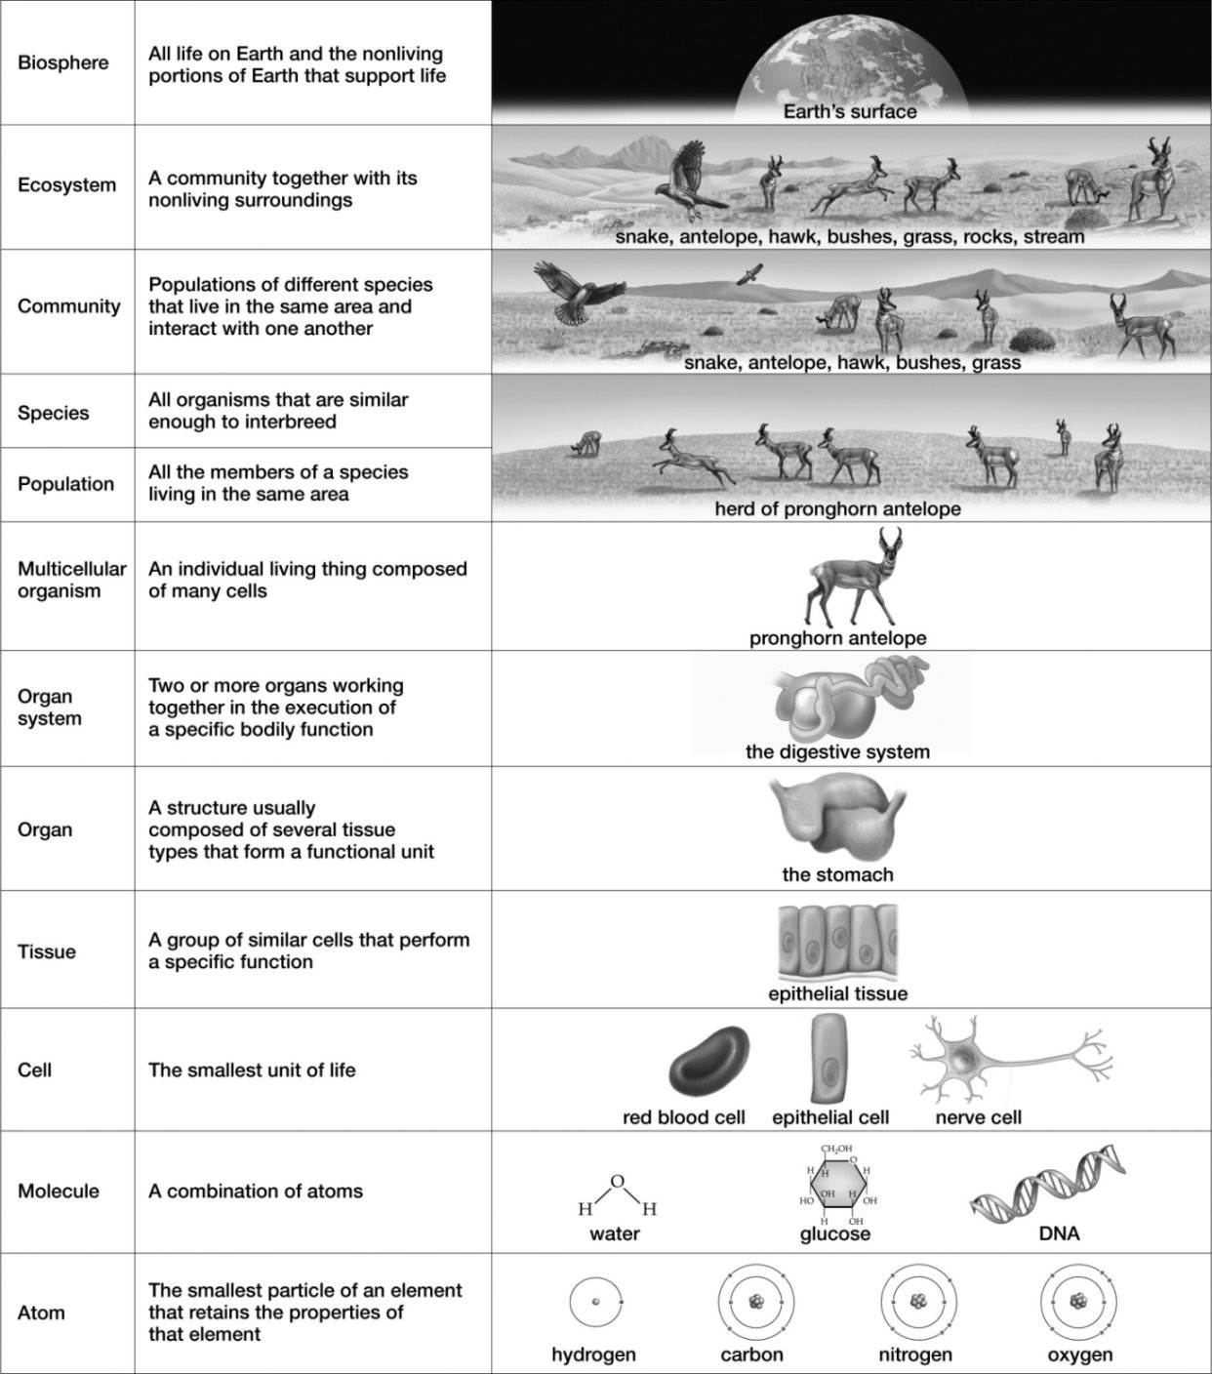
A) Pronghorn antelope
B) Stream
C) Snake
D) Grass
E) Hawk
Answer: B
Diff: 1
Section: 1.1
Skill: Application/Analysis
2) The "first cells" shown at the bottom of this illustration are

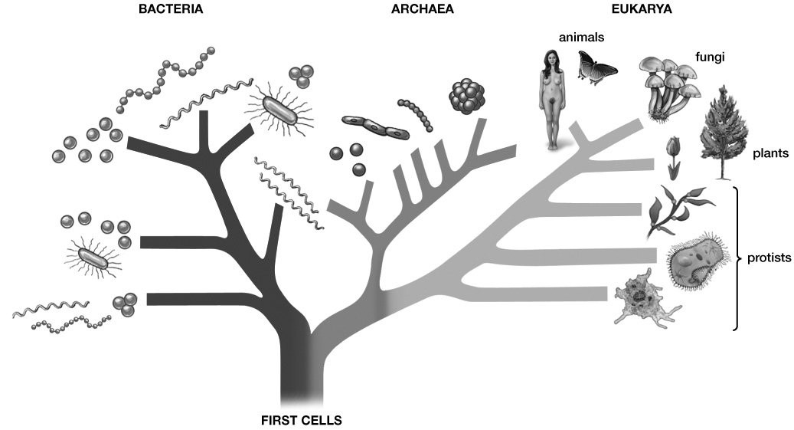
A) prokaryotes.
B) animals.
C) plants.
D) fungi.
E) protists.
Answer: A
Diff: 1
Section: 1.1
Skill: Application/Analysis

1.6 Scenario Questions

1) A 57-year-old woman was admitted to a hospital with an infected toe, and the infection was spreading rapidly. The damage was being caused by an unknown microorganism that could not be cultured in the lab. Doctors observed that antibiotics, which kill only prokaryotes, were ineffective. They suspected that the microbe was a fungus, so they tried the drug Amphotericin, which targets the ergosterols in fungal cells. Because animal cells contain cholesterols, not ergosterols, they are unaffected by the drug. Shortly after receiving Amphotericin, the patient improved, her infection ceased, and she was released from the hospital.

In this scenario, what was the hypothesis?
A) The infection will spread rapidly.
B) Antibiotics will not kill the microbe because it is a fungal species.
C) If the infection is caused by an animal, then Amphotericin will cure the patient.
D) A microbe that lacks cholesterols is causing the infection.
E) Why didn't the antibiotics kill the microbe that caused the infection?
Answer: B
Diff: 3
Section: 1.1
Skill: Application/Analysis
2) Suppose that a meteorite crashes into Earth and a sample of it is taken to a local research lab for analysis. Embedded several inches within the rocky structure, a microscopic cluster of dormant, spore-like structures is found. The scientists culture some of this material in a standard microbiological nutrient broth, and they are surprised to find many single-celled "organisms" moving around, growing, and reproducing in the broth. The "organisms" behave the same in both daylight and dark conditions, do not require oxygen, and persist under a wide range of temperatures and pH levels. They stop moving, growing, and reproducing, however, when fewer nutrients are available in the medium.

In this scenario, the "organisms" most closely resemble a(n)
A) autotrophic species of Eukarya.
B) photosynthetic species of Bacteria.
C) heterotrophic species of Archaea.
D) nonliving virus.
E) heterotrophic species of Eukarya.
Answer: C
Diff: 2
Section: 1.4
Skill: Application/Analysis

