Fundamentals of Corporate Finance, 4e (Berk/DeMarzo/Harford)
Chapter 1 Corporate Finance and the Financial Manager

1.1 Why Study Finance?

1) The Valuation Principle shows how to make the costs and benefits of a decision comparable so that we can evaluate them properly.
Answer: TRUE
Diff: 1 Var: 1
Skill: Conceptual
AACSB Objective: Analytic Skills
Author: DS
Question Status: Previous Edition

2) Financial decisions require that you weigh alternatives in strictly monetary terms.
Answer: FALSE
Diff: 1 Var: 1
Skill: Conceptual
AACSB Objective: Analytic Skills
Author: DS
Question Status: Revised

3) Which of the following best describes why the Valuation Principle is a key concept in making financial decisions?
A) It shows how to assign monetary value to intangibles such as good health and well-being.
B) It allows fixed assets and liquid assets to be valued correctly.
C) It gives a good indication of the net worth of a person, item, or company and can be used to estimate any changes in that net worth.
D) It shows how to make the costs and benefits of a decision comparable so that we can weigh them properly.
Answer: D
Diff: 1 Var: 1
Skill: Conceptual
AACSB Objective: Analytic Skills
Author: DS
Question Status: Previous Edition

1.2 The Four Types of Firms

1) Partnerships are the most common type of business firm in the world.
Answer: FALSE
Diff: 1 Var: 1
Skill: Conceptual
AACSB Objective: Analytic Skills
Author: DS
Question Status: Revised
2) Corporations have come to dominate the business world through their ability to raise large amounts of capital by sale of ownership shares to anonymous outside investors.
Answer: TRUE
Diff: 1 Var: 1
Skill: Conceptual
AACSB Objective: Analytic Skills
Author: DS
Question Status: Revised

3) Which of the following types of firms does NOT have limited liability?
A) sole proprietorships
B) limited partnerships
C) corporations
D) none of the above
Answer: A
Diff: 1 Var: 1
Skill: Conceptual
AACSB Objective: Analytic Skills
Author: DS
Question Status: Revised

4) Over four-fifths of all U.S. business revenue is generated by which type of firm?
A) sole proprietorships
B) partnerships
C) limited partnerships
D) corporations
Answer: D
Diff: 1 Var: 1
Skill: Conceptual
AACSB Objective: Analytic Skills
Author: DS
Question Status: Revised

5) What is the most common type of firm in the United States and the world?
A) sole proprietorships
B) partnerships
C) limited partnerships
D) corporations
Answer: A
Diff: 1 Var: 1
Skill: Conceptual
AACSB Objective: Analytic Skills
Author: DS
Question Status: Previous Edition
6) Which of the following is typically the major factor in limiting the growth of sole proprietorships?
A) The organizational structure of such firms tends to become extremely complicated over time.
B) It is extremely difficult to transfer control of such firms to a new owner if the present owner dies or wishes to sell the firm.
C) The amount of money that can be raised by such firms is limited by the fact that the single owner must make good on all debts.
D) Investors have a great deal of control over the day-to-day running of such firms, leading to confusion when conflicts in direction arise.
Answer: C
Diff: 1 Var: 1
Skill: Conceptual
AACSB Objective: Analytic Skills
Author: DS
Question Status: Revised

7) Joe is a general partner in a limited partnership firm, while Jane is a limited partner in the same firm. Which of the following statements regarding their respective relationships to the firm is correct?
A) Joe has no management authority within the partnership.
B) Jane is legally involved in the managerial decision making of the firm.
C) Jane's liability for the firm's debts consists solely of her investment in the firm.
D) Withdrawal of Jane from the partnership will dissolve the partnership.
Answer: C
Diff: 1 Var: 1
Skill: Conceptual
AACSB Objective: Reflective Thinking Skills
Author: DS
Question Status: Revised

8) What is the major way in which the roles and obligations of the owners of a limited liability company differ from the roles and obligations of limited partners in a limited partnership?
A) The owners of a limited liability company have personal obligation for debts incurred by the company.
B) There is no separation between the company and its owners in a limited liability company.
C) The owners of a limited liability company can withdraw from the company without the company being dissolved.
D) The owners of a limited liability company can take an active role in running the company.
Answer: D
Diff: 1 Var: 1
Skill: Conceptual
AACSB Objective: Analytic Skills
Author: DS
Question Status: Previous Edition
9) In which of the following ways is a limited liability company like a corporation?
A) It was created and developed first in the United States.
B) It can choose to be considered a partnership for tax purposes.
C) Its owners' liability is restricted to their investment.
D) It is directly managed by the owners.
Answer: C
Diff: 1 Var: 1
Skill: Conceptual
AACSB Objective: Analytic Skills
Author: DS
Question Status: Revised

10) Why is it possible for a corporation to enter into contracts, acquire assets, incur obligations, and enjoy protection against the seizure of its property?
A) The number of owners, and hence the spread of risk among these owners, is not limited.
B) Its owners are liable for any obligations it enters into.
C) The state in which a corporation is incorporated provides safeguards against any wrongdoing by the corporation.
D) It is a legally defined, artificial entity that is separate from its owners.
Answer: D
Diff: 1 Var: 1
Skill: Conceptual
AACSB Objective: Analytic Skills
Author: DS
Question Status: Revised

11) Which of the following features of a corporation is LEAST accurate?
A) The owners' identities are separate from a corporation.
B) The owners of a corporation are not liable for any obligations the corporation enters into.
C) Changes in ownership do not result in the dissolution of the corporation.
D) Earnings from a corporation are taxed only once.
Answer: D
Diff: 1 Var: 1
Skill: Conceptual
AACSB Objective: Analytic Skills
Author: DS
Question Status: Revised

12) What is the major advantage corporations have over other business entities?
A) It is easier for a corporation to raise capital than other forms of businesses.
B) A corporation is treated as a separate legal entity for tax and legal purposes.
C) A corporation's shares can be freely traded among its shareholders.
D) All of the above are advantages that a corporation has over other business forms.
Answer: D
Diff: 1 Var: 1
Skill: Conceptual
AACSB Objective: Analytic Skills
Author: DS
Question Status: Previous Edition
13) Helen owns 10.2% of the stock of the Median Corporation. If Median makes a dividend payment of $25,000,000 paid proportionally to its shareholders, how much of this amount would Helen receive, disregarding tax?
A) $3,060,000
B) $2,550,000
C) $3,570,000
D) $2,040,000
Answer: B
Explanation: B) Helen will receive ownership dividend payment proportional to her ownership of 10.2%:
Diff: 2 Var: 50+
Skill: Analytical
AACSB Objective: Analytic Skills
Author: DS
Question Status: Previous Edition

14) Valiant Corp. is a C corporation that earned $3.4 per share before it paid any taxes. Valiant Corp. retained $1 of after-tax earnings for reinvestment and distributed what remained in dividend payments. If the corporate tax rate was 35% and dividend earnings were taxed at 12.5%, what was the value of the dividend earnings received after-tax by a holder of 100,000 shares of Valiant Corp.?
A) $105,875
B) $127,050
C) $148,225
D) $84,700
Answer: A
Explanation: A) Corporate tax paid on $3.4 earnings = $3.4 × 0.35 = 1.190; earnings after- 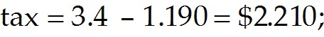 earnings distributed as taxes paid on dividends by a after-tax dividends per hence a holder of 100,000 shares receives 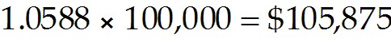
Diff: 2 Var: 22
Skill: Analytical
AACSB Objective: Reflective Thinking Skills
Author: DS
Question Status: Revised

15) Which of the following is unique for an S corporation?
A) The profits and losses of an S corporation are not taxed at the corporate level, but shareholders must include these profits and losses on their individual tax returns.
B) The shareholders of an S corporation must include the firm's profit and losses in their individual income taxes even if no money is distributed to them.
C) There is a maximum limit on the number of shareholders for an S corporation.
D) None of the above statements is unique.
Answer: D
Diff: 3 Var: 1
Skill: Conceptual
AACSB Objective: Analytic Skills
Author: DS
Question Status: Revised

16) You are a shareholder in a corporation which has elected subchapter S tax treatment. The corporation announces a profit of $6 per share, of which it retains $1 for reinvestment and distributes the rest as dividend payments. Given that the personal tax rate is 35%, how much tax must you pay per share?
A) $0
B) $2.10
C) $1.75
D) $2.52
Answer: C
Explanation: C) Tax paid by shareholder of S 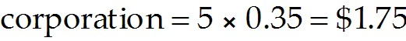
Diff: 2 Var: 8
Skill: Analytical
AACSB Objective: Reflective Thinking Skills
Author: DS
Question Status: Revised

17) A C corporation earns $8.30 per share before taxes. The corporate tax rate is 39%, the personal tax rate on dividends is 15%, and the personal tax rate on non-dividend income is 36%. What is the total amount of taxes paid if the company pays a $6.00 dividend?
A) $3.31
B) $4.96
C) $4.14
D) $5.79
Answer: C
Explanation: C) Corporate tax = $8.30 × 39% = $3.24, 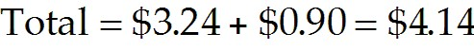
Diff: 2 Var: 50+
Skill: Analytical
AACSB Objective: Reflective Thinking Skills
Author: WC
Question Status: New

18) An S corporation earns $9.10 per share before taxes. The corporate tax rate is 39%, the personal tax rate on dividends is 15%, and the personal tax rate on non-dividend income is 36%. What is the total amount of taxes paid if the company pays a $5.00 dividend?
A) $3.28
B) $3.93
C) $2.62
D) $4.59
Answer: A
Explanation: A) $9.10 × 36% = $3.28
Diff: 2 Var: 50+
Skill: Analytical
AACSB Objective: Reflective Thinking Skills
Author: WC
Question Status: New
19) A C corporation earns $8.30 per share before taxes and the company pays a dividend of $4.00 per share. The corporate tax rate is 39%, the personal tax rate on dividends is 15%, and the personal tax rate on non-dividend income is 36%. What is the after-tax amount an individual would receive from the dividend?
A) $2.72
B) $4.08
C) $4.76
D) $3.40
Answer: D
Explanation: D) Personal tax = $4 × 15% = $0.60. 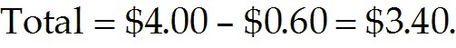
Diff: 2 Var: 50+
Skill: Analytical
AACSB Objective: Reflective Thinking Skills
Author: WC
Question Status: Revised

20) A C corporation earns $4.30 per share before taxes. The corporate tax rate is 35%, the personal tax rate on dividends is 20%, and the personal tax rate on non-dividend income is 39%. What is the total amount of taxes paid if the company pays a $3.00 dividend?
A) $1.68
B) $2.53
C) $2.11
D) $2.95
Answer: C
Explanation: C) Corporate tax = $4.30 × 35% = $1.51, 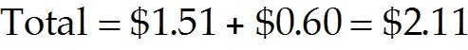
Diff: 2 Var: 50+
Skill: Analytical
AACSB Objective: Reflective Thinking Skills
Author: WC
Question Status: New

21) An S corporation earns $6.00 per share before taxes. The corporate tax rate is 35%, the personal tax rate on dividends is 20%, and the personal tax rate on non-dividend income is 39%. What is the total amount of taxes paid if the company pays a $2.00 dividend?
A) $1.87
B) $2.81
C) $3.28
D) $2.34
Answer: D
Explanation: D) $6.00 × 39% = $2.34
Diff: 2 Var: 50+
Skill: Analytical
AACSB Objective: Reflective Thinking Skills
Author: WC
Question Status: New
22) Which of the following people may not manage the operations of a firm in which they are part or full owners?
A) stockholders in S corporations
B) stockholders in C corporations
C) limited partners in a limited partnership
D) general partners in a limited partnership
Answer: C
Diff: 1 Var: 1
Skill: Conceptual
AACSB Objective: Analytic Skills
Author: DS
Question Status: Previous Edition

23) What is the process of double taxation for the stockholders in a C corporation?
A) Their shares are taxed when they are both bought and sold.
B) The corporation is taxed on the profits it makes, and the owners are taxed when this profit is distributed to them.
C) The owners of a corporation are taxed when they receive dividend payments and when they make a profit from the sale of shares.
D) The corporation must pay taxes on any profits it makes, and the capital raised by the sale of shares is also subject to taxation.
Answer: B
Diff: 1 Var: 1
Skill: Conceptual
AACSB Objective: Analytic Skills
Author: DS
Question Status: Previous Edition

24) A sole proprietorship is owned by ________.
A) one person
B) two or more persons
C) shareholders
D) bankers
Answer: A
Diff: 1 Var: 1
Skill: Definition
AACSB Objective: Analytic Skills
Author: JN
Question Status: Revised

25) Which of the following types of firms generate the most revenue in the United States?
A) S corporation
B) limited partnership
C) C corporation
D) limited liability company
Answer: C
Diff: 1 Var: 1
Skill: Conceptual
AACSB Objective: Analytic Skills
Author: JN
Question Status: Previous Edition

26) Which of the following is NOT an advantage of a sole proprietorship?
A) single taxation
B) ease of setup
C) unlimited liability
D) no separation of ownership and control
Answer: C
Diff: 2 Var: 1
Skill: Conceptual
AACSB Objective: Analytic Skills
Author: JN
Question Status: Revised

27) A limited liability company is essentially ________.
A) a limited partnership without limited partners
B) a limited partnership without a general partner
C) just another name for a limited partnership
D) just another name for a corporation
Answer: B
Diff: 1 Var: 1
Skill: Conceptual
AACSB Objective: Analytic Skills
Author: JN
Question Status: Revised

28) What are the main differences between a partnership and a sole proprietorship?
Answer: A sole proprietorship is a business owned and run by a single person, while a partnership is a business owned and run by more than one owner. Each partner is responsible for his or her own decision as well as any decisions by the other partners.
Diff: 1 Var: 1
Skill: Conceptual
AACSB Objective: Analytic Skills
Author: SS
Question Status: Revised

29) What are the main differences between a limited partnership and a limited liability corporation?
Answer: A limited partnership is required to have at least one general partner. A limited liability corporation is similar to a limited partnership but without the general partner. An LLC also allows all owners, unlike limited partners in an LP, to run the business.
Diff: 2 Var: 1
Skill: Conceptual
AACSB Objective: Analytic Skills
Author: SS
Question Status: Revised
30) How is a corporation different from most of the other forms of business organizations?
Answer: A corporation has a separate legal identity from those of its owners. This separation gives the owners limited liability for the actions of the corporation. The down side is that each dollar earned by the corporation is taxed twice, once when it is earned by the corporation and subsequently when it is passed on to the owners.
Diff: 2 Var: 1
Skill: Conceptual
AACSB Objective: Analytic Skills
Author: SS
Question Status: Revised

1.3 The Financial Manager

1) The principal goal of a financial manager is to maximize the wealth of the stockholders.
Answer: TRUE
Diff: 1 Var: 1
Skill: Conceptual
AACSB Objective: Analytic Skills
Author: DS
Question Status: Revised

2) It is generally not the duty of financial managers to ensure that a firm has the cash it needs for day-to-day transactions.
Answer: FALSE
Diff: 1 Var: 1
Skill: Conceptual
AACSB Objective: Analytic Skills
Author: DS
Question Status: Previous Edition

3) Which of the following is a major duty of a financial manager?
I. To make investment decisions
II. To make financing decisions
III. To manage cash flow from operating activities
A) I only
B) I and II only
C) I and III only
D) all of the above
Answer: D
Diff: 3 Var: 1
Skill: Conceptual
AACSB Objective: Analytic Skills
Author: DS
Question Status: Revised
4) Why in general do financial managers make financial decisions in a corporation, rather than the owners making these decisions themselves?
A) It is best for the control of the finances of a corporation to be in the hands of a disinterested third party.
B) The interests of the various owners may conflict with each other.
C) The owners may not be U.S. citizens or residents.
D) There are often many owners, and they can often change as they buy and sell stock.
Answer: D
Diff: 2 Var: 1
Skill: Conceptual
AACSB Objective: Analytic Skills
Author: DS
Question Status: Previous Edition

5) What is the most important duty of a firm's financial officer?
A) to ensure that the firm has enough cash on hand to meet its commitments at any given time
B) to decide how to pay for investments
C) to manage working capital
D) to make investment decisions
Answer: D
Diff: 2 Var: 1
Skill: Conceptual
AACSB Objective: Analytic Skills
Author: DS
Question Status: Revised

6) The financial manager of a well-regarded book publishing firm wishes to buy a small Internet publishing company to provide an avenue for sale of its materials online. In order to raise the funds to make this purchase, the financial manager decides to sell more stock in the company. How is the financial manager raising funds in this case?
A) by increasing the debt burden carried by the company
B) by raising the company's equity by encouraging new owners to take a stake in the company
C) by decreasing the ratio of equity to debt held by the company
D) by increasing the value of shares held by the existing owners of the company
Answer: B
Diff: 1 Var: 1
Skill: Conceptual
AACSB Objective: Reflective Thinking Skills
Author: DS
Question Status: Previous Edition
7) Which of the following is NOT a reason why a firm's financial managers must take great care when making investment decisions?
A) These investment decisions determine whether the firm will add value for its owners.
B) These investments determine the long-term directions in which the company may move.
C) These investment decisions determine the corporation's mix of debt and equity.
D) These investment decisions typically involve substantial costs which must be carefully weighed against their potential benefits.
Answer: C
Diff: 2 Var: 1
Skill: Conceptual
AACSB Objective: Analytic Skills
Author: DS
Question Status: Revised

8) A company that produces racing motorbikes has several models that sell well within the motorcycle racing community and which are very profitable for the company. Despite having a profitable product, why must this company take care to ensure that it has sufficient cash on hand to meet its obligations?
A) Profits from the sales of popular models will be lost when returned to the shareholders in the form of dividends.
B) New models will require a lot of money to develop and bring to market before they generate any revenue.
C) The company will have built up debts which must be repaid in order to bring the current models to market.
D) Equity must be raised to finance the development of new models to replace the existing models.
Answer: B
Diff: 1 Var: 1
Skill: Conceptual
AACSB Objective: Reflective Thinking Skills
Author: DS
Question Status: Previous Edition

9) A typical company has many types of shareholders, from individuals holding a few shares, to large institutions that hold very large numbers of shares. How does a financial manager ensure that the priorities and concerns of such disparate stockholders are met?
A) The financial manager should seek to make investments that do not harm the interests of the stockholders.
B) The decisions taken by the financial manager should be solely influenced by the benefit to the company since, by maximizing its fitness, he or she will also maximize the benefits of that company to the shareholders.
C) The financial manager should consider the interests and concerns of large shareholders a priority so the needs of those who hold a controlling interest in the company are met.
D) In general, all shareholders will agree that they are better off if the financial manager works to maximize the value of their investment.
Answer: D
Diff: 1 Var: 1
Skill: Conceptual
AACSB Objective: Reflective Thinking Skills
Author: DS
Question Status: Previous Edition

10) Whose interests should a financial manager consider paramount when making a decision?
A) the stockholders who have risked their money to become owners of the company
B) the employees and associated stakeholders who are employed by the company
C) the public who consume the company's goods and services
D) the senior management and associated colleagues at the executive level within the company
Answer: A
Diff: 1 Var: 1
Skill: Conceptual
AACSB Objective: Ethical Understanding and Reasoning Abilities
Author: DS
Question Status: Previous Edition

11) What is the principal guiding factor for the financial manager of a firm?
Answer: Maximizing stockholder wealth is the principal guiding factor for a firm's financial manager.
Diff: 1 Var: 1
Skill: Conceptual
AACSB Objective: Analytic Skills
Author: SS
Question Status: Previous Edition

1.4 The Financial Manager's Place in the Corporation

1) In most corporations, the owners exercise direct control of a corporation.
Answer: FALSE
Diff: 1 Var: 1
Skill: Conceptual
AACSB Objective: Analytic Skills
Author: DS
Question Status: Revised

2) The fact that corporations' shares are easily traded within the market has a net effect of acting as a disincentive for managers to favor the interests of shareholders over their own interests.
Answer: FALSE
Diff: 1 Var: 1
Skill: Conceptual
AACSB Objective: Analytic Skills
Author: DS
Question Status: Previous Edition

3) How do the shareholders of most corporations exercise their control of that corporation?
A) by voting on issues that concern them
B) by electing members of a board of directors
C) by vetting the decisions of the board of directors
D) by providing oversight of the day-to-day running of the corporation
Answer: B
Diff: 1 Var: 1
Skill: Conceptual
AACSB Objective: Analytic Skills
Author: DS
Question Status: Revised

4) Which of the following is NOT a function of the board of directors?
A) determining how top executives should be compensated
B) monitoring the performance of the company
C) answering to shareholders of the company
D) day-to-day running of the company
Answer: D
Diff: 1 Var: 1
Skill: Conceptual
AACSB Objective: Analytic Skills
Author: DS
Question Status: Revised

5) In most corporations, to whom does the chief financial officer report?
A) shareholders
B) the board of directors
C) the chief executive officer
D) the controller
Answer: C
Diff: 1 Var: 1
Skill: Conceptual
AACSB Objective: Analytic Skills
Author: DS
Question Status: Revised

6) Which of the following would be more typically the responsibility of a controller rather than a treasurer?
A) overseeing accounting and tax functions
B) capital budgeting
C) managing credit
D) making investment decisions
Answer: A
Diff: 1 Var: 1
Skill: Conceptual
AACSB Objective: Analytic Skills
Author: DS
Question Status: Revised

7) Which of the following would be best considered to be an agency conflict problem in the behavior of the following financial managers?
A) Bill chooses to pursue a risky investment for the company's funds because his compensation will substantially rise if it succeeds.
B) Sue instructs her staff to skip safety inspections in one of the company's factories, knowing that it will likely fail the inspection and incur significant costs to fix.
C) James ignores an opportunity for his company to invest in a new drug to fight Alzheimer's disease, judging the drug's chances of succeeding as low.
D) Michael chooses to enhance his firm's reputation at some cost to its shareholders by sponsoring a team of athletes for the Olympics.
Answer: A
Diff: 3 Var: 1
Skill: Conceptual
AACSB Objective: Ethical Understanding and Reasoning Abilities
Author: DS
Question Status: Revised
8) A factory owner wants his workers to produce as many widgets as they can so he pays his workers based on how many widgets they produce. However, in order to make sure that the workers do not rush and produce a large number of poorly made widgets, he checks the widgets at random during various stages of their manufacture. If a defect is found in a widget, the pay of the entire section of the factory responsible for that defect is docked. How is this factory owner seeking to solve the agency conflict problem in this case?
A) by supplying incentives so the agents act in the way principal desires
B) by ensuring that all workers co-operate to maximize the gains of their section
C) by making the agents into principals themselves
D) by maximizing the information that the principal obtains about the behavior of the agents
Answer: A
Diff: 1 Var: 1
Skill: Conceptual
AACSB Objective: Ethical Understanding and Reasoning Abilities
Author: DS
Question Status: Previous Edition

9) In which of the following relationships is an agency conflict problem LEAST likely to arise?
A) the relationship between a hire-car company and the persons who hire that company's cars regarding the treatment of those cars
B) the relationship between high-level military officers and the soldiers who serve under them regarding the willingness of the soldiery to take risks
C) the relationship between a restaurateur and the suppliers of produce to that restaurant regarding the freshness of the produce supplied
D) the relationship between a driver and the passengers in a car regarding the safe driving of that car
Answer: D
Diff: 1 Var: 1
Skill: Conceptual
AACSB Objective: Ethical Understanding and Reasoning Abilities
Author: DS
Question Status: Revised

10) What is the most common way that agency conflict problems are addressed in most corporations?
A) by minimizing the number of decisions that a manager makes where there is a conflict between the managers interests and those of the shareholders
B) by terminating the employment of employees who are found to have put their own interests above those of the company
C) by using disinterested outside bodies to adjudicate between managers and shareholders when such conflicts arise
D) by prosecuting managers who have been found to have illegally used company moneys for their own benefit
Answer: A
Diff: 1 Var: 1
Skill: Conceptual
AACSB Objective: Ethical Understanding and Reasoning Abilities
Author: DS
Question Status: Previous Edition
11) A company's board of directors chooses to provide a comprehensive health care plan for the families of all employees, despite the large cost. They argue that this will not only increase the number of employees who stay with the firm, and thus reduce some costs involved in employee turnover, but also increase the employees' diligence and industry. What general principle is being argued by the board of directors?
A) In a conflict between stakeholders in a company, the most important stakeholder is not always the stockholders.
B) Some activities that decrease shareholders' wealth may have intangible benefits which increase the strength of the company overall.
C) When a conflict of interest arises between shareholders and other stakeholders, in general, the correct solution is the one that creates the greatest good for the greatest number of stakeholders.
D) Ethical decisions should be assessed on their moral value, not on their value in dollars and cents.
Answer: B
Diff: 1 Var: 1
Skill: Conceptual
AACSB Objective: Ethical Understanding and Reasoning Abilities
Author: DS
Question Status: Previous Edition

12) Why is the stock price of a company an indication of the performance of the company's senior managers?
A) Well-run companies are invariably highly profitable, which leads to a higher share price.
B) In general, people want to invest in a well-managed corporation, which will drive up the price of shares.
C) Investors who can see that a company is well-run will hold on to their shares, even if the company faces setbacks, since they know that the stock price will likely rise again.
D) Larger companies tend to be better run and so have higher stock prices.
Answer: B
Diff: 1 Var: 1
Skill: Conceptual
AACSB Objective: Reflective Thinking Skills
Author: DS
Question Status: Revised

13) A corporate raider gains a controlling fraction of the shares of a poorly managed company and replaces the board of directors. How does the corporate raider hope to make a profit in this case?
A) by the sale of the assets held by the company that hold most of its value
B) by the rise in the value of the stock held by the raider when the new board of directors is judged to be superior to the ousted board of directors
C) by motivating the board of directors and other stakeholders in the company to make difficult short-term decisions that will increase the long-term viability of the company
D) by removing the employees expectations of the continued poor performance of the company
Answer: B
Diff: 1 Var: 1
Skill: Conceptual
AACSB Objective: Analytic Skills
Author: DS
Question Status: Previous Edition
14) A ________ is when a rich individual or organization purchases a large fraction of the stock of a poorly performing firm and in doing so gets enough votes to replace the board of directors and the CEO.
A) shareholder proposal
B) leveraged buyout
C) shareholder action
D) hostile takeover
Answer: D
Diff: 2 Var: 1
Skill: Definition
AACSB Objective: Analytic Skills
Author: JN
Question Status: Revised

15) Briefly discuss the issues in the agency conflict problem.
Answer: The agency conflict problem arises out of the principal-agent relationship existing between the shareholders and managers of a corporation. Although managers are required to put the shareholders' interests ahead of their own, in practice they tend to put their own interest ahead of the shareholders' interests.
Diff: 2 Var: 1
Skill: Conceptual
AACSB Objective: Ethical Understanding and Reasoning Abilities
Author: SS
Question Status: Revised

16) Explain some of the measures taken to reduce the agency conflict problem.
Answer: The agency conflict problem can be reduced by taking measures that align the managers interests with those of the shareholders. For example, incentive-based compensation, such as employee stock options, helps align the interests of these two constituents.
Diff: 2 Var: 1
Skill: Analytical
AACSB Objective: Ethical Understanding and Reasoning Abilities
Author: SS
Question Status: Revised

1.5 The Stock Market

1) The shares of private corporations are traded on a stock market.
Answer: FALSE
Diff: 1 Var: 1
Skill: Conceptual
AACSB Objective: Analytic Skills
Author: DS
Question Status: Previous Edition

2) Stock markets provide liquidity for a firm's shares.
Answer: TRUE
Diff: 1 Var: 1
Skill: Conceptual
AACSB Objective: Analytic Skills
Author: DS
Question Status: Previous Edition
3) If broker will buy a share of stock from you at $3.85 and sell it to you at $3.87, the ask price would be $3.85.
Answer: FALSE
Diff: 1 Var: 1
Skill: Conceptual
AACSB Objective: Analytic Skills
Author: WC
Question Status: New

4) Which of the following should be true for an asset to be considered liquid?
A) It pays regular dividends.
B) It can be bought and sold at an organized stock market or bourse.
C) It is offered for sale on both primary and secondary markets.
D) It can be easily bought and sold and the selling price is very close to the buying price at a given point in time.
Answer: D
Diff: 1 Var: 1
Skill: Conceptual
AACSB Objective: Analytic Skills
Author: DS
Question Status: Revised

5) Why is it difficult to determine the market price of a private corporation's shares at any point in time?
A) It is difficult to obtain enough information to accurately value such a company.
B) The price of its shares is fixed by the owners.
C) It has a limited number of owners.
D) There is no organized market for its shares.
Answer: D
Diff: 1 Var: 1
Skill: Conceptual
AACSB Objective: Analytic Skills
Author: DS
Question Status: Previous Edition

6) Which of the stock markets listed below is the smallest, as judged by trading volume?
A) Deutsche Börse
B) London Stock Exchange
C) NASDAQ
D) NYSE Euronext (US)
Answer: A
Diff: 1 Var: 1
Skill: Conceptual
AACSB Objective: Analytic Skills
Author: DS
Question Status: Revised
7) Why is a stock exchange like NASDAQ considered a secondary market?
A) It trades the second largest volume of shares in the world.
B) Shares sold on it are exchanged between investors without any involvement of the issuing corporation.
C) The exchange has rules that attempt to ensure that bid and ask prices do not get too far apart.
D) NASDAQ is called a secondary market because NYSE is considered a primary market.
Answer: B
Diff: 1 Var: 1
Skill: Conceptual
AACSB Objective: Analytic Skills
Author: DS
Question Status: Previous Edition

8) On August 19, 2004 Google IPO offered 19,605,052 shares at a price of U.S. $85 per share, which were sold in an online auction in a bid to make the shares more widely available. Which of the following statements best describes why these are considered a primary market transaction?
A) The transaction was between the corporation and investors.
B) Shares of Google from this time onward could be traded between investors on a stock exchange.
C) The shares were the first to be privately issued by Google.
D) Google was at the time a recently founded company seeking capital with which to expand.
Answer: A
Diff: 1 Var: 1
Skill: Conceptual
AACSB Objective: Reflective Thinking Skills
Author: DS
Question Status: Revised

9) What is the bid-ask spread?
A) the difference in price available for an immediate sale of a stock and the immediate purchase of the stock
B) all of the costs and fees that a stock exchange charges in order to process a transaction
C) the rise or fall in the value of a stock between the time it is acquired by an investor and sold by that investor
D) the difference in the selling price of a stock between different exchanges
Answer: A
Diff: 1 Var: 1
Skill: Conceptual
AACSB Objective: Analytic Skills
Author: DS
Question Status: Revised
10) Stella places a market order with her broker to buy 1,000 shares of OneWorld Corp. The broker buys 1,000 shares at $16.00 each, and sells them to Stella at $16.15 each. He also charges a commission of $12.00. What is the total dollar amount spent towards the bid-ask spread in this case?
A) $162
B) $120
C) $210.00
D) $150
Answer: D
Explanation: D) (16.15 - 16.00) × 1,000 = $150
Diff: 2 Var: 33
Skill: Analytical
AACSB Objective: Analytic Skills
Author: DS
Question Status: Revised

11) Which of the following is a measure of the aggregate price level of collections of pre-selected stocks?
A) NASDAQ
B) S&P 500
C) NYSE
D) Euronext
Answer: B
Diff: 1 Var: 1
Skill: Conceptual
AACSB Objective: Analytic Skills
Author: DS
Question Status: Previous Edition
Use the figure for the question(s) below.

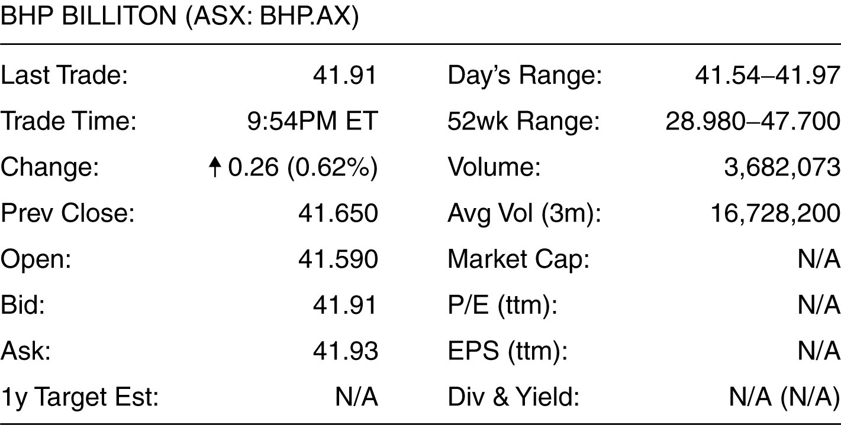

12) Using the above information, how much would you pay for a share of BHP Billiton stock?
A) $41.91
B) $41.93
C) $41.65
D) $41.59
Answer: B
Diff: 1 Var: 1
Skill: Analytical
AACSB Objective: Analytic Skills
Author: DS
Question Status: Previous Edition
Use the figure for the question(s) below.

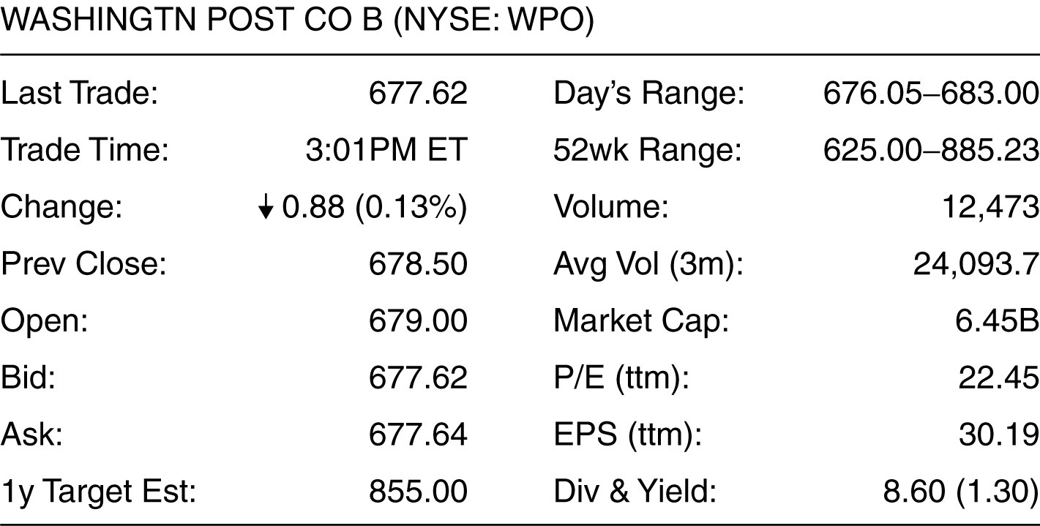

13) Using the above information, how much would you receive if you sold a share of Washington Post stock?
A) $683.00
B) $677.62
C) $678.50
D) $677.64
Answer: B
Diff: 1 Var: 1
Skill: Analytical
AACSB Objective: Analytic Skills
Author: DS
Question Status: Previous Edition
Use the figure for the question(s) below.

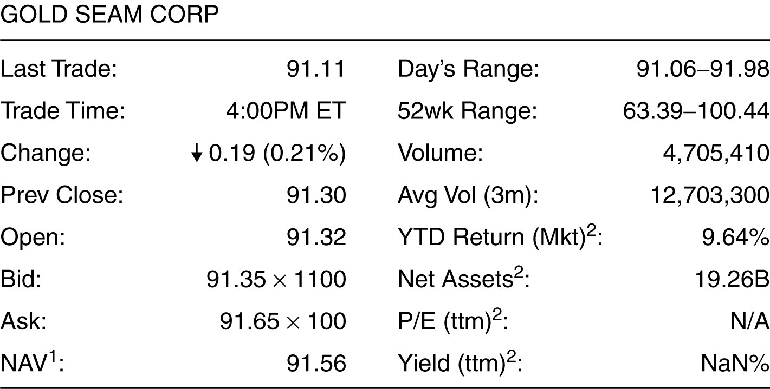

14) Based on the information shown above, what would it cost to buy 1,000 shares of the above stock?
A) $91,110
B) $91,300
C) $91,320
D) $91,650
Answer: D
Diff: 1 Var: 1
Skill: Analytical
AACSB Objective: Analytic Skills
Author: DS
Question Status: Previous Edition
Use the figure for the question(s) below.

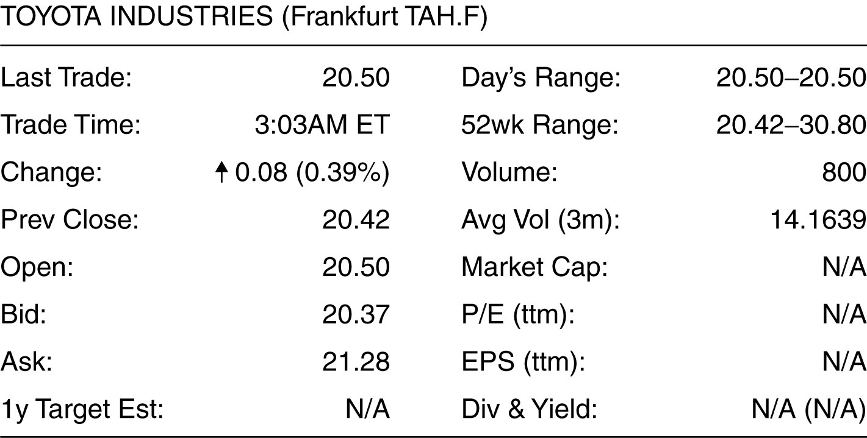

15) Based on the information shown above, how much would you receive from selling 2,000 shares of the above stock?
A) €40,840
B) €40,740
C) €41,000
D) €42,560
Answer: B
Diff: 1 Var: 1
Skill: Analytical
AACSB Objective: Analytic Skills
Author: DS
Question Status: Revised
Use the figure for the question(s) below.

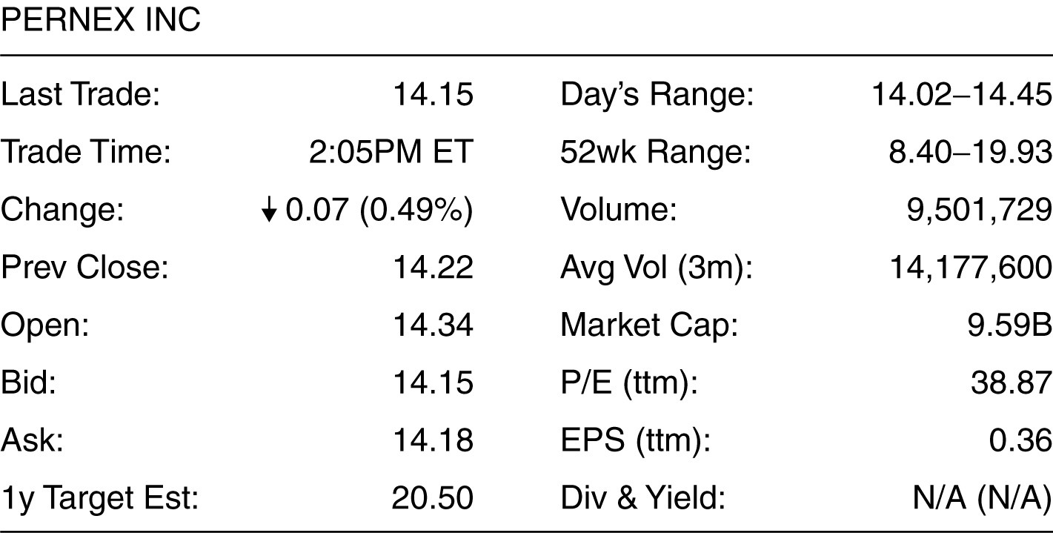

16) What is the bid-ask spread on the stock shown above?
A) 1 cent
B) 3 cents
C) 6 cents
D) 12 cents
Answer: B
Diff: 1 Var: 1
Skill: Analytical
AACSB Objective: Analytic Skills
Author: DS
Question Status: Previous Edition
Use the figure for the question(s) below.

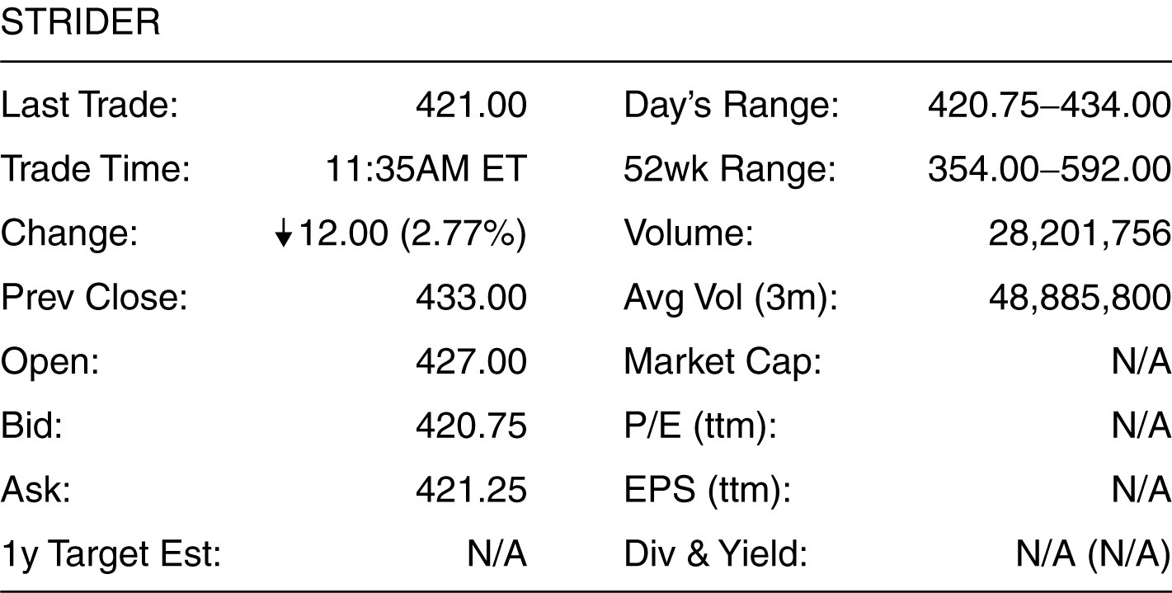

17) How much money would a stock exchange make from buying and selling 500 shares of the stock under the conditions shown above?
A) $250
B) $3,000
C) $5,875
D) $210,375
Answer: A
Explanation: A) (421.25 - 420.75) × 500 = $250
Diff: 2 Var: 1
Skill: Analytical
AACSB Objective: Analytic Skills
Author: DS
Question Status: Revised

18) What are the terms for the two types of prices quoted for a stock on an exchange?
Answer: The two quotes associated with a stock quoted on the exchange are bid price and ask price.
Diff: 2 Var: 1
Skill: Conceptual
AACSB Objective: Analytic Skills
Author: SS
Question Status: Previous Edition

19) What is the general relation of the two types of prices quoted for a stock on a exchange?
Answer: The two prices are bid price and ask price. The ask price is higher than the bid price to deter a buyer from buying a stock and selling it back immediately, assuming everything else remains unchanged.
Diff: 2 Var: 1
Skill: Conceptual
AACSB Objective: Analytic Skills
Author: SS
Question Status: Revised
20) What is the term for the applicable price that I will pay, if I have to buy a stock?
Answer: The buyer of a stock pays the ask price when he buys the stock.
Diff: 2 Var: 1
Skill: Conceptual
AACSB Objective: Analytic Skills
Author: SS
Question Status: Previous Edition

21) What is the term for the applicable price that the seller gets when he sells a stock on the exchange?
Answer: The seller gets the bid price when he sells a stock on the exchange.
Diff: 2 Var: 1
Skill: Conceptual
AACSB Objective: Analytic Skills
Author: SS
Question Status: Previous Edition

22) What are the main differences between the NYSE and NASDAQ stock markets?
Answer: The NYSE has a physical location, a geographical address where traders gather to trade, but NASDAQ is an electronic market. Moreover, while the NYSE has one specialist in each stock, NASDAQ has multiple market makers serving the functions of both matching buyers and sellers and trading on their own account.
Diff: 2 Var: 1
Skill: Conceptual
AACSB Objective: Analytic Skills
Author: SS
Question Status: Previous Edition

1.6 Financial Institutions

1) Raising new capital by issuing bonds is an example of a commercial banking activity.
Answer: FALSE
Diff: 1 Var: 1
Skill: Conceptual
AACSB Objective: Analytic Skills
Author: WC
Question Status: New

2) Put the following steps of the financial cycle in the correct order.
I. Money flows to companies who use it to fund growth through new products.
II. People invest and save their money.
III. Money flows back to savers and investors.
A) I, II, and III
B) II, I, and III
C) III, II, and I
D) II, III, and I
Answer: B
Diff: 1 Var: 1
Skill: Conceptual
AACSB Objective: Reflective Thinking Skills
Author: WC
Question Status: Revised

3) Investments by wealthy individuals and endowments is a major source of money for each of the following EXCEPT ________.
A) private equity funds
B) hedge funds
C) venture capital funds
D) mutual funds
Answer: D
Diff: 1 Var: 1
Skill: Conceptual
AACSB Objective: Analytic Skills
Author: WC
Question Status: New

4) Which of the following is NOT a role of financial institutions?
A) moving funds from savers to borrowers
B) spreading out risk-bearing
C) printing money for borrowers
D) moving funds though time
Answer: C
Diff: 1 Var: 1
Skill: Conceptual
AACSB Objective: Analytic Skills
Author: WC
Question Status: Revised

