Biology, 8e (Campbell)
Chapter 1

Introduction: Themes in the Study of Life

Multiple-Choice Questions

1) Which of the following properties or processes do we associate with living things?
A) evolutionary adaptations
B) energy processing
C) responding to the environment
D) growth and reproduction
E) all of the above

Answer: E
Topic: Overview
Skill: Knowledge/Application

2) Which of the following is not a theme that unifies biology?
A) interaction with the environment
B) emergent properties
C) evolution
D) reductionism
E) structure and function

Answer: D
Topic: Concept 1.1
Skill: Knowledge/Application

3) Which of the following sequences represents the hierarchy of biological organization from the least to the most complex level?
A) organelle, tissue, biosphere, ecosystem, population, organism
B) cell, community, population, organ system, molecule, organelle
C) organism, community, biosphere, molecule, tissue, organ
D) ecosystem, cell, population, tissue, organism, organ system
E) molecule, cell, organ system, population, ecosystem, biosphere

Answer: E
Topic: Concept 1.1
Skill: Knowledge/Application

4) A localized group of organisms that belong to the same species is called a
A) biosystem.
B) community.
C) population.
D) ecosystem.
E) family.

Answer: C
Topic: Concept 1.1
Skill: Knowledge/Application
5) Which of the following is a false statement regarding DNA?
A) Each chromosome has one very long DNA molecule with hundreds of thousands of genes.
B) Every cell is enclosed by a membrane.
C) Every cell uses DNA as its genetic information.
D) All forms of life are composed of cells that have a membrane-enclosed nucleus.
E) DNA is the unit of inheritance that is transmitted from parent to offspring.

Answer: D
Topic: Concept 1.1
Skill: Knowledge/Application

6) In terms of the hierarchical organization of life, a bacterium is at the __________ level of organization, whereas a human is at the __________ level of organization.
A) single-celled organism; multicellular organism
B) single organelle; organism
C) organelle; organ system
D) single tissue; multicellular organism
E) tissue; organism

Answer: A
Topic: Concept 1.1
Skill: Knowledge/Application

7) Which of these is a correct representation of the hierarchy of biological organization from least to most complex?
A) organelle of a stomach cell, digestive system, large intestine, small intestine, intestinal tissue, organism
B) organelle of an intestinal cell, digestive system, small intestine, large intestine, intestinal tissue, organism
C) molecule, intestinal cell organelle, intestinal cell, intestinal tissue, digestive system, organism
D) molecule, small intestine, large intestine, intestinal tissue, digestive system, organism
E) molecule, digestive system, digestive cell organelle, small intestine, large intestine, intestinal cell, organism

Answer: C
Topic: Concept 1.1
Skill: Knowledge/Application

8) Organisms interact with their environments, exchanging matter and energy. For example, plant chloroplasts convert the energy of sunlight into
A) the energy of motion.
B) carbon dioxide and water.
C) the potential energy of chemical bonds.
D) oxygen.
E) kinetic energy.

Answer: C
Topic: Concept 1.1
Skill: Knowledge/Application

9) The main source of energy for producers in an ecosystem is
A) light energy.
B) kinetic energy.
C) thermal energy.
D) chemical energy.
E) ATP.

Answer: A
Topic: Concept 1.1
Skill: Knowledge/Application

10) The dynamics of any ecosystem include the following major processes:
A) the flow of energy from sunlight to producers
B) the flow of energy from sunlight to producers and then to consumers
C) the recycling of chemical nutrients
D) the flow of energy to producers and the recycling of nutrients
E) the flow of energy from sunlight to producers and then to consumers, and the recycling of chemical nutrients.

Answer: E
Topic: Concept 1.1
Skill: Knowledge/Application

11) For most ecosystems __________ is (are) the ultimate source of energy, and energy leaves the ecosystem in the form of __________.
A) sunlight; heat
B) heat; light
C) plants; animals
D) plants; heat
E) producers; consumers

Answer: A
Topic: Concept 1.1
Skill: Knowledge/Application
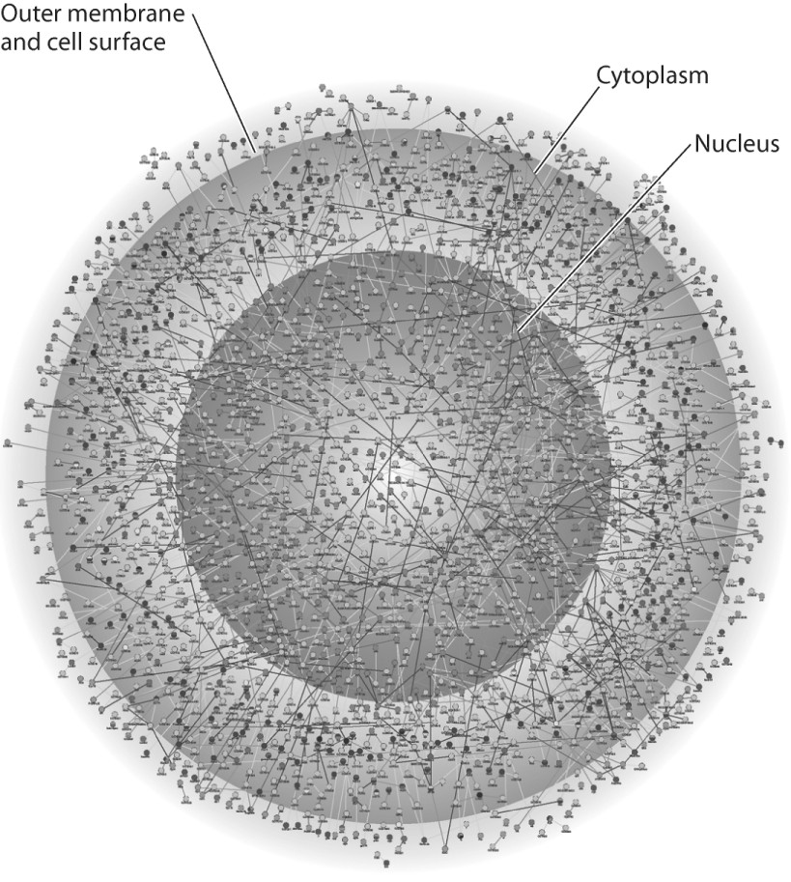

12) The illustration above represents
A) a computer simulation of the structure of a eukaryotic cell.
B) a map of a network of protein interactions within a eukaryotic cell.
C) an inventory of all the genes in a fruit fly.
D) an X-ray diffraction image of the nucleus and cytoplasm of a eukaryotic cell.
E) a computer generated map of the interaction of genes and cytoplasm in a prokaryotic cell.

Answer: B
Topic: Concept 1.1
Skill: Knowledge/Application

13) The lowest level of biological organization that can perform all the activities required for life is the
A) organelle–for example, a chloroplast.
B) cell–for example, a skin cell.
C) tissue–for example, nervous tissue.
D) organ system–for example, the reproductive system.
E) organism–for example, an amoeba, dog, human, or maple tree.

Answer: B
Topic: Concept 1.1
Skill: Knowledge/Application

14) Which of the following is a false statement regarding deoxyribonucleic acid (DNA)?
A) Each deoxyribonucleic acid molecule is composed of two long chains of nucleotides arranged in a double helix.
B) Genes are composed of deoxyribonucleic acid.
C) DNA is composed of chemical building blocks called nucleotides.
D) DNA is a code for the sequence of amino acids in a protein.
E) DNA is an enzyme that puts together amino acids to make a protein.

Answer: E
Topic: Concept 1.1
Skill: Knowledge/Application

15) Which of the following types of cells utilize deoxyribonucleic acid (DNA) as their genetic material but do not have their DNA encased within a nuclear envelope?
A) animal
B) plant
C) archaea
D) fungi
E) protists

Answer: C
Topic: Concept 1.1
Skill: Application/Analysis

16) Which of the following statements concerning prokaryotic and eukaryotic cells is not correct?
A) Prokaryotic cells lack a membrane-bound nucleus.
B) Prokaryotic cells contain small membrane-enclosed organelles.
C) Eukaryotic cells contain a membrane-bound nucleus.
D) DNA, or deoxyribonucleic acid, is present in both prokaryotic cells and eukaryotic cells.
E) DNA or deoxyribonucleic acid is present in the nucleus of eukaryotic cells.

Answer: B
Topic: Concept 1.1
Skill: Knowledge/Application

17) Which of the following is reflective of the phrase "the whole is greater than the sum of its parts"?
A) high-throughput technology
B) emergent properties
C) natural selection
D) reductionism
E) feedback regulations

Answer: B
Topic: Concept 1.1
Skill: Knowledge/Application

18) In order to understand the chemical basis of inheritance, one must understand the molecular structure of DNA. This is an example of the application of __________ to the study of biology.
A) evolution
B) emergent properties
C) reductionism
D) the cell theory
E) feedback regulation

Answer: C
Topic: Concept 1.1
Skill: Application/Analysis

19) A type of protein critical to all cells is organic catalysts called
A) feedback activators.
B) feedback inhibitors.
C) enzymes.
D) metabolites.
E) nutrients.

Answer: C
Topic: Concept 1.1
Skill: Knowledge/Application

20) Once labor begins in childbirth, contractions increase in intensity and frequency until delivery. The increasing labor contractions of childbirth are an example of
A) a bioinformatic system.
B) positive feedback.
C) negative feedback.
D) feedback inhibition.
E) enzymatic catalysis.

Answer: B
Topic: Concept 1.1
Skill: Application/Analysis

21) When blood glucose level rises, the pancreas secretes insulin, and as a result blood glucose level declines. When blood glucose level is low, the pancreas secretes glucagon, and as a result blood glucose level rises. Such regulation of blood glucose level is the result of
A) catalytic feedback.
B) positive feedback.
C) negative feedback.
D) bioinformatic regulation.
E) protein-protein interactions.

Answer: C
Topic: Concept 1.1
Skill: Application/Analysis

22) Life is diverse. How many species are estimated to be presently on the earth?
A) 1,800
B) 180,000
C) 1,800,000
D) 18,000,000
E) 180,000,000

Answer: C
Topic: Concept 1.1
Skill: Knowledge/Application

23) Which branch of biology is concerned with the naming and classifying of organisms?
A) informatics
B) schematic biology
C) taxonomy
D) genomics
E) evolution

Answer: C
Topic: Concept 1.1
Skill: Knowledge/Application

24) Prokaryotic and eukaryotic cells generally have which of the following features in common?
A) a membrane-bounded nucleus
B) a cell wall made of cellulose
C) ribosomes
D) flagella or cilia that contain microtubules
E) linear chromosomes made of DNA and protein

Answer: C
Topic: Concept 1.1
Skill: Knowledge/Application

25) Prokaryotes are classified as belonging to two different domains. What are the domains?
A) Bacteria and Eukarya
B) Archaea and Monera
C) Eukarya and Monera
D) Bacteria and Protista
E) Bacteria and Archaea

Answer: E
Topic: Concept 1.1
Skill: Knowledge/Application

26) Species that are in the same __________ are more closely related than species that are only in the same __________.
A) phylum; class
B) family; order
C) class; order
D) family; genus
E) kingdom; phylum

Answer: B
Topic: Concept 1.2
Skill: Application/Analysis

27) Two species that belong to the same genus must also belong to the same
A) kingdom.
B) phylum.
C) class.
D) order.
E) all of the above

Answer: E
Topic: Concept 1.2
Skill: Application/Analysis

28) Which of these is reflective of the hierarchical organization of life from most to least inclusive?
A) kingdom, order, family, phylum, class, genus, species
B) phylum, class, order, kingdom, family, genus, species
C) kingdom, phylum, class, order, family, genus, species
D) genus, species, kingdom, phylum, class, order, family
E) class, order, kingdom, phylum, family, genus, species

Answer: C
Topic: Concept 1.2
Skill: Knowledge/Application

29) A water sample from a hot thermal vent contained a single-celled organism that had a cell wall but lacked a nucleus. What is its most likely classification?
A) Eukarya
B) Archaea
C) Animalia
D) Protista
E) Fungi

Answer: B
Topic: Concept 1.2
Skill: Application/Analysis

30) A filamentous organism has been isolated from decomposing organic matter. This organism has a cell wall but no chloroplasts. How would you classify this organism?
A) domain Bacteria, kingdom Prokaryota
B) domain Archaea, kingdom Bacteria
C) domain Eukarya, kingdom Plantae
D) domain Eukarya, kingdom Protista
E) domain Eukarya, kingdom Fungi

Answer: E
Topic: Concept 1.2
Skill: Application/Analysis

31) Which of these provides evidence of the common ancestry of all life?
A) the ubiquitous use of catalysts by living systems
B) the universality of the genetic code
C) the structure of the nucleus
D) the structure of cilia
E) the structure of chloroplasts

Answer: B
Topic: Concept 1.2
Skill: Application/Analysis

32) Which of the following is (are) true of natural selection?
A) requires genetic variation
B) results in descent with modification
C) involves differential reproductive success
D) B and C only
E) A, B, and C

Answer: E
Topic: Concept 1.2
Skill: Knowledge/Application

33) Charles Darwin proposed a mechanism for descent with modification which stated that organisms of a particular species are adapted to their environment when they possess
A) non-inheritable traits that enhance their survival in the local environment.
B) non-inheritable traits that enhance their reproductive success in the local environment.
C) non-inheritable traits that enhance their survival and reproductive success in the local environment.
D) inheritable traits that enhance their survival and reproductive success in the local environment.
E) inheritable traits that decrease their survival and reproductive success in the local environment.

Answer: D
Topic: Concept 1.2
Skill: Application/Analysis

34) All of the following statements are part of Charles Darwin's concept of natural selection except
A) Slight inheritable variations within a population may make an individual significantly more or less likely to survive in its environment, and thus to reproduce.
B) Every organism has the potential to produce more offspring than the local environment can support.
C) Characteristics of organisms are inherited as genes on chromosomes.
D) Better adapted members of a species will survive and reproduce more successfully.
E) Most individuals in a species do not survive to reproduce.

Answer: C
Topic: Concept 1.2
Skill: Application/Analysis

35) Which of these individuals is most likely to be successful in an evolutionary sense?
A) a reproductively sterile individual who never falls ill
B) an organism that dies after 5 days of life but leaves 10 offspring, all of whom survive to reproduce
C) a male who mates with 20 females and fathers 1 offspring
D) an organism that lives 100 years and leaves 2 offspring, both of whom survive to reproduce
E) a female who mates with 20 males and produces 1 offspring

Answer: B
Topic: Concept 1.2
Skill: Application/Analysis

36) In a hypothetical world, every 50 years people over 6 feet tall are eliminated from the population. Based on your knowledge of natural selection, you would predict that the average height of the human population will
A) remain unchanged.
B) gradually decline.
C) rapidly decline.
D) gradually increase.
E) rapidly increase.

Answer: B
Topic: Concept 1.2
Skill: Application/Analysis

37) Through time, the lineage that led to modern whales shows a change from four-limbed land animals to aquatic animals with two limbs that function as flippers. This change is best explained by
A) natural philosophy.
B) creationism.
C) the hierarchy of the biological organization of life.
D) natural selection.
E) feedback inhibition.

Answer: D
Topic: Concept 1.2
Skill: Application/Analysis

38) Evolution is biology's core theme that ties together all the other themes. This is because evolution explains
A) the unity and diversity of life.
B) how organisms become adapted to their environment through the differential reproductive success of varying individuals.
C) why distantly related organisms sometimes resemble each other.
D) explains why some organisms have traits in common.
E) all of the above

Answer: E
Topic: Concept 1.2
Skill: Application/Analysis

39) The method of scientific inquiry that describes natural structures and processes as accurately as possible through careful observation and the analysis of data is known as
A) hypothesis-based science.
B) discovery science.
C) experimental science.
D) quantitative science.
E) qualitative science.

Answer: B
Topic: Concept 1.3
Skill: Knowledge/Application

40) Collecting data based on observation is an example of __________; analyzing this data to reach a conclusion is an example of __________ reasoning.
A) hypothesis-based science; inductive
B) the process of science; deductive
C) discovery science; inductive
D) descriptive science; deductive
E) hypothesis-based science; deductive

Answer: C
Topic: Concept 1.3
Skill: Application/Analysis

41) What is a hypothesis?
A) the same thing as an unproven theory
B) a tentative explanation that can be tested and is falsifiable
C) a verifiable observation sensed directly, or sensed indirectly with the aid of scientific instrumentation
D) a fact based on qualitative data that is testable
E) a fact based on quantitative data that is falsifiable

Answer: B
Topic: Concept 1.3
Skill: Knowledge/Application

42) Which of these is based on a deduction?
A) My car won't start.
B) My car's battery is dead.
C) My car is out of gas.
D) I lost my car key.
E) If I turn the key in the ignition while stepping on the gas pedal, then my car will start.

Answer: E
Topic: Concept 1.3
Skill: Application/Analysis

43) When applying the process of science, which of these is tested?
A) a question
B) a result
C) an observation
D) a prediction
E) a hypothesis

Answer: D
Topic: Concept 1.3
Skill: Application/Analysis

44) A controlled experiment is one in which
A) the experiment is repeated many times to ensure that the results are accurate.
B) the experiment proceeds at a slow pace to guarantee that the scientist can carefully observe all reactions and process all experimental data.
C) there are at least two groups, one of which does not receive the experimental treatment.
D) there are at least two groups, one differing from the other by two or more variables.
E) there is one group for which the scientist controls all variables.

Answer: C
Topic: Concept 1.3
Skill: Application/Analysis

45) Why is it important that an experiment include a control group?
A) The control group is the group that the researcher is in control of; it is the group in which the researcher predetermines the nature of the results.
B) The control group provides a reserve of experimental subjects.
C) A control group is required for the development of an "if, then" statement.
D) A control group assures that an experiment will be repeatable.
E) Without a control group, there is no basis for knowing if a particular result is due to the variable being tested or to some other factor.

Answer: E
Topic: Concept 1.3
Skill: Application/Analysis

46) The application of scientific knowledge for some specific purpose is known as
A) technology.
B) deductive science.
C) inductive science.
D) anthropologic science.
E) pure science.

Answer: A
Topic: Concept 1.3
Skill: Knowledge/Comprehension

True/False Questions

47) A common form of regulation in which accumulation of an end product of a process slows that process is called positive feedback.

Answer: FALSE
Topic: Concept 1.1
Skill: Application/Analysis

48) Charles Darwin presented verifiable evidence that supported the view that life can arise by spontaneous generation.

Answer: FALSE
Topic: Concept 1.2
Skill: Application/Analysis

49) Recent evidence points to the conclusion that the ancestral finches of the Galapagos originated in the islands of the Caribbean.

Answer: TRUE
Topic: Concept 1.2
Skill: Application/Analysis

50) Discovery science uses inductive reasoning to derive generalizations from a large number of specific observations.

Answer: TRUE
Topic: Concept 1.3
Skill: Application/Analysis

51) In hypothesis-based science, deductive reasoning is used to predict a result that would be found if a particular hypothesis is correct.

Answer: TRUE
Topic: Concept 1.3
Skill: Application/Analysis

52) Discovery science has contributed much to our understanding of nature without most of the steps of the so-called scientific method.

Answer: TRUE
Topic: Concept 1.3
Skill: Application/Analysis

53) Science requires that hypothesis be testable and falsifiable and that observations be repeatable.

Answer: TRUE
Topic: Concept 1.3
Skill: Application/Analysis

54) A theory in science is equivalent in scope to a well-structured hypothesis.

Answer: FALSE
Topic: Concept 1.3
Skill: Application/Analysis

55) The goal of systems biology is to construct models to predict the emergent properties of cells.

Answer: FALSE
Topic: Concept 1.3
Skill: Application/Analysis

Self-Quiz Questions

1) All the organisms on your campus make up
A) an ecosystem.
B) a community.
C) a population.
D) an experimental group.
E) a taxonomic domain.

Answer: B

2) Which of the following is a correct sequence of levels in life's hierarchy, proceeding downward from an individual animal?
A) brain, organ system, nerve cell, nervous tissue
B) organ system, nervous tissue, brain
C) organism, organ system, tissue, cell, organ
D) nervous system, brain, nervous tissue, nerve cell
E) organ system, tissue, molecule, cell

Answer: D

3) Which of the following is not an observation or inference on which Darwin's theory of natural selection is based?
A) Poorly adapted individuals never produce offspring.
B) There is heritable variation among individuals.
C) Because of overproduction of offspring, there is competition for limited resources.
D) Individuals whose inherited characteristics best fit them to the environment will generally produce more offspring.
E) A population can become adapted to its environment.

Answer: A

4) Systems biology is mainly an attempt to
A) understand the integration of all levels of biological organization from molecules to the biosphere.
B) simplify complex problems by reducing the system into smaller, less complex units.
C) construct models of the behavior of entire biological systems.
D) build high-throughput machines for the rapid acquisition of biological data.
E) speed up the technological application of scientific knowledge.

Answer: C

5) Protists and bacteria are grouped into different domains because
A) protists eat bacteria.
B) bacteria are not made of cells.
C) protists have a membrane-bounded nucleus, which bacterial cells lack.
D) bacteria decompose protists.
E) protists are photosynthetic.

Answer: C

6) Which of the following best demonstrates the unity among all organisms?
A) matching DNA nucleotide sequences
B) descent with modification
C) the structure and function of DNA
D) natural selection
E) emergent properties

Answer: C

7) Which of the following is an example of qualitative data?
A) The temperature decreased from 20°C to 15°C.
B) The plant's height is 25 centimeters (cm).
C) The fish swam in a zig-zag motion.
D) The six pairs of robins hatched an average of three chicks.
E) The contents of the stomach are mixed every 20 seconds.

Answer: C

8) Which of the following best describes the logic of hypothesis-based science?
A) If I generate a testable hypothesis, tests and observations will support it.
B) If my prediction is correct, it will lead to a testable hypothesis.
C) If my observations are accurate, they will support my hypothesis.
D) If my hypothesis is correct, I can expect certain test results.
E) If my experiments are set up right, they will lead to a testable hypothesis.

Answer: D

9) A controlled experiment is one that
A) proceeds slowly enough that a scientist can make careful records of the results.
B) may include experimental groups and control groups tested in parallel.
C) is repeated many times to make sure the results are accurate.
D) keeps all environmental variables constant.
E) is supervised by an experienced scientist.

Answer: B

10) Which of the following statements best distinguishes hypotheses from theories in science?
A) Theories are hypotheses that have been proved.
B) Hypotheses are guesses; theories are correct answers.
C) Hypotheses usually are relatively narrow in scope; theories have broad explanatory power.
D) Hypotheses and theories are essentially the same thing.
E) Theories are proved true in all cases; hypotheses are usually falsified by tests.

Answer: C

11) With rough sketches, draw a biological hierarchy similar to the one in Figure 1.4 in the text but using a coral reef as the ecosystem, a fish as the organism, its stomach as the organ, and DNA as the molecule. Include all levels in the hierarchy.

Answer: Your figure should show: (1) For the biosphere, the Earth with an arrow coming out of a tropical ocean; (2) for the ecosystem, a distant view of a coral reef; (3) For the community, a collection of reef animals and algae, with corals, fishes, some seaweed, and any other organisms you can think of; (4) for the population, a group of fish of the same species; (5) for the organism, one fish from your population; (6) for the organ, the fish's stomach, and for the organ system, the whole digestive tract (see Chapter 41 for help); (7) for a tissue, a group of similar cells from the stomach; (8) for a cell, one cell from the tissue, showing its nucleus and a few other organelles; (9) for an organelle, the nucleus, where most of the cell's DNA is located; and (10) for a molecule, a DNA double helix. Your sketches can be very rough!

