PART 1

Problem Solutions

CHAPTER 1
INTRODUCTORY CONCEPTS

Section 1-1 Digital and Analog Quantities

1. Digital data can be transmitted and stored more efficiently and reliably than analog data. Also, digital circuits are simpler to implement and there is a greater immunity to noisy environments.

2. Analog quantities.

3. Thermometer – measures temperature
Sphygmomanometer – measures blood pressure
Photometer – measures light

Section 1-2 Binary Digits, Logic Levels, and Digital Waveforms

4. No. Because a digital system involves only two states, 1 or zero, represented by two voltage levels, high or low
Note: As there are only two states which can be depicted with respect to the voltage ( low or high and low means 0, high means 1 ), A digital system can take only two values.

5. HIGH is 1 and LOW is 0
(a) 1 1 0 0 0 0 1 1
(b) 1 0 1 0 1 0 1 0

6. 1 is HIGH and 0 is LOW
(a) HIGH, LOW, LOW, LOW, LOW, ONE, ZERO, ONE
(b) HIGH, HIGH, HIGH, HIGH, LOW, LOW, HIGH, HIGH
7. See Figure 1-2.
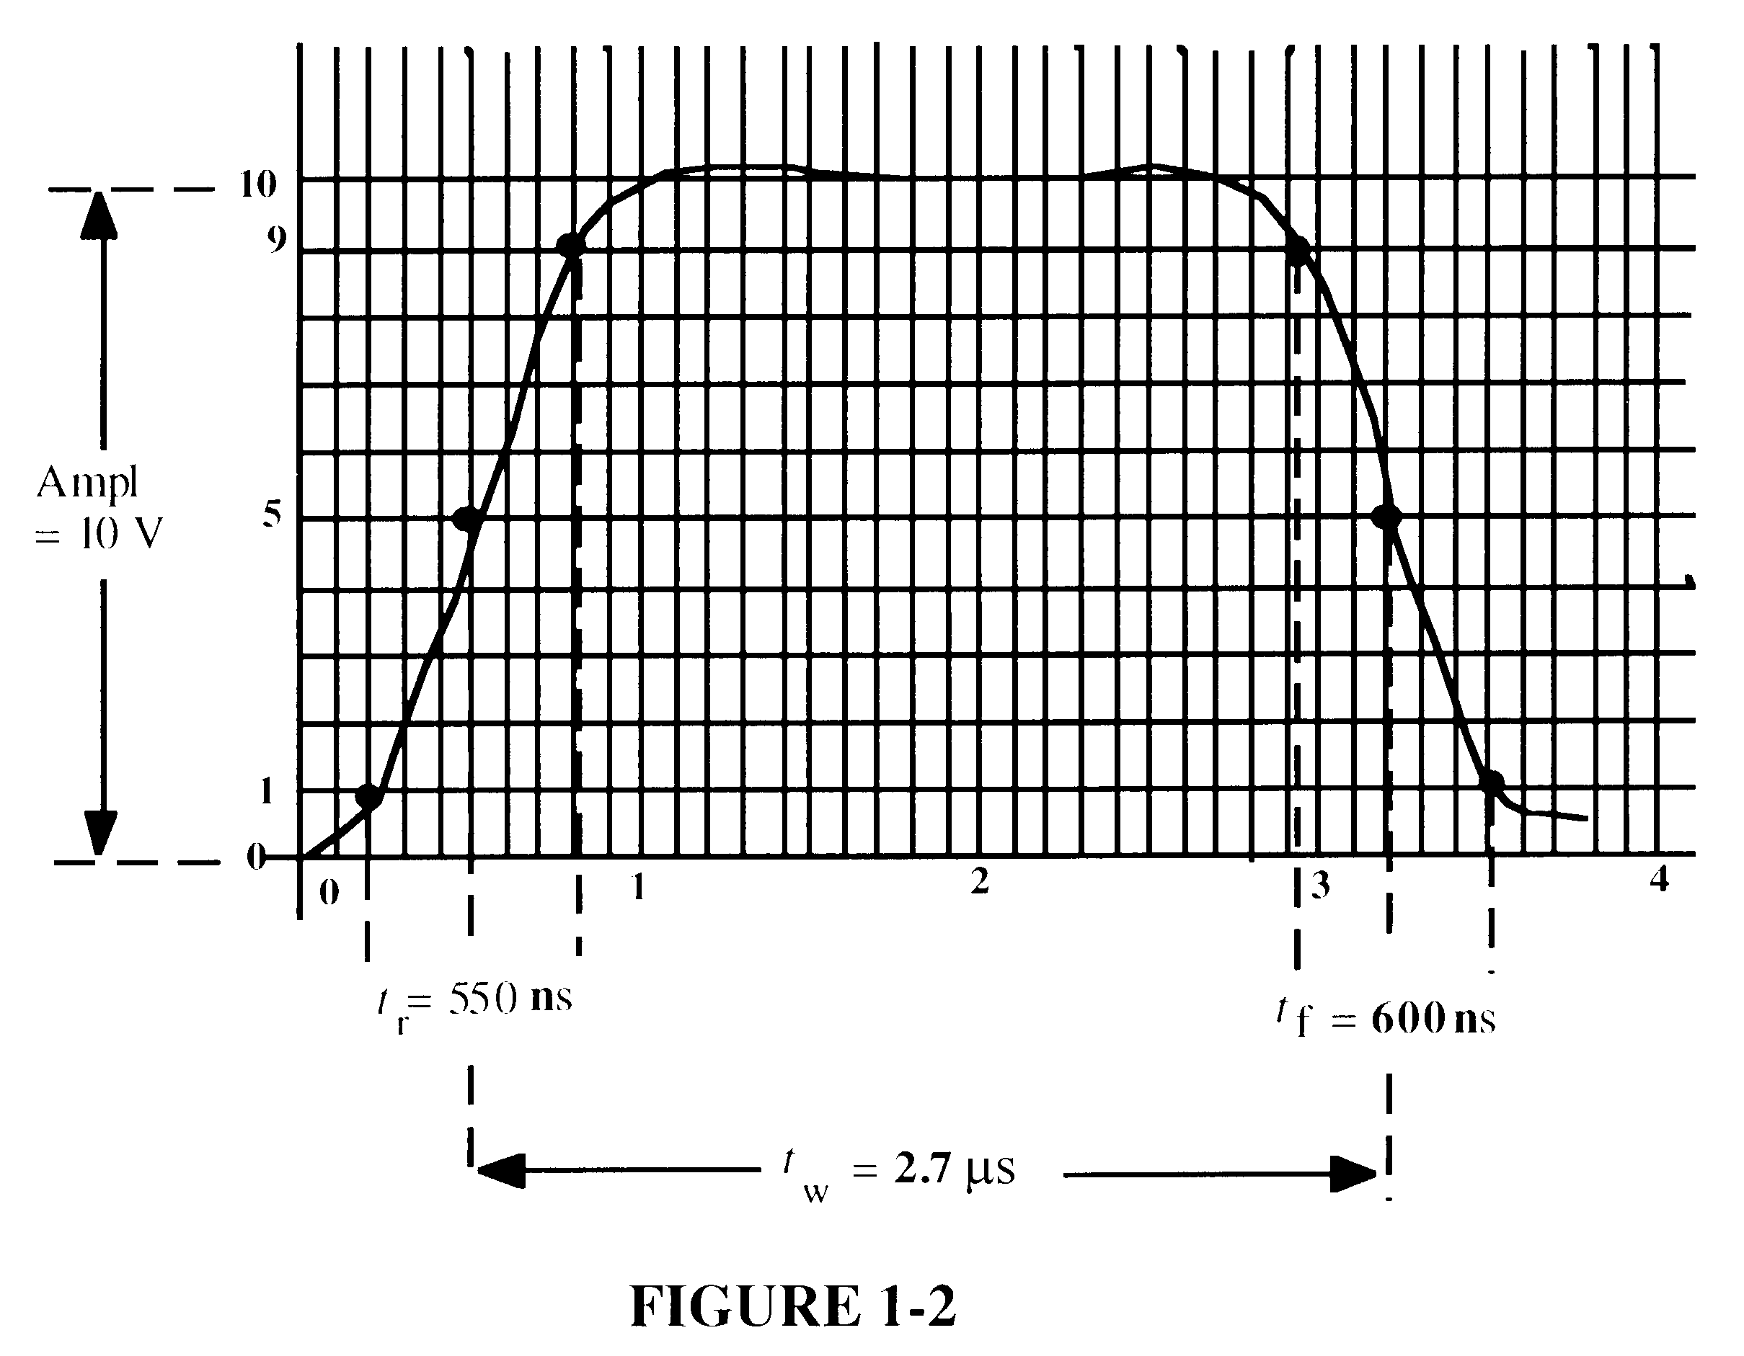
Ampl
= 10 V

8. Yes. Because given waveform is composed of a series of pulses.

9. f = $\frac{1}{T}=\frac{1}{\text{4 ms}}$ = 0.25 kHz = 250 Hz

10. The waveform in Figure 1-61 is periodic because it repeats at a fixed interval.

11. t_{W} = 2 ms; T = 4 ms
% duty cycle = $\left(\frac{t_{W}}{T}\right)\text{100}=\left(\frac{2\text{ ms}}{\text{4 ms}}\right)$100 = 50%

12. Each bit time = 2ms
Serial transfer time = (8 bits)(2ms/bit) = 16ms

13. Each bit time = 1 μs
Serial transfer time = (8 bits)(1 μs/bit) = 8 μs

Parallel transfer time = 1 bit time = 1 μs

14. T = 1/f = 1/(4KHz) = 0.25ms

Section 1-3 Basic Logic Functions

15. = SW1 + SW2 + SW1  SW2

16. NOT gate

17. OR gate

18. AND gate.

Section 1-4 Combinational and Sequential Logic Functions

19. (a) Subtractor
(b) Multiplier
(c) Multiplexer
(d) Comparator

20. T = 1/20kHz = 0.5μs
Pulse counted = 40ms/0.5μs = 8000

21. See Figure 1-7.
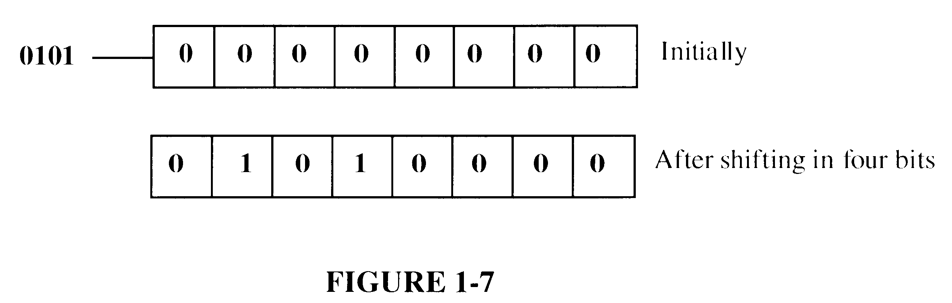

Section 1-5 Introduction to Programmable Logic

22. Synthesis: This refers to the translation of design into a netlist which has a standard form and is device independent
Implementation: This refers to the mapping of the logic structures described by the netlist, into the actual structure of the specific device being programmed
Compiler: A compiler is a program that controls the design flow process and translates the source code into object code in a format that can be logically tested or downloaded to a target device

23. (a) SPLD: Simple Programmable Logic Device
(b) CPLD: Complex Programmable Logic Device
(c) HDL: Hardware Description Language
(d) FPGA: Field-Programmable Gate Array
(e) GAL: Generic Array Logic

24. (a) Design entry: The step in a programmable logic design flow where a description of the circuit is entered in either schematic (graphic) form or in text form using an HDL.
(b) Simulation: The step in a design flow where the entered design is simulated based on defined input waveforms.
(c) Compilation: A program process that controls the design flow process and translates a design source code to object code for testing and downloading.
(d) Download: The process in which the design is transferred from software to hardware.

25. Place-and-route or fitting is the process where the logic structures described by the netlist are mapped into the actual structure of the specific target device. This results in an output called a bitstream.

Section 1-6 Fixed-Function Logic Devices

26. Based on the technique in which they are mounted on a printed circuit board, the Integrated circuit packages are classified as hole-mounted or surface-mounted packages.

27. Circuits with complexities of from 100 to 10,000 equivalent gates are classified as large scale integration (LSI).

28. See Figure 1-8.
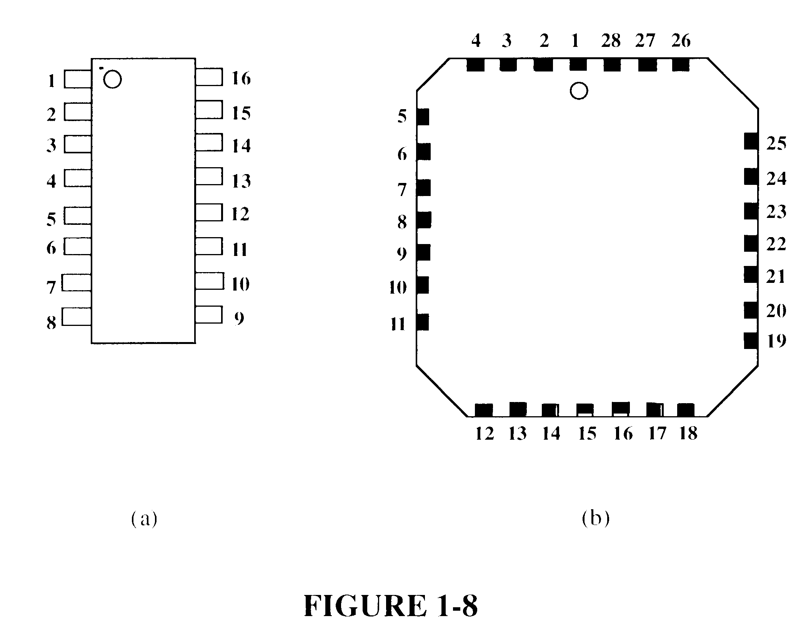

Section 1-7 Test and Measurement Instruments

29. 8V

30. 2V

31. T = (4 div)(2 ms/div) = 8 ms
f = = 125 Hz

32. Record length = (Acquisition time)(sample rate) = (2 ms) 12 Msamples/s = 24 ksamples

Section 1-8 Introduction to Trouble Shooting

33. Troubleshooting is the process of recognizing, isolating, and correcting a fault or failure in a system.

34. In the half-splitting method, a point half way between the input and output is checked for the presence or absence of a signal.

35. In the signal-tracing method, a signal is tracked as it progresses through a system until a point is found where the signal disappears or is incorrect.

36. In signal subsitution, a generated signal replaces the normal input signal of a system or portion of s system. In signal injection a generated signal is injected into the system at a point where the normal signal has been determined to be faulty or missing.

37. When a failure is reported, determine when and how it failed and what are the symptoms.

38. No output signal can be caused by no dc power, no input signal, or a short or open that prevents the signal from getting to the output.

39. An incorrect output can be caused by an incorrect dc supply voltage, improper ground, incorrect component value, or a faulty component.

40. Some types of obvious things that you look for when a system fails are visible faults such as shorted wires, solder splashes, wire clippings, bad or open connections, burned components, Also look for a signal that is incorrect in terms of amplitude shape, or frequency or the absence of a signal.

41. To isolate a fault in a system, apply half-splitting or signal tracing.

42. Two common troubleshooting instruments are the oscilloscope and the DMM.

43. When a fault has been isolated to a particular circuit board, the options are to repair the board or replace the board with a known good board.

