Biology: The Core (Simon)
Chapter 1 An Introduction to the Science of Life

Multiple-Choice Questions

1) How is life defined?
A) The only requirement for life is the ability to reproduce.
B) Life is defined through a set of shared characteristics that all living things display.
C) A living thing must be able to move.
D) Life is determined by neural activity.
Answer: B
Topic: 1.1
Skill: Knowledge/Comprehension
Learning Outcome: 1.1
Global Learning: G2

2) Fire can move, grow, reproduce, use energy, consume oxygen, and interact with its environment. Why is it not alive?
A) It does not have cells.
B) It does not consist of complex, well-ordered structures.
C) It does not pass on genes for traits to its offspring.
D) All of the above are correct.
Answer: D
Topic: 1.1
Skill: Application/Analysis
Learning Outcome: 1.1
Global Learning: G2

3) Is a virus alive?
A) Yes, it possesses all of the requirements for life.
B) Yes, it possesses enough of the requirements for life to be considered living.
C) No, it does not possess all of the requirements for life.
D) No, it does not possess any of the requirements for life.
Answer: C
Topic: 1.1
Skill: Application/Analysis
Learning Outcome: 1.1

4) Which property or properties of life does a virus possess?
A) Has order
B) Has cells
C) Can reproduce on its own
D) All of the above
Answer: A
Topic: 1.1
Skill: Application/Analysis
Learning Outcome: 1.1

5) Certain parasites, such as intestinal tapeworms, cannot survive outside of the host. Why are they still considered alive?
A) Survival outside of a host is not a requirement for life.
B) Parasites often have life stages that do not require a host.
C) They are still considered alive because they are studied by biologists, and biology is the study of life.
D) As long as they are made of cells, they are considered to be alive.
Answer: A
Topic: 1.1
Skill: Synthesis/Evaluation
Learning Outcome: 1.1
Global Learning: G2

6) A population consists of ________.
A) living and nonliving components
B) interacting populations
C) a group of interacting individuals of one species
D) None of the above
Answer: C
Topic: 1.2
Skill: Knowledge/Comprehension
Learning Outcome: 1.2

7) "There are 628 squirrels living on campus." I have just described the ________.
A) species
B) community
C) population
D) ecosystem
Answer: C
Topic: 1.2
Skill: Synthesis/Evaluation
Learning Outcome: 1.2

8) Which of the following would probably not be studied by an ecologist?
A) The effects of increasing CO2 on forests
B) Circulatory system of fish
C) Predator-prey relationships
D) Growth of a mosquito population
Answer: B
Topic: 1.2
Skill: Application/Analysis
Learning Outcome: 1.2
9) If you were to combine all of the ecosystems on the planet, including the planet itself, you would have the ________.
A) ionosphere
B) troposphere
C) biosphere
D) envirosphere
Answer: C
Topic: 1.2
Skill: Knowledge/Comprehension
Learning Outcome: 1.2

10) A college campus—including the students, birds, trees, sidewalks, and air—makes up one complete ________.
A) community
B) ecosystem
C) population
D) organism
Answer: B
Topic: 1.2
Skill: Application/Analysis
Learning Outcome: 1.2

11) Skin is sometimes referred to as the largest organ of the body. Why is skin considered to be an organ and not a tissue or some other structure?
A) Skin consists of multiple cell types functioning as a single integrated unit.
B) Skin consists of multiple tissue types that cooperate to perform a specific task.
C) Skin is a vital component of multiple organ systems.
D) Skin consists of a single cell type.
Answer: B
Topic: 1.2
Skill: Synthesis/Evaluation
Learning Outcome: 1.2
Global Learning: G2

12) The symbol for gold from the periodic table of the elements is Au. Pure gold consists entirely of this element. How long could you repeatedly cut a kilogram of pure gold in half until the portion remaining, if split, would then no longer display the chemical properties of gold?
A) You could do this until you had only a single atom of gold remaining.
B) You could do this until you had only a single molecule of gold remaining.
C) You could do this until you had only a single subatomic particle remaining.
D) You could do this until you had only a single gram of gold remaining.
Answer: A
Topic: 1.2
Skill: Synthesis/Evaluation
Learning Outcome: 1.2
13) Which of the following is the correct organizational hierarchy, from largest to smallest, in the hierarchical order of life? (Some levels have been omitted, so you are looking for the correct order.)
A) Community → Ecosystem → Population → Tissue → Organ → Cell → Organelle → Atom
B) Ecosystem → Community → Population → Organ → Tissue → Cell → Molecule → Atom
C) Biosphere → Community → Population → Tissue → Organ → Cell → Atom → Molecule
D) Ecosystem → Population → Community → Organ System → Organ → Cell → Molecule → Atom
Answer: B
Topic: 1.2
Skill: Application/Analysis
Learning Outcome: 1.2

14) Beginning with an atom and working up to the entire planet, biologists view life as arranged from ________.
A) small and simple to large and complex
B) small and complex to large and simple
C) large and complex to large and simple
D) large and complex to small and simple
Answer: A
Topic: 1.2
Skill: Knowledge/Comprehension
Learning Outcome: 1.2

15) What is typically the first step in the scientific method?
A) Experiment
B) Hypothesis
C) Prediction
D) Observation
Answer: D
Topic: 1.3
Skill: Knowledge/Comprehension
Learning Outcome: 1.3
Global Learning: G1

16) The scientific method ________.
A) is a rigid methodology that must be precisely followed to ensure validity
B) is a rough recipe for answering questions, but the steps need not be performed in the same order as outlined nor must every step be performed every time
C) is only undertaken by trained scientists in a controlled laboratory setting
D) is the means by which absolute truth can be uncovered
Answer: B
Topic: 1.3
Skill: Application/Analysis
Learning Outcome: 1.3
Global Learning: G1
17) A recent commercial advertised for a wristband that claimed to restore health and balance by taking advantage of natural frequencies of your biofield. It even showed several people struggling to balance first without the wristband and then balancing fine with the wristband. For only $20 plus shipping and handling this device can be yours. Why should you be skeptical of the claims made in this ad?
A) Health cannot be tested via the scientific method.
B) You cannot believe anything you see on television.
C) The study was too objective.
D) It was not a controlled experiment.
Answer: D
Topic: 1.3
Skill: Application/Analysis
Learning Outcome: 1.3
Global Learning: G1, G5, G6

A current trend among professional baseball players is wearing braided titanium necklaces. The titanium reportedly regulates the flow of energy through the body. The player wearing the necklace then improves strength, tires less, and recovers more quickly.

18) If you were to evaluate these claims using the scientific method, what would be the first step?
A) Conduct an experiment.
B) Gather testimonials.
C) Develop a hypothesis.
D) Evaluate the results.
Answer: C
Topic: 1.3
Skill: Application/Analysis
Learning Outcome: 1.3
Global Learning: G1, G2

19) Which of the following would be the strongest evidence for or against the necklace's effectiveness?
A) A pie chart comparing the percentage of players who do or do not wear the necklace
B) A scatter plot showing days on the disabled list and percentage of players who do or do not wear the necklace
C) A histogram illustrating the satisfaction levels of the players who wear the necklace
D) A bar graph comparing batting averages of the players who wear the official titanium necklace and those who were unknowingly wearing a fake titanium necklace
Answer: D
Topic: 1.3
Skill: Application/Analysis
Learning Outcome: 1.3
Global Learning: G1, G3
20) What should one do if the results of the experiment consistently do not support the original hypothesis?
A) Change the hypothesis to match the results.
B) Change the results to match the hypothesis.
C) Accept the original hypothesis.
D) Reject the original hypothesis and formulate a new hypothesis.
Answer: D
Topic: 1.3
Skill: Application/Analysis
Learning Outcome: 1.3
Global Learning: G1

21) Gathering information just to add to the knowledge base, such as measuring the beak length of various bird species, is known as ________.
A) discovery science
B) applied science
C) hypothesis-driven science
D) investigative science
Answer: A
Topic: 1.3
Skill: Application/Analysis
Learning Outcome: 1.3
Global Learning: G1

22) What does the term "theory" mean to a scientist?
A) A collection of accepted hypotheses that explain a wide range of natural phenomena
B) A guess
C) A proposed explanation for an observed phenomenon
D) A hypothesis that has been supported by the evidence of an experiment
Answer: A
Topic: 1.3
Skill: Knowledge/Comprehension
Learning Outcome: 1.3
Global Learning: G1

23) Which of the following statements about the scientific method is false?
A) The scientific method can be used by anyone at any time.
B) The scientific method proves things false.
C) The scientific method proves things true.
D) The scientific method is a way of asking questions and getting evidence-driven answers.
Answer: C
Topic: 1.3
Skill: Application/Analysis
Learning Outcome: 1.3
Global Learning: G1
24) In a controlled experiment, the researcher typically manipulates one variable, called the independent variable, to determine how this variable affects the final outcome, called the dependent variable. In the following hypothetical example, a researcher applies varying amounts of fertilizer (0, 2, 4, 8, 10 units) to potted tomato plants. All other variables that may affect the outcome (watering, temperature, sunlight, plant size, etc.) are kept the same from pot to pot. At the end of the growing season, the tomatoes grown on each plant are weighed to determine which fertilizer level produces the largest tomato yield. Which variable was the independent variable and which was the dependent variable?
A) Independent = Fertilizer amount, Dependent = Temperature
B) Independent = Temperature, Dependent = Yield
C) Independent = Fertilizer amount, Dependent = Yield
D) Independent = Yield, Dependent = Fertilizer amount
Answer: C
Topic: 1.3
Skill: Synthesis/Evaluation
Learning Outcome: 1.3
Global Learning: G1

25) Intense UV light from the sun is lethal to living things. Currently, some 99% of all incoming UV is blocked by the ozone layer which didn't develop until well after the first life-forms. How might the very earliest organisms have avoided the intense UV rays?
A) Stayed below ground
B) Had scales
C) Stayed underwater
D) Only came out at night
Answer: C
Topic: 1.4
Skill: Synthesis/Evaluation
Learning Outcome: 1.5
Global Learning: G7

26) Is this an illustration of a plant cell, an animal cell, a fungal cell, or a bacteria cell?

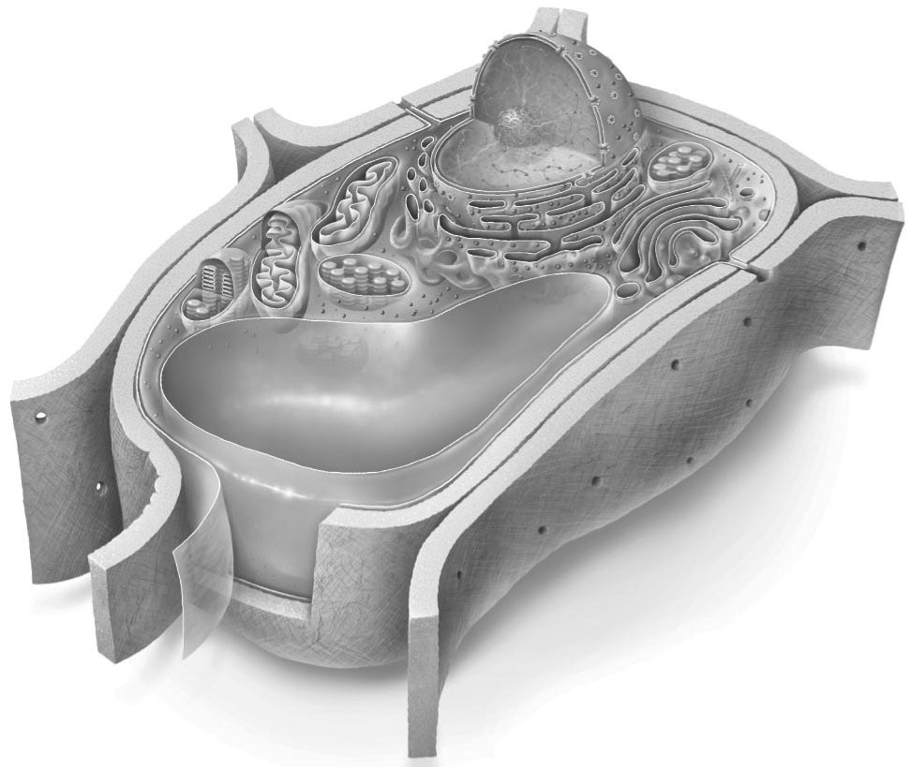
A) Plant
B) Fungus
C) Animal
D) Bacteria
Answer: A
Topic: 1.4
Skill: Knowledge/Comprehension
Learning Outcome: 1.2
27) Which of the following statements is true?
A) Prokaryotic cells are typically 10 to 100 times larger than eukaryotic cells.
B) All prokaryotes are unicellular but eukaryotes could be either unicellular or multicellular.
C) The degree of structural complexity is not a key characteristic of prokaryotic and eukaryotic cells.
D) Only eukaryotic cells have DNA.
Answer: B
Topic: 1.4
Skill: Knowledge/Comprehension
Learning Outcome: 1.2

28) Archaea are a distinct group of organisms that are about the size and shape of bacteria. Although they lack a nucleus or any other organelle, they produce enzymes similar to those produced by animal cells. Which cell type are they?
A) Eukaryotes
B) Prokaryotes
C) Neither of these
D) Both of these
Answer: B
Topic: 1.4
Skill: Application/Analysis
Learning Outcome: 1.2

29) What were the first organisms that appeared on the planet?
A) Prokaryotes
B) Eukaryotes
C) Algae
D) Fungus
Answer: A
Topic: 1.4
Skill: Application/Analysis
Learning Outcome: 1.2

30) Photosynthesis is the primary chemical reaction that creates the oxygen found on the earth. Some prokaryotic organisms and some eukaryotic organisms can produce oxygen through photosynthesis. While all eukaryotic cells and many prokaryotic cells also require oxygen, there are many prokaryotic cells that do not. What then created the oxygen in the earth's atmosphere that allowed the earliest eukaryotic organisms to evolve?
A) Volcanoes
B) Photosynthetic plants
C) Photosynthetic algae
D) Photosynthetic bacteria
Answer: D
Topic: 1.4
Skill: Synthesis/Evaluation
Learning Outcome: 1.5
31) What are the "letters" that make up the chemical language of DNA?
A) D, N, A
B) C, T, G, A
C) A,T, P
D) C, H, O, N
Answer: B
Topic: 1.4
Skill: Knowledge/Comprehension
Learning Outcome: 1.1

32) Why can the gene that produces insulin in a human be inserted into bacteria and produce the same human insulin?
A) Because humans evolved from bacteria, the gene for insulin is already present in bacteria.
B) The insulin gene originated in bacteria and was transferred to humans through an infection.
C) Humans and bacteria have the same proteins.
D) Bacterial DNA is made up of the same chemical building blocks as human DNA.
Answer: D
Topic: 1.4
Skill: Synthesis/Evaluation
Learning Outcome: 1.1

33) Energy flows through an ecosystem. What is typically the originating source of energy in an ecosystem?
A) Plants
B) Water
C) Wind
D) Sun
Answer: D
Topic: 1.5
Skill: Knowledge/Comprehension
Learning Outcome: 1.5

34) Which part of the ecosystem is called a producer?
A) Nutrient recycler
B) Photosynthetic organisms
C) Animals that eat other organisms
D) Animals that eat plants
Answer: B
Topic: 1.5
Skill: Knowledge/Comprehension
Learning Outcome: 1.5

35) Which type of ecologist would be most concerned with nutrient cycles?
A) Species ecologist
B) Organism ecologist
C) Population ecologist
D) Community ecologist
E) Ecosystem ecologist
Answer: D
Topic: 1.5
Skill: Application/Analysis
Learning Outcome: 1.5
36) Which organism in this picture is the consumer?

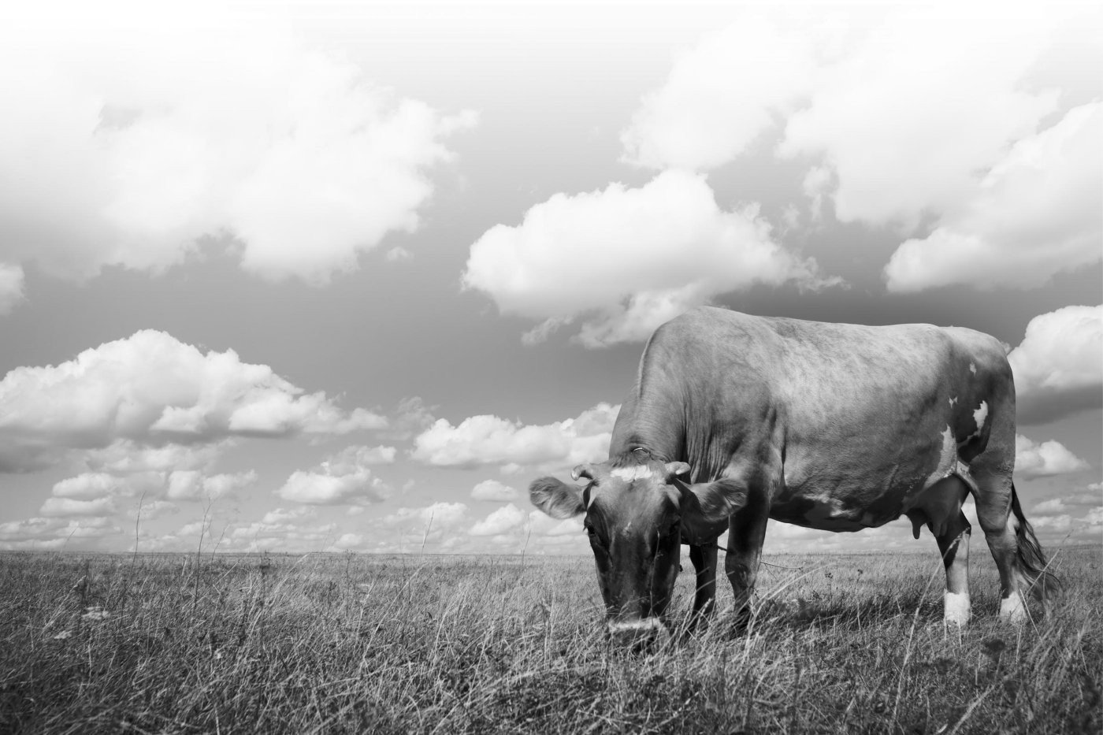
A) The grass
B) The cow
C) The clouds
D) The sky
Answer: B
Topic: 1.5
Skill: Knowledge/Comprehension
Learning Outcome: 1.5

37) Every conversion of energy involves the loss of some of that energy. How is the majority of energy typically lost from an ecosystem?
A) Upon the death of an organism
B) Through the decomposition of organic matter
C) In the form of heat
D) From the migration of organisms out of the ecosystem into another
Answer: C
Topic: 1.5
Skill: Knowledge/Comprehension
Learning Outcome: 1.5

38) All living things require substantial quantities of carbon. Where do plants get the carbon they need to survive?
A) From decaying organic matter
B) From the air
C) From the soil (but not water)
D) From the water in the soil
Answer: B
Topic: 1.5
Skill: Application/Analysis
Learning Outcome: 1.5
39) All living things require substantial amounts of carbon. Where do animals get the carbon they need to survive?
A) From the water they drink
B) From the air they breathe
C) From the sun that warms them
D) From the food they eat
Answer: D
Topic: 1.5
Skill: Application/Analysis
Learning Outcome: 1.5

40) The gasoline that fuels a car has a substantial amount of energy inside of it. What was the original source of that energy?
A) Oil
B) Decaying plants and animals
C) Living plants and animals
D) The sun
Answer: D
Topic: 1.5
Skill: Synthesis/Evaluation
Learning Outcome: 1.5
Global Learning: G2

41) Which domain includes the "extremophiles," organisms often found living in extreme conditions?
A) Archaea
B) Prokarya
C) Eukarya
D) Bacteria
Answer: A
Topic: 1.6
Skill: Knowledge/Comprehension
Learning Outcome: 1.2

42) Which grouping contains the largest number of individual organisms?
A) Kingdom
B) Population
C) Domain
D) Species
Answer: C
Topic: 1.6
Skill: Application/Analysis
Learning Outcome: 1.2
43) You discover a nucleated, unicellular organism that is photosynthetic but can also eat other organisms. Under which grouping should this organism be included?
A) Kingdom Plantae
B) Kingdom Animalia
C) The Protists
D) The Archaea
Answer: C
Topic: 1.6
Skill: Synthesis/Evaluation
Learning Outcome: 1.2
Global Learning: G2

44) Which level of diversity refers to the variety of characteristics within a species?
A) Genetic diversity
B) Species diversity
C) Population diversity
D) Ecosystem diversity
Answer: A
Topic: 1.6
Skill: Application/Analysis
Learning Outcome: 1.2

45) How many species have been identified and named?
A) 1 million
B) 2 million
C) 5 million
D) 25 million
Answer: B
Topic: 1.6
Skill: Knowledge/Comprehension
Learning Outcome: 1.2

46) What does "Descent with Modification" mean?
A) Survival of the fittest
B) Natural selection
C) Modern species replacing primitive species
D) New forms descending from earlier ones but with some changes
Answer: D
Topic: 1.7
Skill: Knowledge/Comprehension
Learning Outcome: 1.4

47) Natural selection ________.
A) prepares organisms for future changes in the environment
B) is a rare phenomenon
C) is the result of sampling error
D) results in evolutionary adaptation
Answer: D
Topic: 1.7
Skill: Application/Analysis
Learning Outcome: 1.4
48) What is the unifying or "core" theme of biology?
A) Evolution
B) Energy transfer
C) Nutrient recycling
D) Hierarchical organization
Answer: A
Topic: 1.7
Skill: Knowledge/Comprehension
Learning Outcome: 1.4

49) Which is not a requirement for natural selection to occur?
A) Unequal reproductive success
B) Competition for limited resources
C) Variation in the offspring
D) Random mating
Answer: D
Topic: 1.7
Skill: Application/Analysis
Learning Outcome: 1.4

50) Individuals with traits that make them more successful in their environment will, on average, produce more offspring. This "fitting" of a population to their environment is called ________.
A) variation
B) survival
C) competition
D) adaptation
Answer: D
Topic: 1.7
Skill: Application/Analysis
Learning Outcome: 1.4

51) Darwin was not the first to propose that organisms evolve. Rather, he proposed a novel idea of what mechanism caused organisms to change over time. By what means did he propose that organisms evolve?
A) Acquired traits
B) Use and disuse
C) Common descent
D) Natural selection
Answer: D
Topic: 1.7
Skill: Application/Analysis
Learning Outcome: 1.4

52) What evolves?
A) The individual
B) The population
C) Both of these
D) Evolution occurs at a level beyond the individual or the population.
Answer: B
Topic: 1.7
Skill: Application/Analysis
Learning Outcome: 1.4
53) Every year new varieties of fruits and vegetables appear on the store shelves. Some are the result of cross breeding existing varieties, and others are from finding and propagating random mutations. Still other varieties come from inserting genes directly from one organism into another. What makes these genetically modified varieties possible?
A) All organisms share the same genes.
B) All organisms share the same proteins.
C) The DNA of all organisms is made of the same building blocks.
D) The DNA of all organisms contains the same sequences.
Answer: C
Topic: 1.7
Skill: Application/Analysis
Learning Outcome: 1.1
Global Learning: G5

54) Select the most accurate statement.
A) Eukaryotes cannot live without prokaryotes.
B) Prokaryotes cannot live without eukaryotes.
C) Neither is dependent upon the other.
D) None of these answers is correct.
Answer: A
Topic: 1.8
Skill: Application/Analysis
Learning Outcome: 1.4

55) What happens to populations that are unable to adapt to changing environmental conditions?
A) They go extinct.
B) They get smaller.
C) They get larger.
D) Their birth rate increases.
Answer: A
Topic: 1.8
Skill: Synthesis/Evaluation
Learning Outcome: 1.5

56) When a horse breeder chooses to breed only the fastest horses in an effort to select for speed, this is an example of which of the following?
A) Artificial selection
B) Natural selection
C) Hybridization
D) Domestication
Answer: A
Topic: 1.8
Skill: Knowledge/Comprehension
Learning Outcome: 1.4
57) Which of the following organisms arose through artificial selection?
A) Polar bears
B) Dandelions
C) Sea bass
D) Dalmatians
Answer: D
Topic: 1.8
Skill: Application/Analysis
Learning Outcome: 1.4

58) What is an antibiotic?
A) A drug that provides resistance to viruses
B) A drug that kills bacteria
C) A drug that prevents free radical damage
D) A drug that fights cancer
Answer: B
Topic: 1.8
Skill: Knowledge/Comprehension
Learning Outcome: 1.5

Short-Answer Questions

59) Name at least three organs that are part of your digestive system. Explain why the organs you chose are in fact organs and not something else. Describe their role in the digestive system.
Answer: Possible Answers: Stomach (chemical digestion), Small intestine (nutrient absorption), Large intestine (water reabsorption), Liver (bile production), Gallbladder (bile storage), Pancreas (digestive enzyme production). These all consist of multiple tissue types that cooperate to perform a specific task.
Topic: 1.2
Skill: Synthesis/Evaluation
Learning Outcome: 1.1
Global Learning: G7

60) The scientific method has limitations. It can only answer objective questions based on quantitative facts from observable, measurable, and repeatable experiments. It cannot answer subjective questions based on qualitative beliefs or opinions such as the presence of deities, ghosts, or who makes the best doughnut. Could the scientific method theoretically be used to answer the question, Does throwing a virgin into a volcano prevent it from erupting? Support your answer.
Answer: Possible Answer: While unethical, after defining a few terms a controlled experiment could be designed to test this hypothesis. It may require multiple virgins and/or multiple volcanoes but it would be possible to discover if a correlation exists.
Topic: 1.3
Skill: Synthesis/Evaluation
Learning Outcome: 1.3
Global Learning: G1, G2

61) How might washing your hands with an antibacterial soap increase your chance of getting a life-threatening bacterial infection?
Answer: Possible Answer: The antibiotic in the soap selectively kills only the weakest strains of bacteria, leaving behind the strains that have a natural resistance to the drug.
Topic: 1.8
Skill: Synthesis/Evaluation
Learning Outcome: 1.4, 1.5
Global Learning: G2, G5

