Exercise 1 The Earth System and Sustainability

James S. Reichard
Georgia Southern University

Student Name

Section

In this lab you will:

1) Explore the way human population grows exponentially.

2) Examine how population growth is related to resource depletion.

3) Calculate your personal ecological footprint on planet Earth. From this you can see why our present consumption patterns and population growth are not sustainable in terms of the human impact on the biosphere.

Background Reading and Needed Supplies

Prior to doing this exercise you should read Chapter 1, Humans and the Geologic Environment, in the textbook. With respect to supplies, the only thing you will need is a calculator.

Part I – Exponential Growth
In this section you will use hand calculations to examine how living organisms undergo exponential population growth. We will use a hypothetical example where you are given 2 rabbits which you are to breed. You place them in a large fenced-in area and give them an unlimited supply of food and water. During your breeding project the rabbits multiple at a net rate of 50% per year (75% reproduction rate minus 25% mortality). This scenario and these rates are not realistic, but then neither is you breeding rabbits!

Exponential growth can easily be calculated by use the following relationship:

new total = old total + (old total x growth rate)

(or)

new total = old total x (1.0 + growth rate)

1) Use the above relationship to calculate the rabbit population and yearly increase for each time interval in Table 1.1. For example, to find the number of rabbits at the end of the first year, simply take the number of rabbits we started with (2), and multiple by 1.50 (i.e., 1.0 + 0.50 growth rate). The entry for year-1 would be as follows:

2 rabbits x 1.50 = 3 rabbits; an increase of 1 rabbit.

When completing the table, be sure to round all your answers to the 2nd decimal place – just follow the examples in the first three rows of the table. Note that you will use the rounded population value at the end of a given year as the beginning population for the next year.

Time (Year) | Beginning Population | Ending Population | Yearly Increase
1 | 2.00 | 3.00 | 1.00
2 | 3.00 | 4.50 | 1.50
3 | 4.50 | 6.75 | 2.25
4 | 6.75 | 10.13 | 3.38
5 | 10.13 | 15.20 | 5.07
6 | 15.20 | 22.80 | 7.60
7 | 22.80 | 34.20 | 11.40
8 | 34.20 | 51.30 | 17.10
9 | 51.30 | 76.95 | 26.65
10 | 76.95 | 115.43 | 38.48
11 | 115.43 | 173.15 | 57.72
12 | 173.15 | 259.73 | 86.56
13 | 259.73 | 389.60 | 129.87
14 | 389.60 | 584.40 | 194.80
15 | 584.40 | 876.60 | 292.20
16 | 876.60 | 1314.90 | 438.30
17 | 1314.90 | 1972.35 | 657.45
18 | 1972.35 | 2958.53 | 986.18
19 | 2958.53 | 4437.80 | 1479.27
20 | 4437.80 | 6656.70 | 2218.90
Table 1.1

2) Using the provided graph paper, accurately plot the number of rabbits at the end of each year from Table 1.1 versus time. Then, draw a smooth curve through the points.

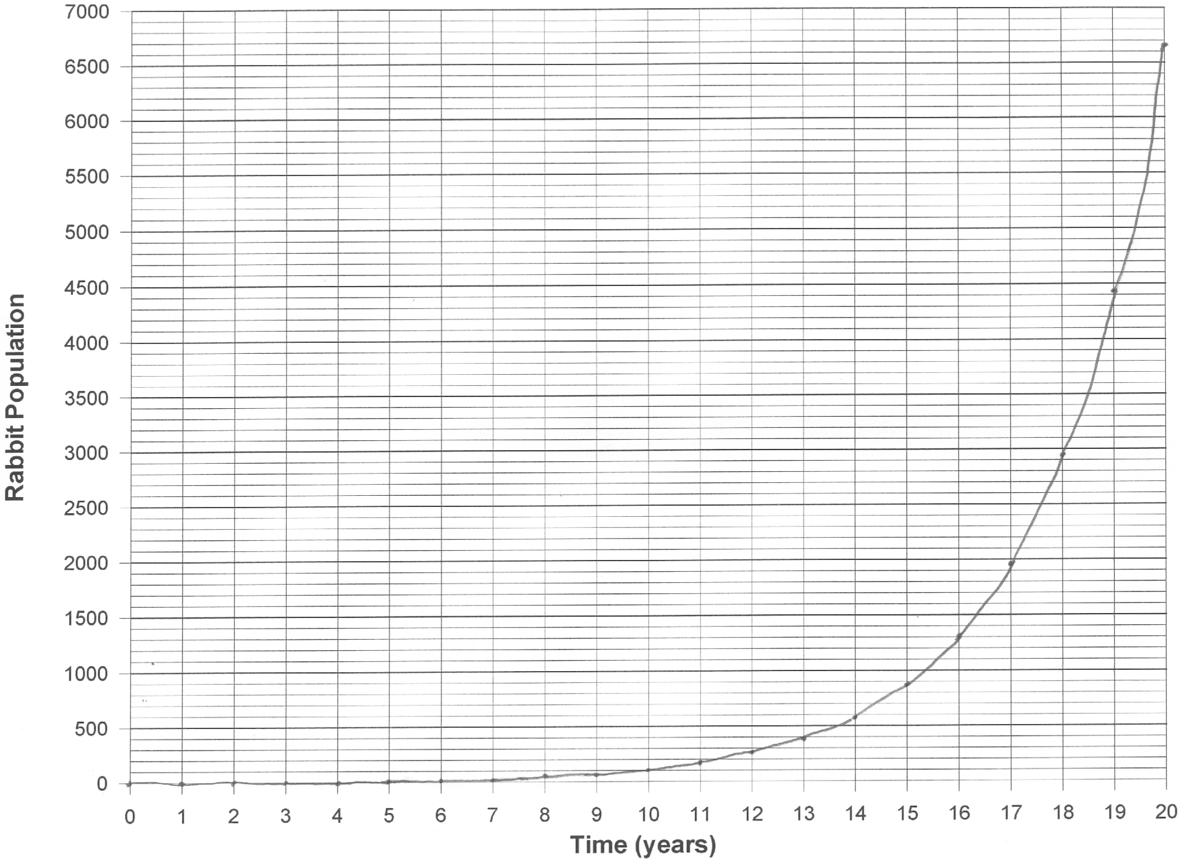
3) Based on the shape of your graph, it should be clear that the rabbit population grows in a non-linear (exponential) manner.

a) Describe the trend you see in the yearly increase column of Table 1.1 that proves the rabbit population grew exponentially.

The yearly increase keeps getting larger for each time step (i.e., one year), which means the slope is constantly increasing with time.

b) In simple terms, explain why exponential growth occurs in natural organisms.

The organism reproduce at a faster rate than they die, hence the growth rate is positive. Because the population is growing, when one takes a percentage of a growing total, the amount added each year keeps getting larger.

4) The graph of human population in Figure 1.1 shows the population growth on planet Earth over the past 8,000 years. Up until the 1700s, growth rate had been fairly slow, but afterwards, the rate greatly accelerated. Describe the change in society that occurred around this time that can account for more rapid population growth.

Around the 1700s the industrial revolution brought about increased rates of food production, and at the same time, significant advances in medicine were taking place. These improvements decreased the death rate while the birth rate remained steady, thereby increasing in the growth rate.

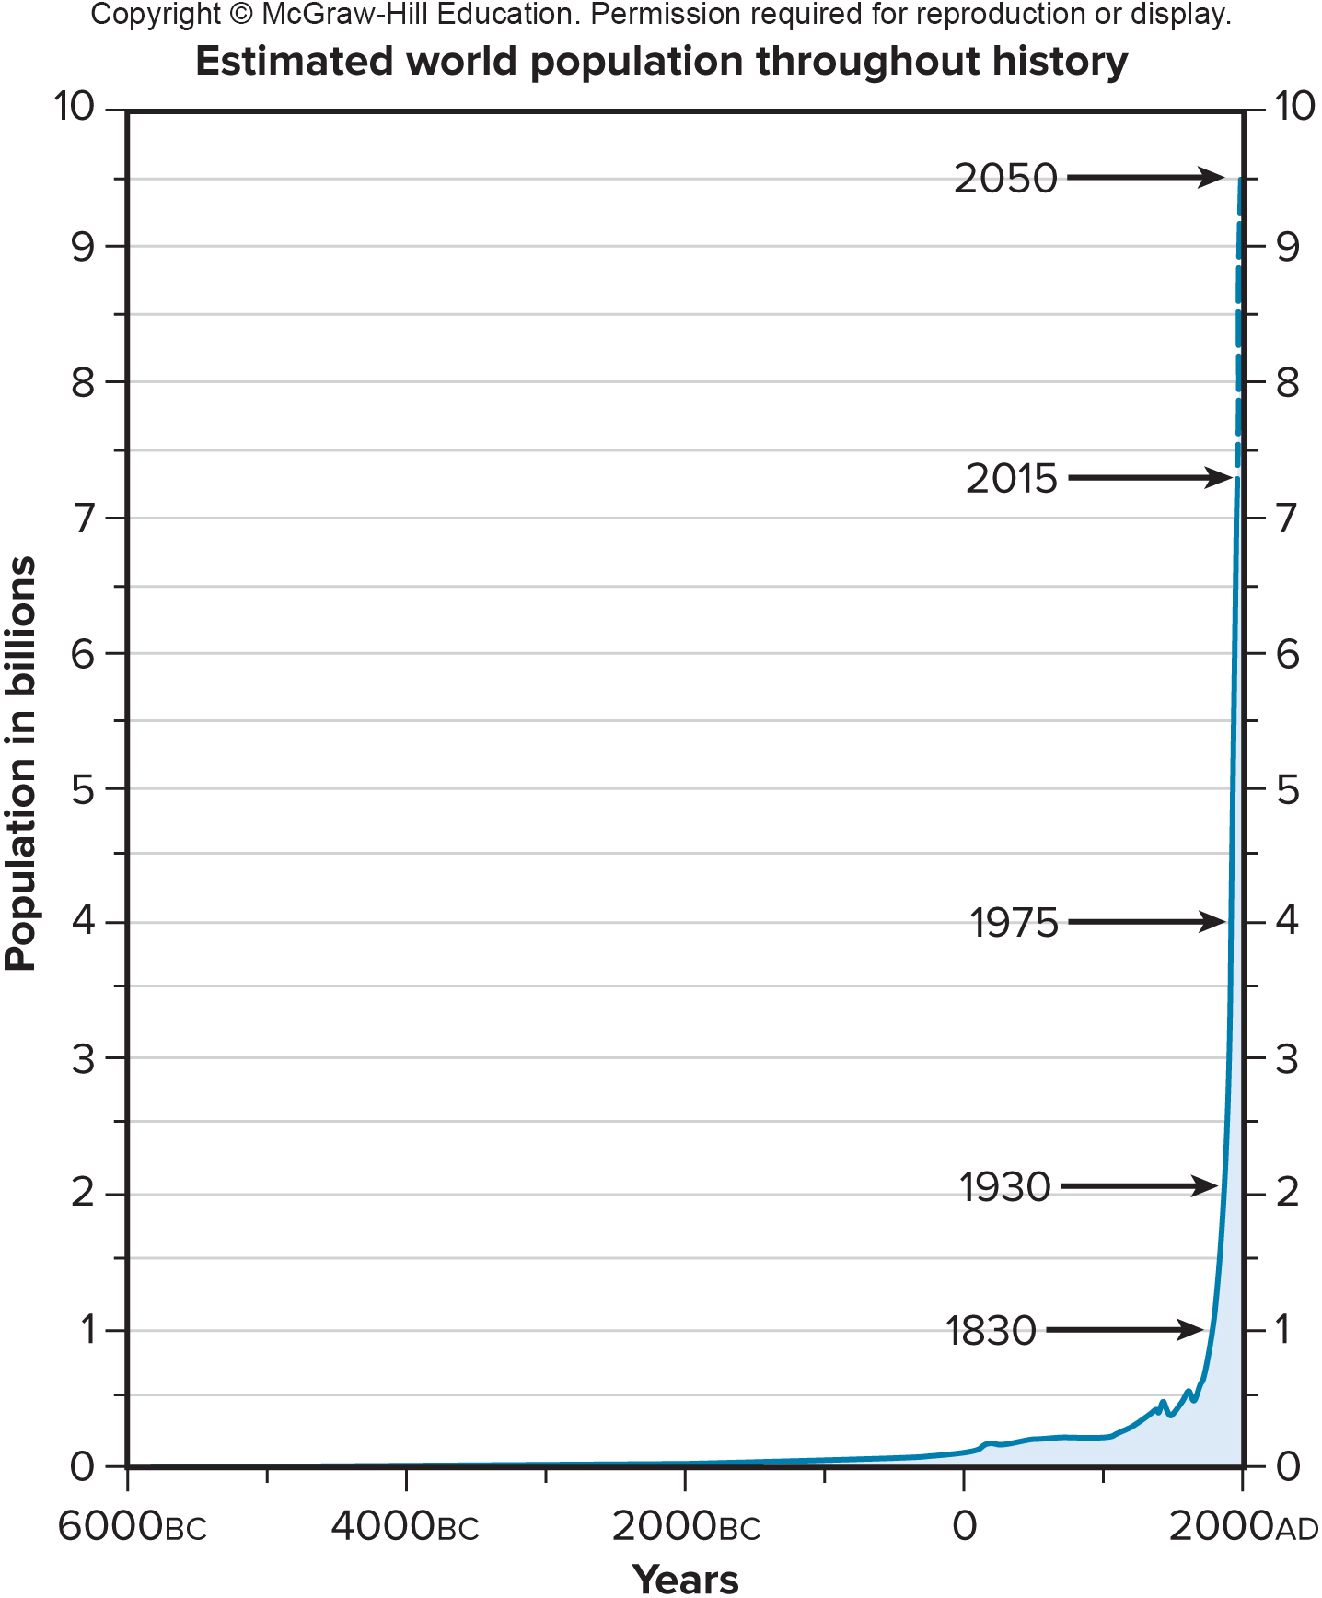
Figure 1.1. Graph showing world population growth over the past 8,000 years. (rei22967_01_20)
5) Ever since the industrial revolution began, some people have been predicting that Earth's human population can continue to expand exponentially. Describe the major factor that environmentalists believe will ultimately limit population growth.

Because Earth's natural resources (soil, water, petroleum, etc.) are limited, food production can not increase indefinitely. Population naturally can not expand beyond its resource base.

6) As shown in Figure 1.2., because human population continues to expand, Earth's finite resources are naturally being depleted at an exponential rate. One reason for the exponential depletion rate is that population is increasing exponentially. Describe another factor (related to industrialization) that is causing resources to become depleted exponentially.

As nations undergo industrialization, their per-capita consumption rates increase, which of course only accelerates resource depletion.

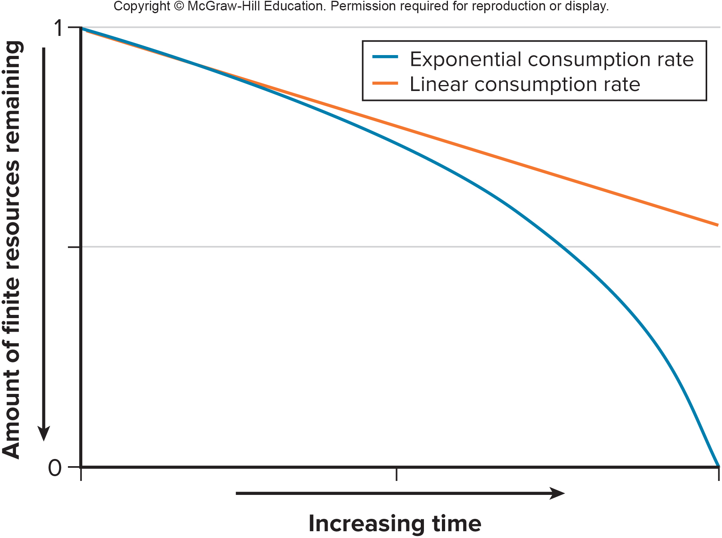
Figure 1.2. Graph comparing linear versus exponential consumption rates. (rei22967_01_27)

7) Because of resource depletion, continued population growth and industrialization will make it difficult for developed nations to maintain the current state of their economies. What is the solution to this problem as described by environmentalists?

Human population must reach a limit and consume resources in such a manner that society is sustainable. Here society would live within the Earth system's ability to provide natural resources so that the resources remain available for future generations.
Part II – Ecological Footprint

The ecological footprint calculator used in this section is modified from that prepared by Lamont C. Hempel and Jason Venetoulis (1999).

In the previous section we explored how population growth is a function of Earth's ability to provide natural resources. The term sustainable society is commonly used to refer to the ideal situation where humans live within Earth’s capacity to provide resources, such that the resources remain available for future generations. In order for society to become sustainable, human population will need to level out, and our per capita consumption of resources will need to be reduced. One way we can gauge our level of sustainability is through the concept of an ecological footprint, which is simply the amount of biologically productive land/sea area needed to support the lifestyle of humans. The idea behind an ecological footprint is that every human requires a certain portion of the biosphere for extracting the resources they use and for absorbing the waste they generate.

In this exercise you will calculate you own personal ecological footprint. We will compare your footprint to what is called the Fair Earthshare, or FES, which is calculated by dividing Earth's ecologically productive land area by total human population. Since the land is divided equally, the FES represents how much of the planets productive land area is available to support each and every person. The FES is about 5.5 acres per person, whereas the ecological footprint of the average American is about 24 acres per person. Clearly, people in developed countries are using a disproportionally large amount of productive land compared to those living in less developed nations. In other words, many of us are using more than our fair share.

8) Use the ecological calculator below to determine your own ecological footprint. Begin by estimating your consumption rates for each category, then multiple your answer by the given multiplication factor. (Note that the "unitless" numbers below represent different weighting factors that ultimately convert each commodity/activity into ecologically productive acres of land area per person.)

Vegetables: US average is 5 pounds per week; a typical serving is about 4 ounces (USDA).
(example: 3 servings/day x 4 oz/serving x 0.063 lb/oz x 7 days/week = 5.3 lbs/week)
Enter amount_____ lbs. x 23 = _____

Fruits: US average is 2.5 pounds per week; a typical serving is about 3 ounces (USDA).
(example: 2 servings/day x 3 oz/serving x 0.063 lb/oz x 7 days/week = 2.6 lbs/week)
Enter amount_____ lbs. x 23 = _____

Pasta: a typical serving is about 4 ounces
(example: 2 servings/week x 4 oz/serving x 1lb/16 oz = 0.5 lbs/week)
Enter amount_____ lbs. x 70= _____

Chicken: US average is about 1.25pounds per person per week (USDA)
Enter amount_____ lbs. x 500= _____

Pork: US average is about 1 pound per person per week (USDA)
Enter amount_____ lbs. x 700= _____

Fish: US average is about 1/3 (.33) pounds per person per week (USDA)
Enter amount_____ lbs. x 3200= _____
Beef: US average is about 1.5 pounds per person per week (USDA)
Enter amount_____ lbs. x 6000= _____

Cheese and Butter: Estimated average of 1/2 pound per person per week
Enter amount_____ lbs. x 250= _____

Eggs: Estimated average is 5 per person per week
Enter amount_____ lbs. x 28= _____

Beverages and Dining:
How many glasses of the following beverages do you drink per week: Average glass=8 oz.
Juice _____ x 11= _____
Wine _____ x 12= _____
Soda _____ x 14= _____
Milk _____ x 15= _____
Coffee_____ x 25= _____

How many times in the average week do you eat breakfast, lunch or dinner at a restaurant?
Enter amount_____ x 2000= _____

Housing
Assuming you have one house or apartment, add 1 for each bedroom you use. Then add 1 for each empty bedroom, study or entertainment room.
Enter amount_____ x 2700= _____

Transportation
Enter the number of miles traveled during an average week, including weekends.
solo in personal car _____ x 52= _____
bus/train/carpool_____ x 0.33 x 52=_____

Airline: Did you fly anywhere in the last year? If so, how far was your trip both ways?
Enter amount_____ x 2= _____

Energy
Do you conserve energy at home and work?
No- add 1000, sometimes - 850, usually- 700, always - 500
Enter amount_________
Note: Subtract the percentage of primary lighting or water heating that is solar or wind power.

Water
Do you conserve water at home and work?
No – then enter 1000, sometimes - 850, usually - 700, always - 500
Enter amount_________
Note: This conservative estimate could be multiplied by 6 to capture the amount of water used per capita in the US for commercial and industrial purposes.

Waste
Do you recycle?
No – then enter 1000, sometimes - 800, consistently - 500
Enter amount_________

Calculate Your Footprint:
Total the results from above: _________
Divide that number by 10,000: _________
Multiply by 2.47:_________

9) Compare your ecological footprint to the 5.5 acre Fair EarthShare (FES) amount described above. Explain why your footprint is higher than the FES.

The footprint of those of us living in developed countries is higher than the FES because we consume a disproportionately large share of Earth's natural resources.

10) List the categories from the calculator that made the largest contribution to your ecological footprint.

For most of us, the largest contributions will be from our food and energy (housing and transportation) needs.

11) Explain the ways in which you personally could reduce your footprint.

Answers here should focus on the personal consumption categories that make the largest contribution to one's own footprint. For example, eating meat requires a great deal of productive land, so switching to a diet with more vegetables and fruits would significantly reduce one's footprint. Likewise, transportation (energy) has a large footprint, so reducing one's energy consumption can be highly significant.

12) If the 5.5 acre FES is what planet Earth can support in a sustainable manner, determine how many planets we would need if all of the world's population were to have a footprint the size of yours.

Here the students need to take their footprint and divide it by the FES. For example: the 24 acre US average is 4.4 times greater than the 5.5 acre FES (24 divided by 5.5 = 4.4x). This means that if everyone on Earth consumed like the average American, then we would need 4.4 Earths.

