Chapter 1

Economics: Foundations
and Models

Brief Chapter Summary

1.1 Three Key Economic Ideas (pages 4–7)

Learning Objective 1.1 Explain these three key economic ideas: People are rational. People respond to incentives. Optimal decisions are made at the margin.

- All of the questions raised in this book reflect the fact that people must make choices as they try to attain their goals. People make choices because resources are scarce. Most of economics analyzes what happens in markets.

1.2 The Economic Problem That Every Society Must Solve
(pages 8–11)

Learning Objective 1.2 Discuss how an economy answers these questions: What goods and services will be produced? How will the goods and services be produced? Who will receive the goods and services?

- Any society has only a limited amount of resources that can produce a limited amount of goods and services.
- The cost of producing more of one good is the value of what must be given up to produce it.

1.3 Economic Models (pages 11–14)

Learning Objective 1.3 Understand the role of models in economic analysis.

- Economists use models—simplified versions of reality—to analyze real-world issues.
- Models must be simple to be useful.
- Economists accept a model if it leads to hypotheses that are confirmed by statistical analysis.

1.4 Microeconomics and Macroeconomics (page 14-15)

Learning Objective 1.4 Distinguish between microeconomics and macroeconomics.

1.5 A Preview of Important Economic Terms (pages 15–16)

Learning Objective 1.5 Become familiar with important economic terms.

Chapter Outline

The Rising Economic Powers in the East: The Arab World and the Global Economy

The rise of China and other economies, such as India, in the past few years, coupled with significant signs of weakened US and European economies, has created an increasing perception that the economic power is shifting eastward. The geographical location of the Arab nations, as the passage between the East and the West, gives the region a great advantage and raises its potential to benefit from the expected future growth in the developing world in the East. The feature “Economics in Your Life” asks students to consider whether they expect to find future jobs based on the expected growth in the GCC economies.

>>Teaching Tips
There are special features that open and close each chapter of the book. The introduction, or chapter opener, uses a real-world business to preview the economic issues of the chapter. The end of the chapter includes a feature entitled An Inside Look that consists of an article from a magazine (such as the Financial Times) plus analysis and questions. The article links back to the topic of the chapter opener.
The Economics in Your Life feature complements the business example that opens the chapter and adds a personal dimension to the chapter. The feature poses questions that help students make a personal connection with the chapter theme. At the end of the chapter, the authors answer the questions using the concepts of the chapter. You can use these features—the chapter opener, Economics in Your Life, and An Inside Look—as the basis for classroom discussion, homework assignments, and examination questions.

>>Teaching Tips
It is important to define economics and explain what scarcity means at the beginning of the course, especially because many students will not have studied economics previously. Some students will better understand what scarcity means if you give them examples of things that are not scarce. You can provide examples of “free resources”—sand on a beach, fresh air—and ask students to contribute examples. The list of free resources is very much shorter than the list of scarce resources.

People must make choices as they try to attain their goals. The choices people make represent the trade-offs made necessary by scarcity. Scarcity is the situation in which unlimited wants exceed the limited resources available to fulfill those wants. Economics is the study of the choices people make to attain their goals, given their scarce resources. An economic model is a simplified version of reality used to analyze real-world economic situations.

1.1 Learning Objective

1.1 Three Key Economic Ideas (pages 4–7)

Learning Objective 1.1 Explain these three key economic ideas: People are rational. People respond to incentives. Optimal decisions are made at the margin.

A market is a group of buyers and sellers of a good or service and the institution or arrangement by which they come together to trade. There are three important ideas students should understand in order to understand how people make choices and interact in markets: People are rational, people respond to economic incentives, and optimal decisions are made at the margin.

A. People are Rational

This assumption does not mean that economists believe everyone knows everything or always makes the best decision. Rational individuals weigh the benefits and costs of each action and choose the action if the benefits outweigh the costs.

B. Respond to Incentives

Economists emphasize that consumers and firms consistently respond to economic incentives.

C. Optimal Decisions Are Made at the Margin

Economists use the word marginal to mean an extra or additional benefit of the cost of a decision. The optimal decision is to continue any activity to the point where the marginal benefit equals the marginal cost. Marginal analysis involves comparing marginal benefits and marginal costs.

>>Teaching Tips
You don’t need to spend a lot of class time with explanations, since subsequent chapters will reinforce students’ understanding of what markets are and the “three key economic ideas.” But provide examples of unconventional markets – for example, an online book vendor – to help students realize that markets may not have well-defined geographic dimensions, and interaction between buyers and sellers can be very impersonal. Students often assume that rational people who respond to economic incentives are necessarily greedy and selfish. This is not always true. Many rational people contribute to charities and receive satisfaction from working with and helping others. The book includes a Making the Connection feature in this section to discuss a news story that is related to one of the three key ideas: people respond to incentives. In 2004, the government of Estonia began to offer women financial incentives to have children. There is some evidence (though not conclusive) that these incentives have had the intended effect. Also, Arab countries give incentives to reduce the number of births. To test students’ understanding, assign the related end-of-chapter problem.
This section of the chapter includes a special feature entitled Solved Problem that shows the step-by-step process of solving an economic problem related to a chapter learning objective. Solved Problem 1-1 provides an example of how Apple Computers can increase its profits through the application of marginal analysis. Work through the Solved Problem in class and also assign the related homework problem so students can test their understanding. Each chapter of this Instructor’s Manual includes Extra Solved Problems that are not in the main book so that you have unique problems to present in class.

1.2 Learning Objective

1.2 The Economic Problem That Every Society Must Solve (pages 8–11)

Learning Objective 1.2 Discuss how an economy answers these questions: What goods and services will be produced? How will the goods and services be produced? Who will receive the goods and services produced?

Any society faces the economic problem that it has only a limited amount of economic resources and so can produce only a limited amount of goods and services. Society faces trade-offs. A trade-off is the idea that because of scarcity, producing more of one good or service means producing less of another good or service. Trade-offs force society to answer three fundamental questions:

- What goods and services will be produced?
- How will the goods and services be produced?
- Who will receive the goods and services produced?

>>Teaching Tips
Use one commodity—for example, corn, wheat, rice, or potatoes—and ask students for answers to the three questions. Most people take for granted that a society must answer these questions continually for these and millions of other goods and services.

A. Centrally Planned Economies versus Market Economies

Societies organize their economies in two main ways. A centrally planned economy is an economy in which the government decides how economic resources will be allocated. A market economy is an economy in which the decisions of households and firms interacting in markets allocate economic resources.

B. The Modern “Mixed” Economy and the Arab Economies

Through the 1960s and 70s, the objective of most Arab governments was to provides strong economic and social support to newly independent Arab countries, expand public sector employment and establish a large Social Security system. By the middle of the 1980s, however, many Arab economies started to limit government intervention and downsize the public sector, allowing greater market freedom,

Some government intervention is designed to raise the incomes of the elderly, the sick, and people with limited skills. In recent years, government intervention has expanded to meet social goals such as protection of the environment and the promotion of civil rights. Some economists argue that government intervention makes it more accurate to refer to the U.S. and other nations as mixed economies rather than market economies. Most Arab economies are also believed to be mixed economies. A mixed economy is an economy in which most economic decisions result from the interaction of buyers and sellers in markets, but in which the government plays a significant role in the allocation of resources. In recent years, China has moved from being a centrally planned economy to being a more mixed economy. Production of most goods is determined in markets.

C. Efficiency and Equity

Market economies tend to be more efficient than planned economies. There are two types of efficiency.

Productive efficiency is the situation in which a good or service is produced at the lowest possible cost.

Allocative efficiency is a state of the economy in which production is in accordance with consumer preferences; in particular, every good or service is produced up to the point where the last unit produced provides a marginal benefit to society equal to the marginal cost of producing it.

Voluntary exchange is the situation that occurs in markets when both the buyer and the seller of a product are made better off by the transaction.

Markets promote efficiency but don’t guarantee it. Inefficiency arises from various sources: It may take time for firms to achieve productive efficiency; governments may reduce efficiency by interfering with voluntary exchanges in markets; the production of some goods may damage the environment when firms ignore the costs of environmental damage.

Society may not find efficient economic outcomes to be desirable. Many people prefer economic outcomes that they consider fair or equitable even if these outcomes are less efficient. Equity is the fair distribution of economic benefits. Equity is harder to define than efficiency. Programs designed to increase equity may reduce efficiency.

>>Teaching Tips
Ask students for examples of government regulation of private markets in their countries. Responses can include: the prohibition of addictive drugs; alcoholic beverages; the resale of tickets to concerts and sporting events; the prohibition of the sale of new drugs before their efficacy is demonstrated through government supervised tests. You can ask students whether one of these examples promotes equity or fairness. The difficulty of defining equity will soon become apparent.
To show how students may value equity less than they claim, an economics teacher at a college in western New York once told her students at the beginning of her course that their grades would be auctioned to the highest bidders. Since grades are typically normally distributed, she offered to sell a few A grades, a few more B grades, etc. Although the announcement produced shock and grumbling, the auction proceeded and frenzied bidding took place for the A grades. As prices for A grades rose, bidding switched to B grades. Because few students bothered to bid for C grades, one enterprising students bid on several such grades in the belief that those who lost out on getting an A or B would have to buy their C grades from him—for a higher price than he paid! After about a week, the instructor informed the class the auction was intended only as an economics lesson; they would have to earn their grades the old-fashioned way.

Extra Solved Problem 1-2

Giving Advice to New Government Leaders

Supports Learning Objective 1.2: Discuss how an economy answers these questions: What goods and services will be produced? How will the goods and services be produced? Who will receive the goods and services produced?

Suppose that a poor nation experienced a change in government leadership. Prior to this change the nation employed a centrally planned economy to allocate its resources. The new leaders are willing to try a different system if someone can convince them that it will yield better results. They hire an economist from a nation with a market economy to advise them and will order their citizens to follow this advisor’s recommendations for change. The economist suggests that a market economy replace central planning to answer the nation’s economic questions (what, how and who?).

- What will the economist suggest the leaders order their citizens to do?
- Do you believe the leaders and citizens will accept the economist’s suggestions?

Solving the Problem:

Step 1: Review the chapter material.
The problem concerns which economic system a nation must select, so you may wish to review the section “Centrally Planned Economies versus Market Economies” on page 9 of the textbook.

Step 2: What will the economist suggest the leaders order their citizens to do?
Market economies allow members of households to select occupations and purchase goods and services based on self-interest and allow privately owned firms to produce goods and services based on self-interest. Therefore, the economist would advise the leaders of the poor country not to issue any orders. Government officials should have no influence over individual decisions made in markets.

Step 3: Do you believe the leaders and citizens will accept the economist’s suggestions?
Even democratically elected leaders, especially those with significant government involvement in their nation’s resource allocation, would find it difficult to accept the new system. They may wonder how self-interested individuals will produce and distribute goods and services so as to promote the welfare of the entire nation. This new system requires a significant reduction in government influence in people’s lives; history has shown that government officials are often reluctant to give up this influence. Acceptance is most likely when the leaders have some knowledge and experience with the successful operation of a market economy in other countries. Ordinary citizens are more likely to accept the economist’s suggestions since they will have more freedom to pursue their own economic goals.

Extra Making  the  Connection | Estonia Chooses a Market Economy

Citizens from nations that have market economies often take for granted that they need to answer the three fundamental questions: What goods and services will be produced? How will the goods and services be produced? Who will receive the goods and services produced? The Arab world, for example, uses the market system to answer these questions. Based on the experience of nations that adopted a centrally planned economy, an alternative in which the government answers these questions does not have popular appeal. However, the demise of the Soviet Union and the fall of the Berlin Wall in 1989 offered a rare opportunity for many nations to consider making the opposite change: to abandon their centrally planned economies for a system in which the decisions of households and firms interacting in markets provides answers to the fundamental questions. Making this type of change is not easy, but some newly independent nations that chafed under the rule of the Soviet Union were eager to try. Estonia, a tiny Baltic nation located just south of Finland, wasted no time following its declaration of independence from the Soviet Union in 1991. Under the leadership of Prime Minister Mart Laar, Estonia introduced sweeping economic reforms, including the abolishment of most tariffs, privatization of many government functions, and dramatic tax cuts for individuals and firms. The Index of Freedom, published annually by the Heritage Foundation and The Wall Street Journal, surveys 157 countries and grades them as “free,” “mostly free,” “mostly unfree,” and “repressed.” In 2007, Estonia ranked 12th with a score of 78.1 percent on the Index of Freedom. The Heritage Foundation noted that “Estonia scores highly in investment freedom, fiscal freedom, financial freedom, property rights, business freedom and monetary freedom … [Estonia] should be a model for developing nations.” Economic freedom is positively correlated with material benefit—an important selling point for those who urge economic reforms. The Wall Street Journal reported that the per capita income of “mostly unfree” nations averaged around $4,000 in 2005, while “free” countries had average per capita incomes of over $30,000.

Sources: “Index of Economic Freedom 2007 – Estonia” http://www.heritage.org/research/features/index/country.cfm?id=Estonia.; Mary Anastasia O’Grady, “Wish They All Could Be Like Estonia,” Wall Street Journal, January 4, 2006.

1.3 Learning Objective

1.3 Economic Models (pages 11–14)

Learning Objective 1.3 Understand the role of models in economic analysis.

Models are simplified versions of reality used to analyze real-world situations. To develop a model, economists generally follow five steps.

- Decide on the assumptions to be used in developing the model.
- Formulate a testable hypothesis.
- Use economic data to test the hypothesis.
- Revise the model if it fails to explain well the economic data.
- Retain the revised model to help answer similar economic questions in the future.

A. The Role of Assumptions in Economic Models

Models are based on making assumptions because models must be simplified to be useful. For example, when using models, economists make behavioral assumptions about the motives of consumers and firms. Economists assume consumers will buy goods and services that will maximize their satisfaction.

Economists assume firms will act to maximize their profits.

An economic variable is something measurable that can have different values, such as the wages of software programmers.

A hypothesis in an economic model is a statement that may be correct or incorrect about an economic variable. An economic hypothesis is usually about a causal relationship; for example, “employing foreign labor leads to fewer jobs being available for nationals.”

Positive analysis is analysis concerned with what is. Normative analysis is analysis concerned with what ought to be.

>>Teaching Tips
This section includes another Making the Connection feature. Students have probably heard much about how international human rights organizations have criticized the GCC countries for their labor laws and their treatment of guest workers. However, labor is still willingly flowing to these countries. So, students should discuss whether the GCC governments should interfere in the free flow of labor by setting regulations, and protecting migrant workers.

1.4 Learning Objective

1.4 Microeconomics and Macroeconomics (pages 14–15)

Learning Objective 1.4 Distinguish between microeconomics and macroeconomics.

Microeconomics is the study of how households and businesses make choices, how they interact in markets, and how the government attempts to influence their choices.

Macroeconomics is the study of the economy as a whole, including topics such as inflation, unemployment, and economic growth.

Extra Solved Problem 1-4

Watching From On High—or Low

Supports Learning Objective 1.4: Distinguish between microeconomics and macroeconomics.

Sports fans are used to seeing game action on television from different camera angles. For popular events such as the Olympics, or the World Cup, network coverage captures action from ground level as well as from higher locations. At many events there is a camera located in a blimp that circles above the venue where the event is held. The aerial view of the blimp’s camera is often visually appealing but is never broadcast for very long; the athletes can only be seen from a great distance, if they can be seen at all. Often coverage of the events also includes a view from a mobile or “sideline” camera that can zoom in on individual players or fans sitting in the stands, a degree of detail in stark contrast to that provided by the aerial view. How do the different camera views help to explain the difference between microeconomics and macroeconomics?

Solving the Problem:

Step 1: Review the chapter material.
The problem concerns the differences between microeconomics and macroeconomics, so you may wish to review “Microeconomics and Macroeconomics” on pages 14–15 of the textbook.

Step 2: Compare the focus of microeconomics with the television coverage of a sports event.
Microeconomics focuses on how individual households and firms make decisions and how government attempts to influence these choices. This focus is similar to that of a sideline camera at a football game. The camera can focus in on an individual player or fan.

Step 3: Compare the focus of macroeconomics with the television coverage of a sports event.
Macroeconomics studies the economy as a whole, including topics such as economic growth. Macroeconomics does not study the decisions made by individuals but the consequences of the actions of all decision-makers in an economy. This is similar to the blimp’s aerial view of the venue where a sports event occurs. One can see the entire venue, but the blimp’s point of view is too far away to see any individual player or fan.

1.5 Learning Objective

1.5 A Preview of Important Economic Terms (pages 15–16)

Learning Objective 1.5 Become familiar with important economic terms.

This section provides a brief definition and preview of terms students will see throughout the book: entrepreneur, innovation, goods, services, firms, capital, human capital, etc. Students don’t need to memorize these terms because the authors return to these terms in later chapters. Some students may already be familiar with some of these terms.

Appendix
Using Graphs and Formulas

Learning Objective: Review the use of graphs and formulas.

Graphs simplify economic ideas and help make ideas more concrete. Economists and policymakers can use graphs to help solve real-world problems.

A. Graphs of One Variable

Figure 1A-1 displays examples of two common types of graphs: bar graphs and pie charts. Information on economic variables can also be displayed in time-series graphs. These graphs are displayed on a coordinate grid. The vertical axis (y-axis) of a coordinate grid measures the value of one variable. The point where the vertical axis intersects the horizontal axis is the origin. The horizontal axis of a coordinate grid measures the value of another variable. The points in a coordinate grid represent the values of the two variables. Figure 1A-2 illustrates two examplea of time-series graphs.

>>Teaching Tips
Examples of bar graphs, pie charts, and time-series graphs are shown in the appendix. Students should be able to read and understand the graphs in Figures 1A-1 and 1A-2 on their own. Most of the graphs they will encounter in microeconomics will be graphs of two variables.

B. Graphs of Two Variables

Both microeconomics and macroeconomics use two-variable graphs extensively. Figure 1A-3 illustrates the graph of a linear or straight-line demand curve where price is measured along the vertical axis and quantity is measured along the horizontal axis.

C. Slopes of Lines

The slope of a straight line indicates how much the variable measured along the y-axis changes as the variable measured along the x-axis changes. Slope can be measured between any two points on the line since the slope of a straight line has a constant value. Slope can expressed as the change in the value measured on the vertical axis divided by the change in the value measured on the horizontal axis; slope can also expressed using the Greek letter delta (Δ) to stand for the change in a variable (slope = Δy /Δx). The slope is also referred to as the rise over the run.

$$\text{Slope}=\frac{\text{Change in value on the vertical axis }}{\text{Change in value on the horizontal axis}}=\frac{Δy}{Δx}=\frac{\text{Rise}}{\text{Run}}$$

D. Taking Into Account More Than Two Variables on a Graph

The demand curve in Figure 1A-4 shows the relationship between the price of pizza and the quantity of pizza sold, but the quantity of any good sold depends on more than just the price of the good. Allowing other variables to change will cause the position of the demand curve in the graph to change. The table in Figure 1A-5 shows the effect of a change in the price of hamburgers on the quantity of pizza demanded. By shifting the demand curve we take into account the effect of changes in a third variable.

E. Positive and Negative Relationships

Sometimes the relationship between two variables is negative, as in the case with the price of pizza and the quantity of pizza demanded. The relationship between two variables can be positive, as shown in Figure 1A-6, which shows values for the Gross National Income of Jordan and consumption spending for the years 1990–2008.

F. Determining Cause and Effect

Inferring cause and effect relationships by observing graphs can lead to incorrect conclusions. One reason for this is that there may be an omitted variable that is not accounted for in the graph. A related problem in determining cause and effect is reverse causality; this occurs when we conclude that changes in variable X cause changes in variable Y, when changes in variable Y cause changes in variable X.

G. Are Graphs of Economic Relationships Always Straight Lines?

The relationship between two variables is linear when it can be represented by a straight line. Few economic relationships are actually linear. However, it is often useful to approximate a nonlinear relationship with a linear relationship.

H. Slopes of Nonlinear Curves

To measure the slope of a nonlinear curve at a particular point, we must measure the slope of a tangent to the curve at that point. A tangent line touches the curve at only one point. The slope of a tangent is measured in the same way as the slope of any straight line.

I. Formulas

This section reviews several useful formulas and shows how to use them.

J. Formula for a Percentage Change

The formula for a percentage change between two variables for any two periods:

Percentage change $=\frac{\text{Value in the second period - Value in the first period}}{\text{Value in the first period }}×\text{ 100}$

K. Formulas for the Areas of a Rectangle and a Triangle

The formula for the area of a rectangle is base × height. The formula for the area of a triangle is ½ × base × height.

>>Teaching Tips
You can assign the appendix as on “on your own” reading. But don’t assume students will understand the formula for computing a slope or a percentage change. Reviewing these formulas in class will be time well spent, either at this point in the course or when these formulas are first applied. Unlike bar charts and pie charts, students will have to use graphs of two variables and percentage changes throughout the remainder of the text.

SOLUTIONS TO END-OF-CHAPTER EXERCISES

Chapter 1 and Chapter 1 Appendix

Answers to Thinking Critically Questions

1. In recent years, the oil surpluses have been invested in the financial markets of the US, Europe, and the emerging markets. The return from investing the oil receipts allowed the GCC governments to support a falling demand at times of low oil prices, preventing a decline in non-oil activities. This recently became the main source of economic fluctuations. These countries pay a price for global integration in terms of greater exposure to external shocks and global crises.

2. The Gulf became the newly growing financial hub in the region. In addition, this integration encouraged a larger flow of direct foreign investment, which became the catalyst for economic growth in many Gulf States.

Learning Objective

LEARNING OBJECTIVE 1.1 Explain these three key economic ideas: People are rational. People respond to incentives. Optimal decisions are made at the margin.

Review Questions

1.1 “People are rational” is the assumption that decision-makers explicitly or implicitly weigh the benefits and costs of each action, and then choose an action only if the benefits are expected to outweigh the costs. “People respond to incentives” means that people respond to economic incentives—they may change their behavior if the expected benefits or costs of an action change by enough. “Optimal decisions are made at the margin” means that most decisions are not “all or nothing,” but involve doing a little more or a little less of an activity. Thus, the optimal decision is to continue any activity up to the point where the marginal benefit equals the marginal cost.

1.2 Scarcity is the situation in which unlimited wants exceed the limited resources available to fulfill those wants. Economics is the study of the choices consumers, business managers and government officials make to attain their goals. Scarcity is central to economics because scarcity requires people to make choices about how to use their resources to best fulfill their wants.

Problems and Applications

1.3 The manager is failing to think at the margin. Dell has lost $400,000 on the last 10,000 laptops, so their profits would have been higher if they had not produced them. In other words, Dell is producing where the marginal cost is greater than the marginal benefit.

1.4 Ali is correct because profit equals revenue minus cost, so the additional revenue minus the additional cost will equal the additional profit.

1.5 One possibility would be that the government of the UAE compensates women only for the second or third child they have. Ideally we would like to know how many children the woman expects to have anyway and give a financial compensation for any child above this level. As this information is impossible to collect, compensation above the average number of children per family may be an alternative. That said, we may in this case be compensating women who would have lots of children anyway and it is not clear that these are the women we want to target. One way of learning whether the incentive scheme is encouraging more births rather than just earlier births is to wait until child-bearing years are over and then look at the total number of births per mother and see if there is a positive trend in this figure.

Learning Objective

LEARNING OBJECTIVE 1.2 Discuss how an economy answers these questions: What goods and services will be produced? How will the goods and services be produced? Who will receive the goods and services produced?

Review Questions

2.1 The three economic questions that every society must answer are: 1) What goods and services will be produced? 2) How will the goods and services be produced? 3) Who will receive the goods and services produced? In a centrally planned economy, most of these decisions are made by the government. In a pure market economy, almost all of these decisions are made by the decentralized interaction of households and firms in markets. In a mixed economy, most economic decisions result from the interaction of buyers and sellers in markets, but government plays a significant role in the allocation of resources.

2.2 Productive efficiency occurs when a good or service is produced at the lowest possible cost. Allocative efficiency means that what is produced reflects consumer preferences—every good or service is produced up to the point at which the last unit provides a marginal benefit to consumers equal to the marginal cost of producing it.

2.3 Efficiency is concerned with producing the goods and services that people want at the lowest cost. Equity is “fairness,” a concept that can differ dramatically from person to person. Government policymakers often want to make economic outcomes “fairer,” but this often involves redistributing income from one group to another, which usually (but not always) hampers efficiency because it reduces incentives to produce and drives up production costs.

Problems and Applications

2.4 Yes, even Carlos Slim faces scarcity because his wants exceed his resources. Slim has established a foundation with billions of dollars to spend on worthy causes like improving health and development conditions of women, girls and boys in Latin America. However, there are an unlimited number of worthy causes that Slim desires to fund, so even he faces scarcity. Secondly, even Slim has only twenty-four hours in a day, so he must make choices about how to spend his scarce time. Everyone faces scarcity, because human desires are virtually unlimited. Because the world’s resources are limited, the only way not to face scarcity would be to reduce one’s wants to be less than one’s resources.

2.5 Managers in a market system generally have a greater economic incentive to adopt better machinery and equipment whenever the benefits to their firms exceed the costs. Managers in centrally planned economies rarely are rewarded as directly for such decisions and they rarely are given the authority to carefully weigh costs versus benefits in making decisions.

2.6 a. It is doubtful that centrally planned economies have been less efficient purely by chance. The underlying reason seems to be that centrally planned economies don’t provide as great incentives for hard work and innovation as market economies do. In addition, the people running centrally planned economies cannot make the most efficient decisions because they don’t have the information that is in the minds of all the decentralized decision-makers in a market economy.
b. You might still prefer having a centrally planned economy if you considered it to be more equitable. (Also, you might prefer a centrally planned economy if you were in charge.)

2.7 If an economic system didn’t put in place some restrictions, such as laws against theft, it could reduce both the efficiency and equity of the system. A major restriction of the market economy is that you can only get a good or service if you have enough money to purchase it.

2.8 a. The groups that are most likely to get the tickets will be those for whom the expected marginal benefit of going on Monday morning is greater than the expected marginal costs. These might include people who have a very low opportunity cost of traveling and standing in line, such as people who don’t have a job in the morning and those who live or work very close by. These might also include people who see a large benefit from going to get the tickets, such as die-hard football fans or professional ticket scalpers.
b. The major opportunity cost of distributing the tickets this way is the cost to the people who attempt to get the tickets—the cost of travel to get the tickets, the activities that cannot be done (such as earning money at work) when one is standing in line, and the costs to all those people who try to get tickets but don’t get there soon enough. (There’s also the cost of people blocking traffic in and around the park.)
c. This isn’t an efficient way to distribute the tickets because it wastes so much time. Perhaps the most efficient way to distribute the tickets is to hand them out unannounced to people walking by—this would take only a few minutes. Alternatively, the city could sell them back to ticket dealers and have them distribute the tickets. Auctioning off the tickets to the highest bidder would ensure that those who were willing to pay the highest price would obtain the tickets.
d. Equity is hard to define. Some people will see this as equitable, because only the deserving, true fan will put up with the hassle of getting the tickets. Some people might also argue that this system is equitable because the tickets are being distributed for free, making it possible for people with very low incomes to obtain one. Others will disagree, saying that people with a strong desire to obtain the tickets but who are unable to be at the park at the designated time would have no chance to get the tickets. Other people might argue that the system is not equitable because no money was raised for the taxpayers of the city, who deserve to get the benefits of selling the tickets because they fund the police department.

Learning Objective

LEARNING OBJECTIVE 1.3 Understand the role of models in economic analysis.

Review Questions

3.1 Economists use models for the same reason that any other scientist (and indeed everyone else) does—to make the complicated world simple enough that it can be understood and analyzed, so that questions about it can be usefully answered. Useful models will generate testable predictions. If these predictions are consistent with economic data, then the model isn’t rejected and can be used to understand the economy. Testing models with data can be very difficult, however, because the economy is always changing and it is virtually impossible to conduct controlled economic experiments.

3.2 In arriving at a useful economic model, these five steps are followed: 1) decide on the assumptions to be used; 2) formulate a testable hypothesis; 3) use economic data to test the hypothesis; 4) revise the model if it fails to explain well the economic data; and 5) retain the revised model to help answer similar economic questions.

3.3 Positive economic analysis concerns what is, that is, it deals with how the economy actually behaves. Normative economic analysis concerns what ought to be. Economics is mainly concerned with positive analysis—conceptualizing and measuring the costs and benefits of different courses of action. Decision-makers (including voters and government officials) can use the tradeoffs and costs and benefits identified by positive economic analysis in normatively deciding what course of action should be taken.

Problems and Applications

3.4 Economists assume that people are rational in the sense that their actions are intended to achieve their goals. This does not mean that economists assume everyone is a genius or always makes the “right” decision in every circumstance. It does mean that economists assume that the actions of consumers and businesses reflect their attempts to achieve their goals.

3.5 The model should be revised in light of its failure to explain or predict real world events.

3.6 The problem with Dr. Khaled’s theory is that it cannot be tested unless we can devise a way to measure the emission of these subatomic particles, which seems to be impossible since they don’t exist in our universe. Because we cannot test the model’s predictions, it is not very useful to us—even though it might be true, we have no way of knowing.

3.7. In the GCC countries, for example, as part of worker’s nationalization policies, private sector companies are required by labor laws to hire a minimum percentage of national workers. However, since the public sector pays local workers high salaries that exceed their foreign worker’s counterparts, the private sector is usually discouraged and unwilling to hire the required percentage of local workers. Often, loopholes in the law (such as paying a fine) are used to avoid hiring the required ratio, since they can find an unlimited supply of foreign workers willing to work at a lower wage rate. To overcome this problem, Saudi Arabia adopted some measures in 2011 by which a company is classified according to their compliance with the national labor law. A company classified in the red zone (highest degree of non-compliance) would be jeopardizing, among other things, the non-renewal of their foreign workers visas. This law enforcement mechanism will encourage local employment and negatively affect the flow of migrant workers to Saudi Arabia.

3.8 a. and c. are positive statements; b. and d. are normative statements.

Learning Objective

LEARNING OBJECTIVE 1.4: Distinguish between microeconomics and macroeconomics.

Review Question

4.1. Microeconomics is the study of how households and firms make choices, how they interact in specific markets, and how the government influences their choices. “Micro” means small, and microeconomics deals with individual decision-makers. Macroeconomics is the study of the economy as a whole. “Macro” means large, and macroeconomics deals with economy-wide outcomes, such as the inflation rate, the unemployment rate, and the economic growth rate.

Problems and Applications

4.2 a. and d. are microeconomic questions; b. and c. are macroeconomic questions.

4.3 I disagree with the assertion. Microeconomics deals with individual decision-makers, so the unemployment rate in any one city would be an issue for the economy of the entire city and not an individual. Macroeconomics deals with economy-wide outcomes, so the impact of a tax on cigarettes on teen smoking would be too specific to be a macro concept.

SOLUTIONS TO CHAPTER 1 APPENDIX

1A.1
a. negative

b.
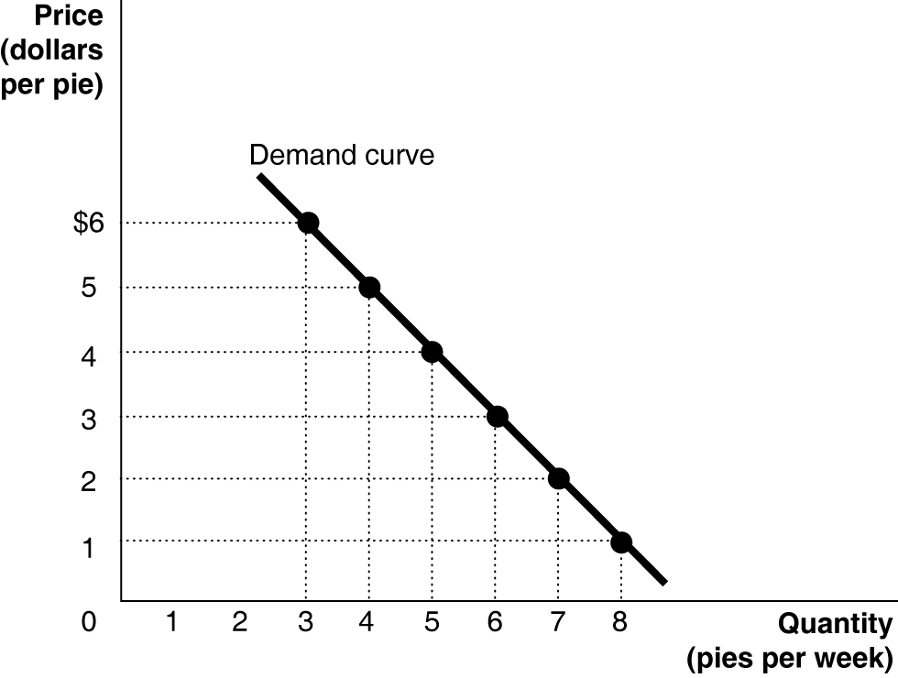

c. The slope = –1.

1A. 2

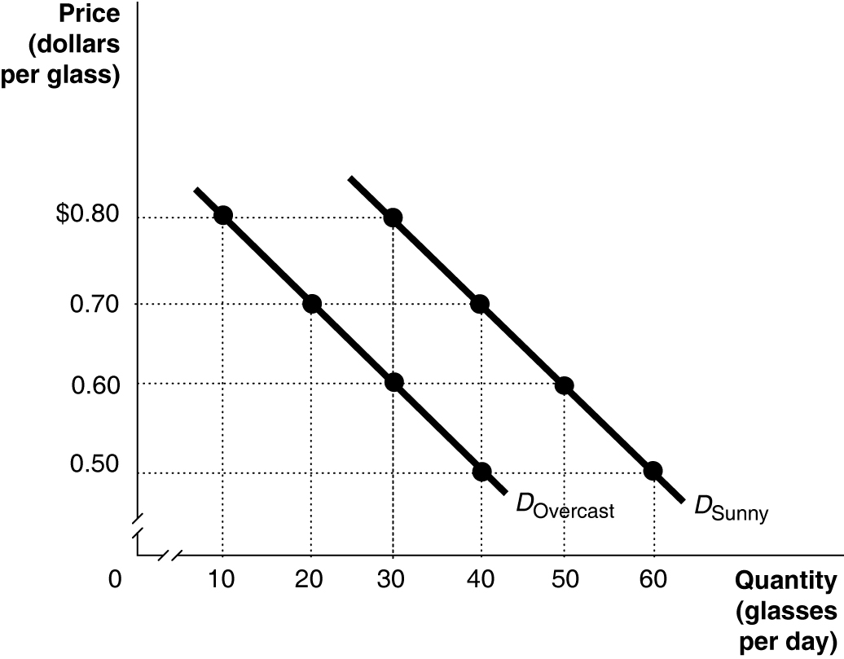

1A.3

Period Percentage Change
2002 to 2003 [(82 − 83)/83] × 100 = –1.2%
2003 to 2004 [(93 − 83)/83] × 100 = +12.0%
2004 to 2005 0%
2005 to 2006 0%
2006 to 2007 [(94.5 − 93.5)/93.5] × 100 = +1.1%
Rates rose at the fastest rate between 2003 and 2004.

1A.4 [($5,189 billion − $5,292 billion)/$5,292 billion] × 100 = –1.9%. The percentage change in real GDP from one year to the next is the economy’s growth rate.

1A.5
a.

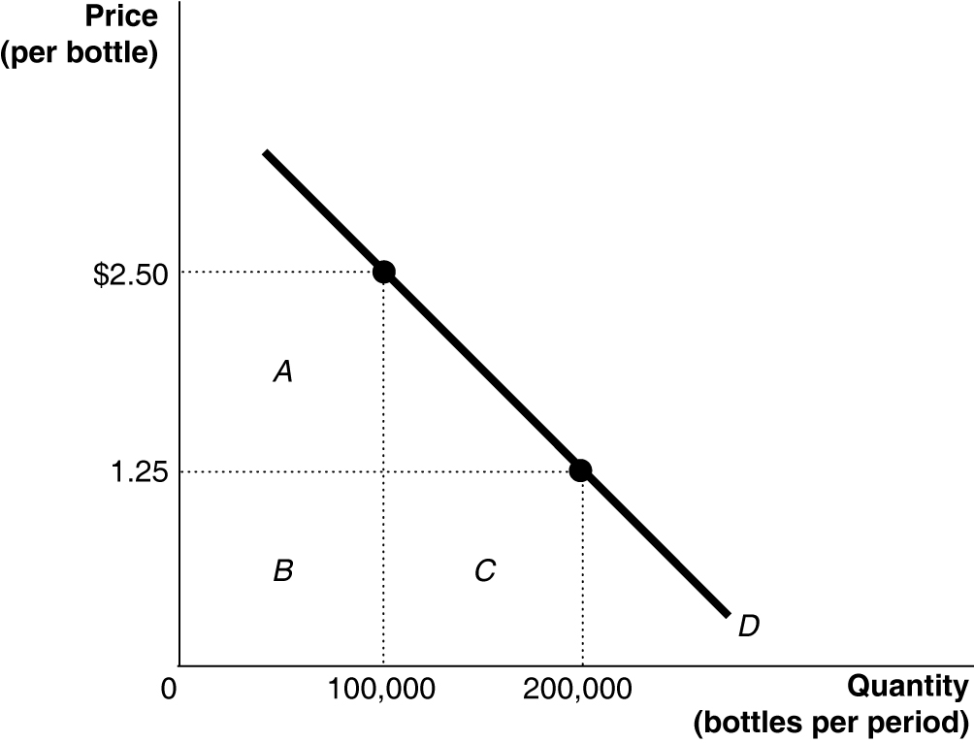

b. At $2.50, the total revenue equals rectangles A + B = $250,000 (because $2.50 × 100,000 = $250,000). At $1.25, the total revenue equals rectangles B + C = $250,000 (because $1.25 × 200,000 = $250,000).

1A.6 The triangle’s area = 0.5 × 60,000 × $0.75 = $22,500.

1A.7 The slope is calculated using the formula:

At point A: rise = 300 − 175 = 125, run = 7 − 5 = 2. Therefore, the slope = 125/2 = 62.5.
At point B: rise = 900 − 700 = 200, run = 14 − 12= 2. Therefore, the slope = 200/2 = 100.

