Elements of Ecology, 9e (Smith)
Chapter 1 The Nature of Ecology

1.1 Short Answer Questions

1) ________ is activism with a stated aim of protecting the natural environment, particularly from the negative impacts of human activities.
Answer: Environmentalism
Topic: Section 1.1
Bloom's Taxonomy: Knowledge/Comprehension

2) ________ is the scientific study of the relationship between organisms and their environment.
Answer: Ecology
Topic: Section 1.1
Bloom's Taxonomy: Knowledge/Comprehension

3) The living, or ________, and nonliving, or ________, components of the environment interact within an ecosystem.
Answer: biotic; abiotic
Topic: Section 1.2
Bloom's Taxonomy: Knowledge/Comprehension

4) A group of individuals of the same species that occupies a given area is referred to as a(n) ________.
Answer: population
Topic: Section 1.3
Bloom's Taxonomy: Knowledge/Comprehension

5) All populations of different species living and interacting within an ecosystem are referred to collectively as a(n) ________.
Answer: community
Topic: Section 1.3
Bloom's Taxonomy: Knowledge/Comprehension

6) At the ________ level, an ecologist might focus on the factors that affect the relative abundance of various populations in the area.
Answer: community
Topic: Section 1.4
Bloom's Taxonomy: Knowledge/Comprehension

7) All science begins with ________, which is the first step in the process known as the scientific method.
Answer: observation
Topic: Section 1.5
Bloom's Taxonomy: Knowledge/Comprehension

8) In a field experiment, an ecologist measures the effects of nitrogen on productivity, plotting data for nitrogen on the x-axis and productivity on the y-axis. In this experiment, the dependent variable is ________.
Answer: productivity
Topic: Section 1.5
Bloom's Taxonomy: Application/Analysis
9) A(n) ________ is an abstract, simplified representation of a real system, allowing us to predict some behavior or response using a set of explicit assumptions.
Answer: model
Topic: Section 1.6
Bloom's Taxonomy: Knowledge/Comprehension

10) The ________ forms the basic unit in ecology.
Answer: individual
Topic: Section 1.9
Bloom's Taxonomy: Knowledge/Comprehension

1.2 Multiple-Choice Questions

1) The term "ecology" is defined as the study of the
A) environment.
B) relationships between organisms.
C) relationships between organisms and their environment.
D) impact of humans on the environment.
Answer: C
Topic: Section 1.1
Bloom's Taxonomy: Knowledge/Comprehension

2) Which of the following is a cornerstone of the science of ecology?
A) Environmentalism
B) Darwin's theory of natural selection
C) Economics
D) Populations
Answer: B
Topic: Section 1.1
Bloom's Taxonomy: Knowledge/Comprehension

3) Moisture and concentration of oxygen
A) are parts of an organism's environment.
B) have no effect on the physiology of an organism.
C) are biological conditions that impact an organism's survival.
D) do not vary in the environment.
Answer: A
Topic: Section 1.2
Bloom's Taxonomy: Knowledge/Comprehension

4) The interaction of a biotic community and its abiotic environment is referred to as a(n)
A) biosphere.
B) ecosystem.
C) population.
D) biome.
Answer: B
Topic: Section 1.2
Bloom's Taxonomy: Knowledge/Comprehension
5) Which of the following is considered an abiotic component of the ecosystem?
A) temperature
B) microbes
C) plants
D) animals
Answer: A
Topic: Section 1.2
Bloom's Taxonomy: Knowledge/Comprehension

6) A biome is
A) the thin layer surrounding the Earth that supports all life.
B) all the populations of different species living and interacting within an ecosystem.
C) a broad-scale region dominated by similar types of ecosystems.
D) an area of land or water composed of a patchwork of communities and ecosystems.
Answer: C
Topic: Section 1.3
Bloom's Taxonomy: Knowledge/Comprehension

7)
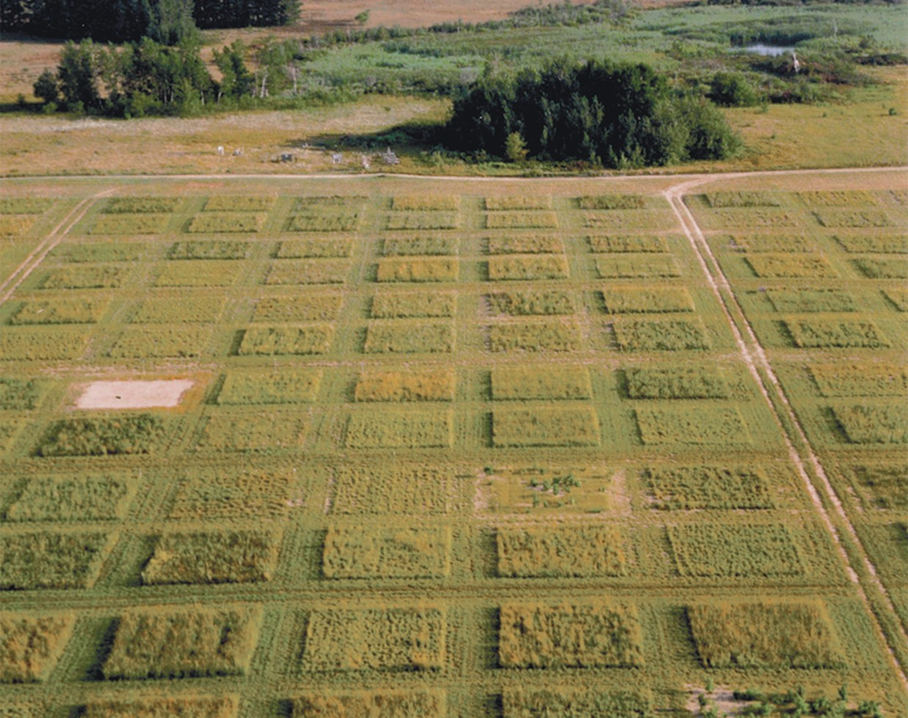

Experiments done at Cedar Creek Long Term Ecological Research site are ideal for examining concepts at what level?
A) ecosystem
B) population
C) community
D) individual
Answer: A
Topic: Section 1.3
Bloom's Taxonomy: Synthesis/Evaluation
8) All populations of different species living and interacting within an ecosystem are referred to collectively as a(n)
A) community.
B) biome.
C) population.
D) ecosystem.
Answer: A
Topic: Section 1.3
Bloom's Taxonomy: Knowledge/Comprehension

9) Which of the following is an example of a biome?
A) community
B) landscape
C) tropical rainforest
D) ecosystem
Answer: C
Topic: Section 1.3
Bloom's Taxonomy: Knowledge/Comprehension

10) A predator consuming prey would occur at the organizational level of the
A) community.
B) biome.
C) population.
D) ecosystem.
Answer: A
Topic: Section 1.3
Bloom's Taxonomy: Knowledge/Comprehension

11) Broad scale regions dominated by similar types of ecosystems are called
A) communities.
B) biospheres.
C) biomes.
D) landscapes.
Answer: C
Topic: Section 1.3
Bloom's Taxonomy: Knowledge/Comprehension

12) Which of the following represents the correct organization of ecological systems from the lowest to the highest level of organization?
A) individual, biome, biosphere, community, population, ecosystem
B) individual, community, population, ecosystem, biosphere, biome
C) individual, population, community, ecosystem, biome, biosphere
D) individual, population, community, biome, biosphere, ecosystem
Answer: C
Topic: Section 1.3
Bloom's Taxonomy: Knowledge/Comprehension
13) Which of the following questions is most appropriate to an investigation at the population level?
A) What is the effect of diminished resources on an individual's life span?
B) What is the relationship between resource availability and birthrate?
C) What factors influence the distribution of tropical forests?
D) How long does it take for carbon to be cycled from the atmosphere into living tissue?
Answer: B
Topic: Section 1.4
Bloom's Taxonomy: Application/Analysis

14) An ecologist who focuses on the individual could study all of the following, except
A) morphology.
B) physiology.
C) behavior.
D) death rate.
Answer: D
Topic: Section 1.4
Bloom's Taxonomy: Knowledge/Comprehension

15) Which of the following questions is most appropriate to an investigation at the landscape level?
A) What is the effect of diminished resources on an individual's life span?
B) What is the relationship between resource availability and birthrate?
C) Which factors give rise to the spatial extent and arrangement of the various ecosystems?
D) How long does it take for carbon to be cycled from the atmosphere into living tissue?
Answer: C
Topic: Section 1.4
Bloom's Taxonomy: Knowledge/Comprehension

16) Consider the question: "Why do tropical rain forests support a greater diversity of species than temperate forests?" At which level of organization would this be addressed?
A) individual
B) population
C) landscape
D) global
Answer: D
Topic: Section 1.4
Bloom's Taxonomy: Knowledge/Comprehension

17) A hypothesis refers to a(n)
A) phenomenon that is observed but is not yet understood.
B) testable explanation for an observed phenomenon.
C) untestable explanation for an observed phenomenon.
D) falsified explanation for an observed phenomenon.
Answer: B
Topic: Section 1.5
Bloom's Taxonomy: Knowledge/Comprehension
18) Which of the following best represents the flow of the scientific method?
A) question, hypothesis, hypothesis testing, observation, predictions
B) predictions, question, observation, hypothesis, hypothesis testing
C) observation, hypothesis, hypothesis testing, question, predictions
D) observation, question, hypothesis, predictions, hypothesis testing
Answer: D
Topic: Section 1.5
Bloom's Taxonomy: Knowledge/Comprehension

19) The correct sequence of the scientific method is
A) ask a question, observation, form a hypothesis, test a hypothesis, form a theory.
B) form a hypothesis, ask a question, observation, test a hypothesis, form a theory.
C) form a theory, ask a question, form a hypothesis, observation, test a hypothesis.
D) observation, ask a question, form a hypothesis, test a hypothesis, form a theory.
Answer: D
Topic: Section 1.5
Bloom's Taxonomy: Knowledge/Comprehension

20) A scientist wants to manipulate glucose levels in amphibians to determine freeze tolerance at -5 Celsius. Which arena would suit this question best?
A) Laboratory experiment
B) Field experiment
C) Field surveys
D) Observation in the wild
Answer: A
Topic: Section 1.5
Bloom's Taxonomy: Knowledge/Comprehension

21) An integrated set of hypotheses that together explain a broader set of observations is considered a(n)
A) experiment.
B) educated guess.
C) fact.
D) theory.
Answer: D
Topic: Section 1.5
Bloom's Taxonomy: Knowledge/Comprehension

22) An ecologist conducts a greenhouse experiment to study the effect of nitrogen concentration on the productivity of sunflower seedlings. What is the independent variable in this experiment?
A) productivity of sunflowers
B) concentration of nitrogen
C) the number of sunflower seeds planted
D) the daily amount of water given to each sunflower seed
Answer: B
Topic: Section 1.5
Bloom's Taxonomy: Application/Analysis
23)
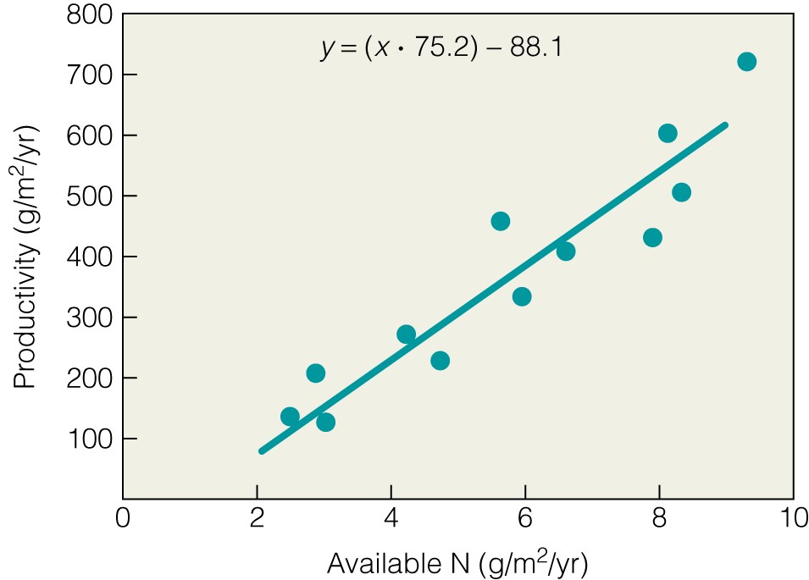

In Figure 1.8, Available N is the
A) dependent variable.
B) model.
C) independent variable.
D) response variable.
Answer: C
Topic: Section 1.5
Bloom's Taxonomy: Knowledge/Comprehension
24)
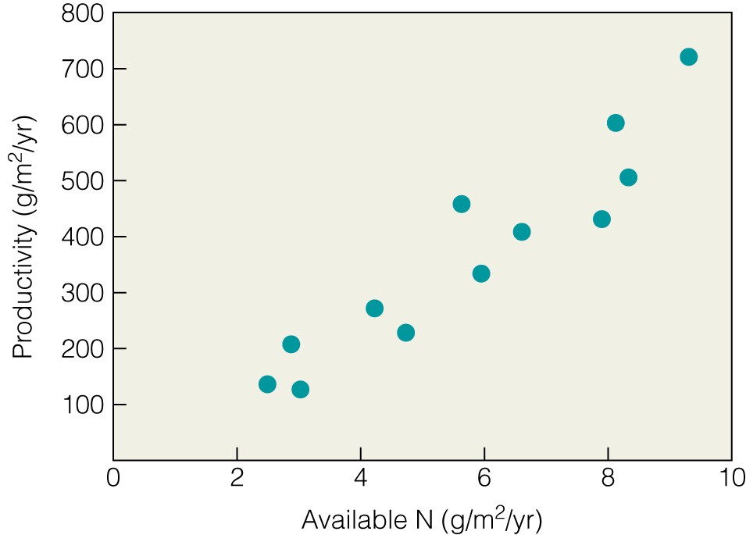

Figure 1.5 represents which type of plot?
A) Random
B) Scatter
C) Linear
D) Factorial
Answer: B
Topic: Section 1.5
Bloom's Taxonomy: Knowledge/Comprehension

25) Which model would you use to examine the relationship between nitrogen concentration and plant growth?
A) linear regression
B) species area curve
C) intermediate disturbance
D) Hamilton's rule
Answer: A
Topic: Section 1.6
Bloom's Taxonomy: Application/Analysis

26) A model is used by ecologists to
A) prove how nature works by demonstrating cause-and-effect relationships.
B) analyze data that have been collected during an experiment.
C) make predictions about how nature works using a set of explicit assumptions.
D) observe how nature works in an experimental setting.
Answer: C
Topic: Section 1.6
Bloom's Taxonomy: Knowledge/Comprehension
27) The real goal of hypothesis testing is to
A) eliminate incorrect ideas.
B) form a theory.
C) fully explain observations.
D) understand why science never changes.
Answer: A
Topic: Section 1.7
Bloom's Taxonomy: Knowledge/Comprehension

28) Science can best be described as
A) a search for the ultimate truth.
B) a search for evidence that proves our concepts wrong.
C) proving facts.
D) a complete lack of dissent amongst ideas to obtain the truth.
Answer: B
Topic: Section 1.7
Bloom's Taxonomy: Knowledge/Comprehension

29) Because ecology relies on many different branches of science (e.g., geology), it is considered
A) hypothetical.
B) unscientific.
C) permanent.
D) interdisciplinary.
Answer: D
Topic: Section 1.8
Bloom's Taxonomy: Knowledge/Comprehension

30) Why is ecology considered an interdisciplinary science?
A) It involves a large expanse of various species.
B) It involves and draws from various fields of science such as geology, hydrology, and meteorology.
C) It encompasses the field of environmental science.
D) It includes the study of human population growth.
Answer: B
Topic: Section 1.8
Bloom's Taxonomy: Knowledge/Comprehension

31) The basic unit in ecology is the
A) ecosystem.
B) gene.
C) individual.
D) species.
Answer: C
Topic: Section 1.9
Bloom's Taxonomy: Knowledge/Comprehension
32) The basic unit of ecology is the individual because it
A) is the basis for ecosystems.
B) is the unit on which natural selection acts.
C) cannot be further reduced to smaller parts.
D) passes genetic information to successive individuals.
Answer: D
Topic: Section 1.9
Bloom's Taxonomy: Application/Analysis

33) An ecologist measured the length and weight of different individuals of a species of bird. The most common method of graphically displaying the data is a
A) frequency distribution.
B) histogram.
C) pie chart.
D) scatter plot.
Answer: D
Topic: Quantifying Ecology 1.1
Bloom's Taxonomy: Application/Analysis

34) If x and y have a positive relationship as shown by a scatter plot, then the value of y will
A) increase as the value of x decreases.
B) increase as the value of x increases.
C) decrease as the value of x increases.
D) stay the same as the value of x decreases.
Answer: B
Topic: Quantifying Ecology 1.2
Bloom's Taxonomy: Knowledge/Comprehension

35) Which economist influenced Darwin's conception of natural selection?
A) Charles Elton
B) Gregor Mendel
C) Thomas Malthus
D) Frederic Clements
Answer: C
Topic: Ecological Issues & Applications 1: History
Bloom's Taxonomy: Knowledge/Comprehension

1.3 True/False Questions

1) Ecology is the same as environmentalism.
Answer: FALSE
Topic: Section 1.1
Bloom's Taxonomy: Knowledge/Comprehension

2) A community includes both living and nonliving components.
Answer: FALSE
Topic: Section 1.2
Bloom's Taxonomy: Knowledge/Comprehension
3) Microbes are considered an abiotic factor within an ecosystem.
Answer: FALSE
Topic: Section 1.2
Bloom's Taxonomy: Knowledge/Comprehension

4) A population refers to all the individuals of the same species that occupy a given area.
Answer: TRUE
Topic: Section 1.3
Bloom's Taxonomy: Knowledge/Comprehension

5) A freshwater pond ecosystem includes only the living organisms within the pond.
Answer: FALSE
Topic: Section 1.3
Bloom's Taxonomy: Knowledge/Comprehension

6) The number of seeds produced by a single flower affects the birthrate of that population of flowers.
Answer: TRUE
Topic: Section 1.4
Bloom's Taxonomy: Knowledge/Comprehension

7) A valid scientific hypothesis must be testable.
Answer: TRUE
Topic: Section 1.5
Bloom's Taxonomy: Knowledge/Comprehension

8) A theory is an integrated set of hypotheses that explains a broad set of observations.
Answer: TRUE
Topic: Section 1.5
Bloom's Taxonomy: Knowledge/Comprehension

9) A field experiment gives the investigator much more control over the environmental conditions than does a laboratory experiment.
Answer: FALSE
Topic: Section 1.5
Bloom's Taxonomy: Knowledge/Comprehension

10) Ecological models can be mathematical or they can be verbally descriptive.
Answer: TRUE
Topic: Section 1.6
Bloom's Taxonomy: Knowledge/Comprehension

11) Science is a process of testing and correcting concepts in order to explain the world around us.
Answer: TRUE
Topic: Section 1.7
Bloom's Taxonomy: Knowledge/Comprehension

12) There is generally only one valid explanation for an observation.
Answer: FALSE
Topic: Section 1.7
Bloom's Taxonomy: Knowledge/Comprehension
1.4 Essay Questions

1) Explain the distinction between ecology and environmentalism.
Topic: Section 1.1
Bloom's Taxonomy: Synthesis/Evaluation

2) Using a real example, illustrate how an organism can both respond to and modify the abiotic conditions of its ecosystem.
Topic: Section 1.2
Bloom's Taxonomy: Application/Analysis

3) Explain the distinction between an ecosystem and a biome.
Topic: Section 1.3
Bloom's Taxonomy: Knowledge/Comprehension

4) Explain why ecology is inherently an interdisciplinary science. Give two examples of the ties between ecology and other branches of science.
Topic: Section 1.8
Bloom's Taxonomy: Application/Analysis

5) Describe a field experiment that you might use to test the hypothesis that water availability affects plant growth. Suggest one set of possible results and the implications of those results for the hypothesis.
Topic: Section 1.5
Bloom's Taxonomy: Synthesis/Evaluation

6) Explain why it is difficult for ecologists to give definitive answers.
Topic: Section 1.7
Bloom's Taxonomy: Synthesis/Evaluation

7) Explain why human population growth, biological diversity, sustainability, and global climate change are considered crucial environmental problems facing humans.
Topic: Section 1.8
Bloom's Taxonomy: Synthesis/Evaluation

