CHAPTER 1—ENVIRONMENTAL PROBLEMS, THEIR CAUSES, AND SUSTAINABILITY

MULTIPLE CHOICE

1. Which of the following is not a goal of environmental science?
a. | learn how nature works
b. | understand how we interact with the environment
c. | find ways to deal with environmental problems
d. | learn how to live more sustainably
e. | learn how to persuade politicians to enact sustainability legislation

ANS: E PTS: 1 DIF: Easy
TOP: 1-1 What Are Three Principles of Sustainability?

2. A key component of environmental science is
a. | botany
b. | political science
c. | sociology
d. | ecology
e. | psychology

ANS: D PTS: 1 DIF: Easy
TOP: 1-1 What Are Three Principles of Sustainability?

3. Natural capital includes all of the following except
a. | solar energy
b. | air
c. | water
d. | soil
e. | nutrients

ANS: A PTS: 1 DIF: Moderate
TOP: 1-1 What Are Three Principles of Sustainability?

4. Using normally renewable resources faster than nature can renew them is called
a. | nutrient cycling
b. | nutrient deficit
c. | sustainability
d. | trade-offs
e. | degrading natural capital

ANS: E PTS: 1 DIF: Easy
TOP: 1-1 What Are Three Principles of Sustainability?

5. Solar energy is known as
a. | renewable resource
b. | recyclable resource
c. | perpetual resource
d. | reusable resource
e. | nonrenewable resource

ANS: C PTS: 1 DIF: Difficult
TOP: 1-1 What Are Three Principles of Sustainability?

6. Scientists estimate we could recycle and reuse what percentage of the resources we now use?
a. | 50-60%
b. | 60-70%
c. | 70-80%
d. | 80-90%
e. | 90-100%

ANS: D PTS: 1 DIF: Easy
TOP: Figure 1-8 | 1-1 What Are Three Principles of Sustainability?

7. The annual market value of all goods and services produced by all businesses, foreign and domestic, operating within a country is called:
a. | per capita GNP
b. | GNP
c. | per capita GDP
d. | PPP
e. | GDP

ANS: E PTS: 1 DIF: Moderate
TOP: 1-1 What Are Three Principles of Sustainability?

8. The changes in a country’s economic growth per person is measured by the
a. | per capita GDP
b. | per capita GNP
c. | per capita
d. | per capita GDP
e. | PPP

ANS: A PTS: 1 DIF: Moderate
TOP: 1-1 What Are Three Principles of Sustainability?

9. More-developed countries, including the US, Japan, and most European countries have __________ % of the world’s population and use about __________% of all the world’s resources.
a. | 75, 25
b. | 30, 70
c. | 5, 25
d. | 20, 88
e. | 33, 68

ANS: D PTS: 1 DIF: Moderate
TOP: 1-1 What Are Three Principles of Sustainability?

10. Which of the following generalizations about developing countries is true?
a. | They make up about one-tenth of the world's population.
b. | They have high average per capita GNP.
c. | They include Canada, Japan, and Australia.
d. | They use about 12% of the world's resources.
e. | They are highly industrialized.

ANS: D PTS: 1 DIF: Moderate
TOP: 1-1 What Are Three Principles of Sustainability?

11. What is the primary difference between renewable resources and nonrenewable resources?
a. | how easily they are discovered
b. | the amount of the resource
c. | the length of time it takes for them to be replenished
d. | how fast they are being used up
e. | none of these

ANS: C PTS: 1 DIF: Easy
TOP: 1-1 What Are Three Principles of Sustainability?

12. The highest rate at which a renewable resource can be used indefinitely without reducing its available supply is called
a. | conservation
b. | sustainable yield
c. | preservation
d. | perpetual resource
e. | degradation

ANS: B PTS: 1 DIF: Moderate
TOP: 1-1 What Are Three Principles of Sustainability?

13. Which of the following would not be considered a nonrenewable resource?
a. | copper
b. | oil
c. | fresh air
d. | salt
e. | sand

ANS: C PTS: 1 DIF: Easy
TOP: 1-1 What Are Three Principles of Sustainability?

14. Which of the following is not a renewable resource?
a. | groundwater
b. | trees in a forest
c. | fertile soil
d. | oil
e. | crops

ANS: D PTS: 1 DIF: Easy
TOP: 1-1 What Are Three Principles of Sustainability?

15. All non-renewable resources can theoretically be
a. | converted to nonmetallic minerals
b. | converted to renewable ones
c. | exhausted or depleted
d. | recycled or reused
e. | alive

ANS: C PTS: 1 DIF: Easy
TOP: 1-1 What Are Three Principles of Sustainability?

16. Which of the following is an example of reuse?
a. | re-melting aluminum cans
b. | making compost out of kitchen scraps
c. | using plastic butter tubs to store leftovers
d. | using waste heat to warm a room
e. | making paper goods from previously used paper

ANS: C PTS: 1 DIF: Easy
TOP: 1-1 What Are Three Principles of Sustainability?

17. Use of a natural resource based on sustainable yields applies to
a. | nonrenewable resources
b. | renewable resources
c. | perpetual resources
d. | amenity resources
e. | recycling

ANS: B PTS: 1 DIF: Moderate
TOP: 1-1 What Are Three Principles of Sustainability?

18. An average ecological footprint of an individual in a given country or area is called
a. | per capita gross GNP
b. | ecological footprint
c. | per capita GDP
d. | sustainable yield
e. | per capita ecological footprint

ANS: E PTS: 1 DIF: Moderate
TOP: 1-1 What Are Three Principles of Sustainability?

19. The U.N. Millennium Ecosystem Assessment reports that human activities have degraded what percentage of the earth’s natural services, mostly in the last 50 years.
a. | 20
b. | 40
c. | 60
d. | 80
e. | 95

ANS: C PTS: 1 DIF: Easy
TOP: 1-2 How Are Our Ecological Footprints affecting the Earth?

20. Which of the following is not one of the types of property or resource rights?
a. | private property
b. | unusable property
c. | open access renewable
d. | common property
e. | all of these are types of property rights

ANS: B PTS: 1 DIF: Moderate
TOP: 1-2 How Are Our Ecological Footprints Affecting the Earth?

21. Which of the following is not a solution suggested by the author to the problem of the degradation of a shared common resource?
a. | Remove it from use by anyone.
b. | Convert it to private ownership.
c. | Use it as a rate well below estimated sustainable yields.
d. | Regulate access to the resource.
e. | All of these.

ANS: A PTS: 1 DIF: Moderate
TOP: 1-2 How Are Our Ecological Footprints Affecting the Earth?

22. In 2008, the World Wildlife Fund estimated that humanity's global ecological footprint exceeded the earth's biological capacity by how much?
a. | 30%
b. | 12%
c. | 20%
d. | 45%
e. | 80%

ANS: A PTS: 1 DIF: Moderate
TOP: 1-2 How Are Our Ecological Footprints Affecting the Earth?

23. If everyone on earth consumed at the same current level as the average U.S. citizens, we would need
a. | 30% more resources
b. | 75% more resources
c. | 100% more resources
d. | two more earths
e. | five more earths

ANS: E PTS: 1 DIF: Easy
TOP: 1-2 How Are Our Ecological Footprints Affecting the Earth?

24. The per capita ecological footprint of U.S. citizen is about ____ times as much as an average citizen of China.
a. | 2.1
b. | 4.5
c. | 6
d. | 10
e. | 30

ANS: C PTS: 1 DIF: Easy
TOP: 1-2 How Are Our Ecological Footprints Affecting the Earth?

25. According to the author, three of the following are major cultural changes (revolutions) that have occurred in human history, and one is not. Choose the one that is not.
a. | Information-Globalization
b. | Transportation
c. | Industrial-Medical
d. | Agricultural
e. | none of these

ANS: B PTS: 1 DIF: Moderate
TOP: 1-2 How Are Our Ecological Footprints Affecting the Earth?

26. Pollution includes
a. | detergents dumped into streams
b. | volcanoes spewing toxic gases into the atmosphere
c. | CO₂ releases from coal burning power plants
d. | fertilizer runoff from golf courses
e. | all of these

ANS: E PTS: 1 DIF: Easy
TOP: 1-2 How Are Our Ecological Footprints Affecting the Earth?

27. Pollutants can have which of the following unwanted effects?
a. | degrade life-support systems for humans
b. | damage wildlife
c. | lower human health
d. | unpleasant smells, sights, tastes
e. | all of these

ANS: E PTS: 1 DIF: Moderate
TOP: 1-2 How Are Our Ecological Footprints Affecting the Earth?

28. Which of the following would not be a type of nondegradable pollutant?
a. | lead
b. | arsenic
c. | toxic chemicals
d. | mercury
e. | human sewage

ANS: E PTS: 1 DIF: Moderate
TOP: 1-2 How Are Our Ecological Footprints Affecting the Earth?

29. At our current average rate of use per person, we will need the equivalent of how many earth’s to provide an endless supply of renewable resources.
a. | 0.88
b. | 0.91
c. | 1.15
d. | 1.3
e. | 2.1

ANS: D PTS: 1 DIF: Easy
TOP: 1-2 How Are Our Ecological Footprints Affecting the Earth?

30. According to data available in 2003, the average US citizen has an ecological footprint that is how many times that of the average citizen of the low-income countries?
a. | 13
b. | 12
c. | 11
d. | 10
e. | 4.5

ANS: B PTS: 1 DIF: Moderate
TOP: 1-2 How Are Our Ecological Footprints Affecting the Earth?

31. Nonpoint sources of pollution include all of the following except
a. | wind carrying dirt and pesticides from croplands
b. | runoff from a stockyard
c. | a smokestack from a power plant
d. | fertilizer runoff from lawns
e. | runoff from cropland

ANS: C PTS: 1 DIF: Moderate
TOP: 1-2 How Are Our Ecological Footprints Affecting the Earth?

32. Scientists have identified several problems with relying primarily on pollution cleanup. Which of the following is not one of those problems?
a. | It is only a temporary bandage as long as the situation remains the same.
b. | Elimination of pollution at the time of production is expensive.
c. | It often simply moves the pollutant from one place to another.
d. | Once pollutants are released it is too expensive to remove them.
e. | All of these are identified problems.

ANS: B PTS: 1 DIF: Difficult
TOP: 1-2 How Are Our Ecological Footprints Affecting the Earth?

33. Which of the following is one of the root causes of environmental problems?
a. | rapid population growth
b. | even distribution of wealth
c. | increasingly sustainable use of resources
d. | prices reflecting environmental costs
e. | using nonrenewable resources sensibly

ANS: A PTS: 1 DIF: Easy
TOP: 1-3 Why Do We Have Environmental Problems?

34. Which of the following is not normally an effect of poverty?
a. | premature death from normally nonfatal diarrhea
b. | lack of clean drinking water
c. | severe respiratory illness from openly burning wood indoors
d. | diseases from poor sanitation
e. | heart disease and diabetes from obesity

ANS: E PTS: 1 DIF: Moderate
TOP: 1-3 Why Do We Have Environmental Problems?

35. The harmful effects of poverty are serious but those of affluence are ____.
a. | a lot less serious
b. | a little less serious
c. | about the same
d. | a little more serious
e. | a lot more serious

ANS: E PTS: 1 DIF: Easy
TOP: 1-3 Why Do We Have Environmental Problems?

36. The real prices of goods and services do not include
a. | the cost of raw materials
b. | the cost of manufacturing
c. | the environmental costs of resource use
d. | the cost of distribution
e. | the cost of advertising

ANS: C PTS: 1 DIF: Easy
TOP: 1-3 Why Do We Have Environmental Problems?

37. Subsidies and tax breaks to companies are
a. | helpful to the environment
b. | not helpful to the economy
c. | not helpful to the company
d. | not helpful to the environment
e. | none of these

ANS: D PTS: 1 DIF: Moderate
TOP: 1-3 Why Do We Have Environmental Problems?

38. The set of assumptions and values reflecting how you think the world works and what you think your role in the world should be is called
a. | environmental worldview
b. | environmental justice
c. | environmental ethics
d. | environmental economics
e. | environmental capital

ANS: A PTS: 1 DIF: Moderate
TOP: 1-3 Why Do We Have Environmental Problems?

39. The idea that we should be responsible, caring managers of the earth is
a. | the planetary management worldview
b. | the stewardship worldview
c. | the environmental wisdom worldview
d. | the environmental justice movement
e. | all of these

ANS: B PTS: 1 DIF: Easy
TOP: 1-3 Why Do We Have Environmental Problems?

40. Which of the following would be representative of an environmental wisdom worldview?
a. | Continuous rapid economic growth improves environmental conditions.
b. | Learning how life sustains itself and do the same
c. | More money should be directed to research for controlling the environment.
d. | Human beings are the most important life forms on earth.
e. | There is always more.

ANS: B PTS: 1 DIF: Difficult
TOP: 1-3 Why Do We Have Environmental Problems?

41. Research by social scientists suggests that it takes ____ percent of the population of a community, country, or the world to bring about major social change.
a. | 1−2
b. | 5−10
c. | 15−20
d. | 25−35
e. | 50−60

ANS: B PTS: 1 DIF: Easy
TOP: 1-4 What Is an Environmentally Sustainable Society?

42. An irreversible shift in the behavior of a natural system is called a(n)
a. | ecological tipping point
b. | overuse of resources
c. | failure to recycle
d. | renewable natural capital
e. | ecological footprint

ANS: A PTS: 1 DIF: Easy
TOP: 1-2 How Are Our Ecological Footprints Affecting the Earth?

TRUE/FALSE

1. While heavily dependent on the environment, we are not dependent for everything we need to stay alive and healthy.

ANS: F PTS: 1 DIF: Easy
TOP: 1-1 What Are Three Principles of Sustainability?

2. Environmental science is a branch of environmentalism and has the aim of protecting the earth's life-support systems.

ANS: F PTS: 1 DIF: Easy
TOP: 1-1 What Are Three Principles of Sustainability?

3. The three overarching themes relating to the long-term sustainability of life on this planet are: solar energy, biodiversity, and energy cycling.

ANS: F PTS: 1 DIF: Easy
TOP: 1-1 What Are Three Principles of Sustainability?

4. Natural services are functions of nature, such as purification of air and water, which support life and human economies.

ANS: T PTS: 1 DIF: Easy
TOP: 1-1 What Are Three Principles of Sustainability?

5. In environmental science, individuals tend to matter less because the issues are global in nature.

ANS: F PTS: 1 DIF: Moderate
TOP: 1-1 What Are Three Principles of Sustainability?

6. Take away solar energy and all natural capital would collapse.

ANS: T PTS: 1 DIF: Easy
TOP: 1-1 What Are Three Principles of Sustainability?

7. More than 1.4 billion people in today's world struggle to live on an income of $1.25 or less per day.

ANS: T PTS: 1 DIF: Moderate
TOP: 1-2 How Are Our Ecological Footprints Affecting the Earth?

8. Natural capital includes both natural resources and natural resources.

ANS: T PTS: 1 DIF: Easy
TOP: 1-1 What Are Three Principles of Sustainability?

9. If everyone on earth consumed at the rate of an average U.S. citizen, the earth could only support about 5 billion of the 6.9 billion now alive.

ANS: T PTS: 1 DIF: Moderate
TOP: 1-2 How Are Our Ecological Footprints Affecting the Earth?

10. A drainpipe of a factory that is releasing a pollutant, is an example of nonpoint source of pollution.

ANS: F PTS: 1 DIF: Easy
TOP: 1-2 How Are Our Ecological Footprints Affecting the Earth?

11. The Tragedy of the Commons refers to a lack of agricultural resources available for the common (poor) people in a country.

ANS: F PTS: 1 DIF: Easy
TOP: 1-2 How Are Our Ecological Footprints Affecting the Earth?

12. The amount of biologically productive land and water required to supply the people in a country with renewable resources and recycling wastes and pollution is the ecological footprint.

ANS: T PTS: 1 DIF: Moderate
TOP: 1-2 How Are Our Ecological Footprints Affecting the Earth?

13. An environmental problem that is not addressed can continue to grow until it reaches an often irreversible tippling point.

ANS: T PTS: 1 DIF: Moderate
TOP: 1-2 How Are Our Ecological Footprints Affecting the Earth?

14. Pollutants are all human-made; they can not enter the environment naturally.

ANS: F PTS: 1 DIF: Moderate
TOP: 1-2 How Are Our Ecological Footprints Affecting the Earth?

15. Species are becoming extinct at least 100 times faster than they were in pre-human times.

ANS: T PTS: 1 DIF: Easy
TOP: 1-2 How Are Our Ecological Footprints Affecting the Earth?

16. Pollution cleanup is usually the best way of dealing with the release of a pollutant.

ANS: F PTS: 1 DIF: Easy
TOP: 1-2 How Are Our Ecological Footprints Affecting the Earth?

17. The harmful environmental effects of poverty are much worse than those of affluence.

ANS: F PTS: 1 DIF: Easy
TOP: 1-3 Why Do We Have Environmental Problems?

18. Overall, the air quality is poorer and drinking water more polluted today than in the 1970s.

ANS: F PTS: 1 DIF: Easy
TOP: 1-3 Why Do We Have Environmental Problems?

19. A basic cause of environmental problems results from the fact that companies using resources have to pay for the cost of the harmful environmental costs of supplying their products.

ANS: F PTS: 1 DIF: Moderate
TOP: 1-3 Why Do We Have Environmental Problems?

20. The old lesson that you should “protect your capital and live on the income it provides” applies to the use of the earth’s natural capital as well as financial resources.

ANS: T PTS: 1 DIF: Easy
TOP: 1-4 What Is an Environmentally Sustainable Society?

COMPLETION

1. _______________ is the capacity of the earth’s natural systems and human cultural systems to survive, flourish, and adapt to changing environmental conditions indefinitely.

ANS: Sustainability

PTS: 1 DIF: Easy
TOP: 1-0 Core Case Study - Environmental Problems, Their Causes, and Sustainability

2. Our lives and economies depend on energy from ____________________ and natural resources and natural services provided by the earth.

ANS: the sun

PTS: 1 DIF: Easy TOP: 1-1 What Are Three Principles of Sustainability?

3. Natural Capital equals __________ __________ plus __________ __________.

ANS: natural resources, natural services

PTS: 1 DIF: Moderate
TOP: Figure 1-14 | 1-1 What Are Three Principles of Sustainability?

4. The circulation of chemicals necessary for life, from the environment through organisms and back to the environment, is called ____________________.

ANS: nutrient cycling

PTS: 1 DIF: Easy TOP: 1-1 What Are Three Principles of Sustainability?

5. Changes in a country's economic growth per person are measured by ____________________.

ANS: per capita GDP

PTS: 1 DIF: Easy TOP: 1-1 What Are Three Principles of Sustainability?

6. Some of the world’s countries are called low-income, __________-__________ countries, and include Congo, Haiti, Nigeria, and Nicaragua.

ANS: least-developed

PTS: 1 DIF: Difficult TOP: 1-1 What Are Three Principles of Sustainability?

7. A resource such as solar energy, that is constantly available, is called a(n) ____________________.

ANS: perpetual resource

PTS: 1 DIF: Easy TOP: 1-1 What Are Three Principles of Sustainability?

8. Fish, fresh air, forests, and fertile soil are examples of ____________________.

ANS: renewable resources

PTS: 1 DIF: Easy TOP: 1-1 What Are Three Principles of Sustainability?

9. Old drink bottles that are collected, washed, and refilled are an example of ____________________.

ANS: reuse

PTS: 1 DIF: Easy TOP: 1-1 What Are Three Principles of Sustainability?

10. ____________________ is the amount of biologically productive land and water needed to supply the people in a particular country or area with an indefinite supply of renewable resources and to absorb and recycle the wastes and pollution produced by such resource use.

ANS: Ecological footprint

PTS: 1 DIF: Easy
TOP: 1-2 How Are Our Ecological Footprints Affecting the Earth?

11. Approximately one-third of all land in the US is jointly owned by all US citizens and managed for them by the government. This type of property is called ____________________ and is often degraded.

ANS: common property

PTS: 1 DIF: Moderate
TOP: 1-2 How Are Our Ecological Footprints Affecting the Earth?

12. Environmental degradation, also known as __________ __________ __________ is the process of wasting, depleting, and degrading the earth’s natural capital at an accelerating rate.

ANS: natural capital degradation

PTS: 1 DIF: Moderate
TOP: 1-2 How Are Our Ecological Footprints Affecting the Earth?

13. The exhaust pipe of an automobile or the smokestack of a coal-burning powerplant are examples of ______________ sources.

ANS: point

PTS: 1 DIF: Easy
TOP: 1-2 How Are Our Ecological Footprints Affecting the Earth?

14. One way of dealing with pollution is to clean up pollutants after we have produced them, which is called __________ __________ __________.

ANS: output pollution control

PTS: 1 DIF: Moderate
TOP: 1-2 How Are Our Ecological Footprints Affecting the Earth?

15. If everyone consumed as much as the average American does today, the earth could indefinitely support only about _______________ of the currently 6.9 billion people.

ANS: 1.3 billion

PTS: 1 DIF: Moderate
TOP: 1-2 How Are Our Ecological Footprints Affecting the Earth?

16. IPAT is a simple way of looking at how three factors influence the impact humans have on the environment. The formula is Impact = Population (P) x __________ x Technology (T).

ANS: Affluence

PTS: 1 DIF: Moderate
TOP: 1-2 How Are Our Ecological Footprints Affecting the Earth?

17. ____________________ is the world's leading consumer of wheat, rice, meat, coal, fertilizers, steel, and cement.

ANS: China

PTS: 1 DIF: Easy
TOP: 1-2 How Are Our Ecological Footprints Affecting the Earth?

18. An often irreversible shift in the behavior of a natural system is caused when an environmental problem builds slowly until it reaches an __________ __________ __________.

ANS: ecological tipping point

PTS: 1 DIF: Moderate
TOP: 1-2 How Are Our Ecological Footprints Affecting the Earth?

19. Your ____________ ____________ is a set of assumptions and values reflecting how you think the world works and what you think your role in the world should be.

ANS: environmental worldview

PTS: 1 DIF: Easy TOP: 1-3 Why Do We Have Environmental Problems?

SHORT ANSWER

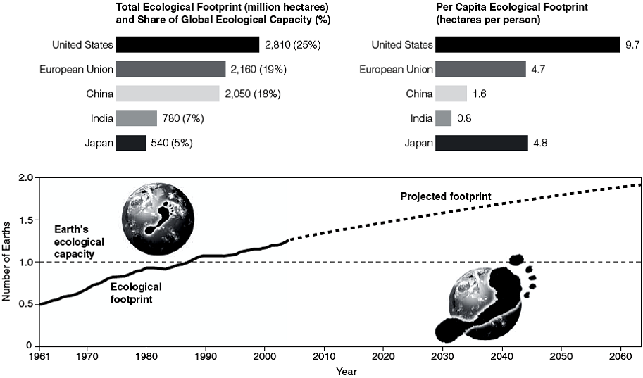

Use the Figure above to answer the following question(s).

1. What is the current percentage difference between humanity's ecological footprint and earth's ecological capacity?

ANS:
approximately 25% above ecological capacity

PTS: 1 DIF: Difficult OBJ: Critical Thinking

2. What will happen if humanity's ecological footprint continues to be greater than earth's ecological capacity?

ANS:
Humans will destroy their environment.
More and more animal and plant species will be lost.
Poverty and disease will increase.

PTS: 1 DIF: Moderate OBJ: Critical Thinking

3. How much greater is India's total ecological footprint than that of Japan?

ANS:
240 million hectares

PTS: 1 DIF: Easy OBJ: Critical Thinking

4. What does the difference between the ecological footprint of India and Japan mean?

ANS:
India's overall effect on the environment is more severe than that of Japan.

PTS: 1 DIF: Difficult OBJ: Critical Thinking

5. Assuming you will retire at age 70, how many earths will be necessary to support the earth's human population at that time?

ANS:
Depends on their age

PTS: 1 DIF: Difficult OBJ: Critical Thinking

6. What is the percentage of the per capita ecological footprint for a person in China as compared to a person in the United States?

ANS:
1.6/9.7 = 16%

PTS: 1 DIF: Difficult OBJ: Critical Thinking

7. What percentage of the world's pollution is the responsibility of developed countries?

ANS:
75%

PTS: 1 DIF: Moderate OBJ: Critical Thinking

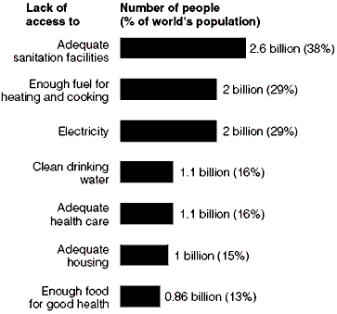

Use the Figure above to answer the following question. Assume that the total world population is 6.9 billion people, and the total population of the United States is 310 million people.

8. Those people who lack clean drinking water are equal to what percentage of the population of the United States?

ANS:
355% (1100/100)

PTS: 1 DIF: Difficult OBJ: Critical Thinking
TOP: Figure 1-20 1-3 Why Do We Have Environmental Problems?

9. What percentage of the world's total population lacks adequate sanitation facilities?

ANS:
38%

PTS: 1 DIF: Moderate OBJ: Critical Thinking
TOP: Figure 1-20 1-3 Why Do We Have Environmental Problems?

10. What is the significance of those who lack adequate sanitation facilities, lack clean drinking water, and lack adequate health care?

ANS:
The interaction of these factors result in increased disease without the likelihood of proper intervention to prevent or cure them, making those populations vulnerable to difficult survival and/or death.

PTS: 1 DIF: Difficult OBJ: Critical Thinking
TOP: Figure 1-20 1-3 Why Do We Have Environmental Problems?

11. What is the likely result if the portion of the world's population that lack adequate sanitation had their problem resolved?

ANS:
People would be living healthier, longer lives, and would likely be interested in becoming part of the developed world.

PTS: 1 DIF: Moderate OBJ: Critical Thinking
TOP: Figure 1-20 1-3 Why Do We Have Environmental Problems?

ESSAY

1. The word "sustainability" is becoming a commonly used slogan. Many people who use the word may not understand the complexities involved in the concept. Explain how the author uses the concept of natural capital to argue for sustainability.

ANS:
The authors state: "natural capital can support the earth’s diversity of species as long as we use its natural resources and services in a sustainable fashion."

PTS: 1 DIF: Moderate OBJ: Critical Thinking
TOP: 1-1 What Are Three Principles of Sustainability?

2. The author’s suggest humans need to mimic the three strategies nature has followed toward sustainability. Explain why they suggest this.

ANS:
The author’s state “To learn how to live more sustainably and thus more wisely, we need to find out how life on the earth has sustained itself. Our research leads us to believe that in the face of drastic environmental changes, there are three overarching themes relating to the long-term sustainability of life on this planet: solar energy, biodiversity, and chemical cycling.”

PTS: 1 DIF: Moderate OBJ: Critical Thinking
TOP: 1-1 What Are Three Principles of Sustainability?

3. The people of the United States are often said to have more of an impact on the environment than the citizens of other countries. Using the concepts of per capita resource use and per capita degradation, explain why that is true.

ANS:
The author’s state “In more-developed countries, high rates of per capita resource use and the resulting high per capita levels of pollution and resource depletion and degradation usually are the key factors determining overall environmental impact.”

PTS: 1 DIF: Difficult OBJ: Critical Thinking
TOP: 1-2 How Are Our Ecological Footprints Affecting the Earth?

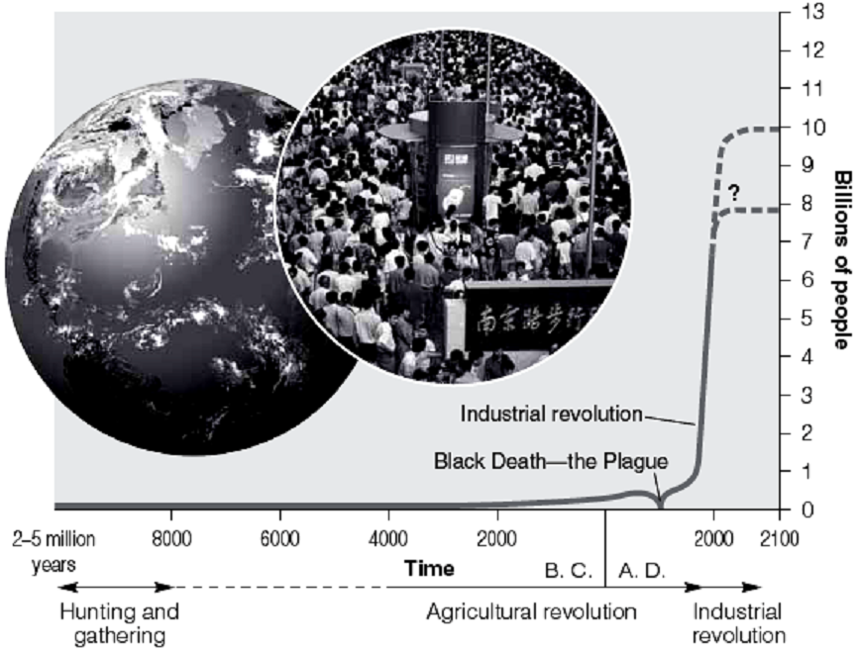

4. In the figure above note that following the Black Death, the line representing the total human population rose dramatically. This rise indicates a fundamental relationship between births, deaths, and growth rates. Discuss this relationship, indicating why the steep rise occurred, and why an expected leveling off may occur soon.

ANS:
Death rate fell without a drop in birth rates. Leveling off will result when birth rate drops.

PTS: 1 DIF: Moderate OBJ: Critical Thinking
TOP: 1-3 Why Do We Have Environmental Problems?

5. Describe what Garrett Hardin meant by the Tragedy of the Commons, and give an example.

ANS:
Hardin uses the term to indicate a resource that no one owns individually, that is held "in common," and which is available for exploitation. Open range land, owned by the government but used by ranchers to graze cattle, is an example.

PTS: 1 DIF: Moderate OBJ: Critical Thinking
TOP: 1-2 How Are Our Ecological Footprints Affecting the Earth?

6. It has been estimated (Rees and Wackernagel) that it would take the land area of five additional planet earths to meet the consumption of the people now on earth if they all consumed at the level of the United States. Discuss what the implications are of this statistic and any solutions that you see.

ANS:
As countries move toward developed status their populace wishes to attain the level of affluence of the U.S. That level of affluence requires immense consumption of resources and is not physically possible. The pressure to attain U.S. levels of affluence will lead to heightened competition for the resources. Either alternative means of attaining affluence will have to be found, or increasing competition will lead to conflict for the resources, or both.

PTS: 1 DIF: Difficult OBJ: Critical Thinking
TOP: 1-2 How Are Our Ecological Footprints Affecting the Earth?

7. The "biological capacity" is the ability of the natural world to replenish its renewable resources and absorb the resulting waste products and pollution. Exceeding the biological capacity creates an "ecological deficit." Discuss the potential future implications for the earth resulting from the fact that we are currently exceeding the earth's biological capacity by about 25 percent.

ANS:
Overuse of a resource will result in its degradation and ultimately its permanent loss. The pollution levels resulting from the use of the resource will overcome the biological capacity to cleanse the earth and societies will suffer from both results.

PTS: 1 DIF: Moderate to Difficult OBJ: Critical Thinking
TOP: 1-2 How Are Our Ecological Footprints Affecting the Earth?

8. As China and India become developed nations, their combined populations of nearly 3 billion people will be approximately 10 times more than that of the United States. As their per capita ecological footprint nears that of the United States, competition for resources will become more intense. What, if anything, should the developed countries of today do to lessen or avoid potential conflicts in the future?

ANS:
Steps taken today to become more sustainable, that is to emphasize sustainability, may reduce the competition that would be inevitable. Without taking those steps, we will have no moral justification for overconsumption and advocating for sustainability will be all the more difficult.

PTS: 1 DIF: Difficult OBJ: Critical Thinking
TOP: 1-2 How Are Our Ecological Footprints Affecting the Earth?

9. According to Lester R. Brown concerning the western economic model:

"The western economic model⎯the fossil fuel-based, automobile-centered, throwaway economy⎯is not going to work for China. Nor will it work for India, which by 2033 is projected to have a population even larger than China's, or for the other 3 billion people in developing countries who are also dreaming the 'American dream'."

Do we, in the developed western world, have a responsibility to address this impending crisis, or should we merely strengthen our defenses and let the rest of the world work it out?

ANS:
This answer depends on the worldview of the individual. If the person believes the U.S. has a right to anything it wants, then he/she will likely suggest beefing up the military and claiming "our right" to what we want. If the person sees the world in terms of sharing or justice, then sustainability leading to a more egalitarian distribution may be the direction.

PTS: 1 DIF: Difficult OBJ: Critical Thinking
TOP: 1-2 How Are Our Ecological Footprints Affecting the Earth?

