**Activity Title**

Entrepreneurship and Innovation

**Summary**

This activity creates a map showing where in the United States new patents have been assigned.

This activity is suitable for addressing the following question:

1. Where are the geographical centers of entrepreneurship and innovation in the United States?

**Difficulty**

Low

**Goals**

After the completion of this activity students will be able to:

1. Use GeoFRED maps to perform visual data comparisons.
2. Assess how innovation is clustered around specific urban centers or institutions.

**Prerequisite Skills**

Graph literacy

**Prerequisite Concepts**

Innovation; Patents; Entrepreneurship

**Activity Description and Teaching Materials**

The following is a description of this activity being used as an instructor-led example. For a basic step-by-step description of this activity –also suitable for a student-led exploration of the topic– a handout would be made available to the students.

Within a course unit discussing entrepreneurship and innovation an instructor will use this activity to help students understand this concept and to guide a discussion of its concentration.

Data Visualization #1: Entrepreneurship and Innovation (Choropleth Graph)

(Step 1)

The instructor will access <https://geofred.stlouisfed.org/> and click on “Build a New Map.” Next, the instructor will click on “Tools” and select “CHOOSE DATA”, “Region Type: County”, “Data: New Patent Assignments.”

(Step 2)

The instructor will then select “Frequency: Annual” and “Sum” from the drop-down menu directly below the menu for selecting frequency.

(Step 3)

Lastly, the instructor will “CHOOSE COLORS” and select from “Multi Hue” the right-most color scheme from the second row (tagged “ylorrd”)

*Notes*

* Because the information is displayed at the county level (see Figure 1) it might be difficult to notice high concentrations of new patents assigned in East Coast counties such as Fairfax County, VA, or the District of Columbia (see Figure 2).

*Discussion Questions*

1. What does the grey color represent in the map?
2. Where does innovation –recorded as new patents—take place in the United Sates? Can you locate the county with the most patents assigned during 2016?
3. How can concentration benefit innovation? How can universities contribute to innovation?

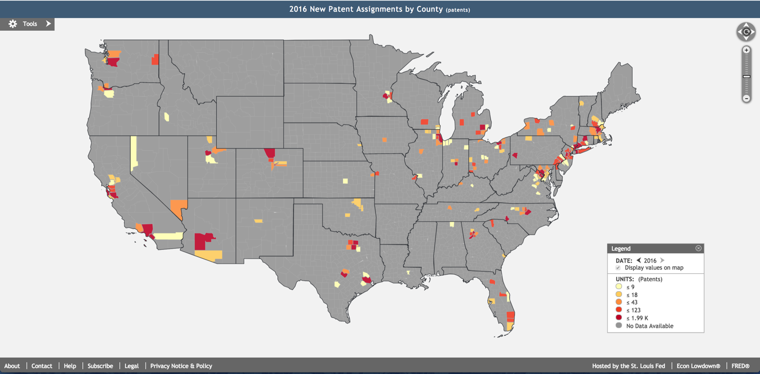

**Figure 1**: United States Map of New Patent Assignments

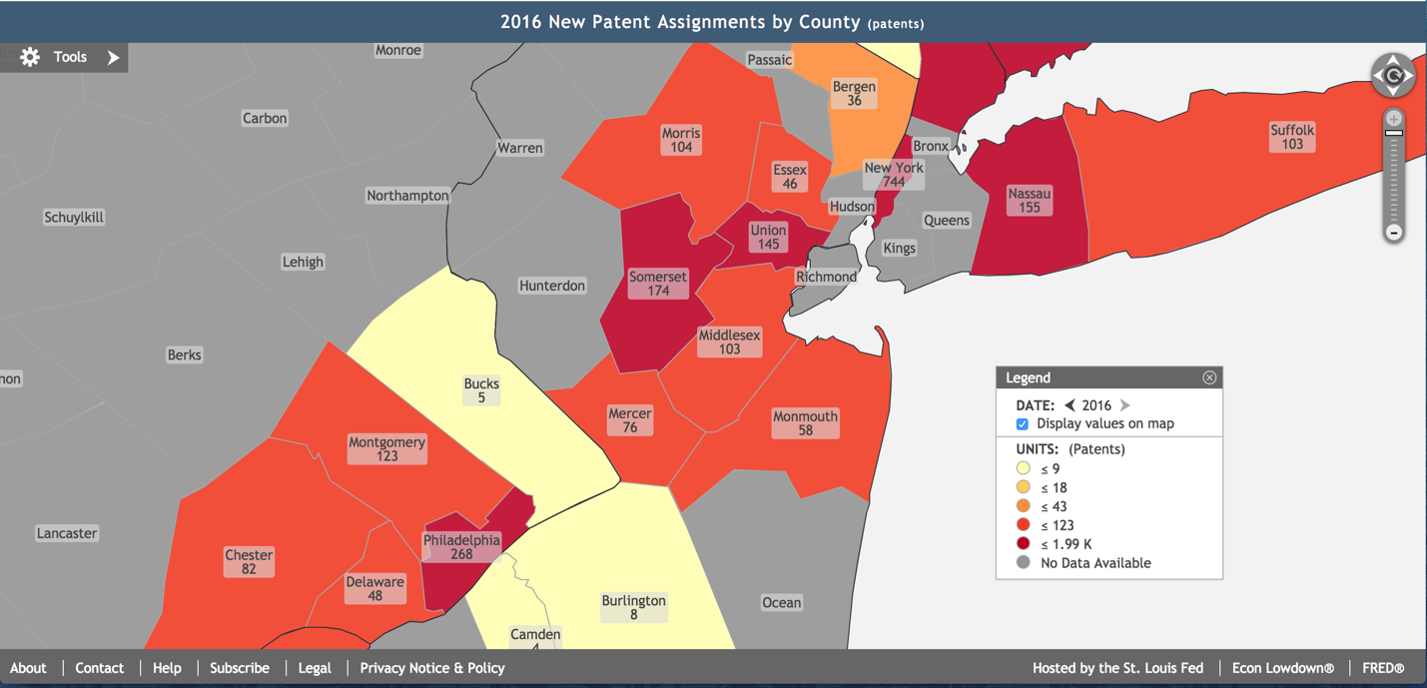

**Figure 2**: East Coast (Fragment) Map of New Patent Assignments