CHAPTER ONE
Introduction
Why Project Management?

Chapter Outline
Project Profile
Case—Development Projects that are Transforming Africa
1.1 The Importance of projects
1.2 What is a Project?
General Project Characteristics
Project Profile
President Obama Signs the Program Management Improvement and Accountability Act
1.3 Why are projects important?
Project Profile
London’s Crossrail: Europe’s Largest Construction Project
1.4 Project Life Cycles
Project Managers In Practice
Theresa Hinkler, R. Conrader Company
1.5 Determinants of Project Success
Project Management Research In Brief
Assessing Information Technology (IT) Project Success
1.6 Developing Project Management Maturity
1.7 employability skills
1.8 Project Elements and Text Organization

Summary
Key Terms
Discussion Questions
Case Study 1.1 MegaTech, Inc.
Case Study 1.2 The IT Department at Hamelin Hospital
Case Study 1.3 Disney’s Expedition Everest
Case Study 1.4 “Throwing Good Money after Bad”: the BBC’s Digital Media Initiative
Internet Exercises
PMP Certification Sample Questions
Answers
Notes

TRANSPARENCIES
Note for Instructors: To present transparencies in class, please download the PowerPoint Presentations (available on www.pearsonhighered.com) that accompanies this product. The PPT ISBN is 9780134730479.

1.1 GENERAL PROJECT CHARACTERISTICS
- Projects are ad hoc endeavors with a clear life cycle.
- Projects are building blocks in the design and execution of organizational strategies.
- Projects are responsible for the newest and most improved products, services, and organizational processes.
- Projects provide a philosophy and strategy for the management of change.
- Project management entails crossing functional and organizational boundaries.
- The traditional management functions of planning, organizing, motivation, directing, and control apply to project management.
- The principal outcomes of a project are the satisfaction of customer requirements within the constraints of technical, cost, and schedule objectives.
- Projects are terminated upon successful completion of performance objectives.

1.2 DIFFERENCES BETWEEN PROCESS AND PROJECT MANAGEMENT

Process Project

Repeat process or product New process or product
Several objectives One objective
Ongoing One shot—limited life
People are homogenous More heterogeneous
Well established systems in Systems must be created to
place to integrate efforts integrate efforts
Greater certainty of Greater uncertainty of
performance, cost, schedule performance, cost, schedule
Part of line organization Outside of line organization
Bastions of established Violates established
practice practice
Supports status quo Upsets status quo

1.3 WHY ARE PROJECTS IMPORTANT?
- Shortened product life cycles.
- Narrow product launch windows.
- Increasingly complex and technical products.
- Global markets.
- An economic period marked by low inflation.

1.4 PROJECT LIFE CYCLES

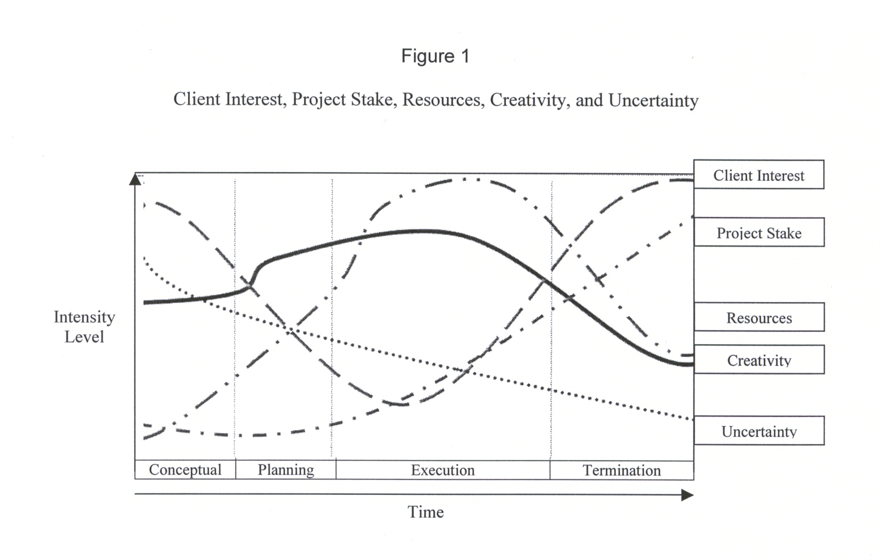
1.5 PROJECT SUCCESS—THE NEW QUADRUPLE CONSTRAINT

1.6 PROJECT MANAGEMENT MATURITY—A GENERIC MODEL

1.7 EMPLOYABILITY SKILLS
Mastering project management will contribute to key skills employers are looking for:
- Communication
- Critical Thinking
- Collaboration
- Knowledge Application and Analysis
- Business Ethics and Social Responsibility
- Information Technology Application and Computing Skills
- Data Literacy

1.8 PMBoK KNOWLEDGE AREAS

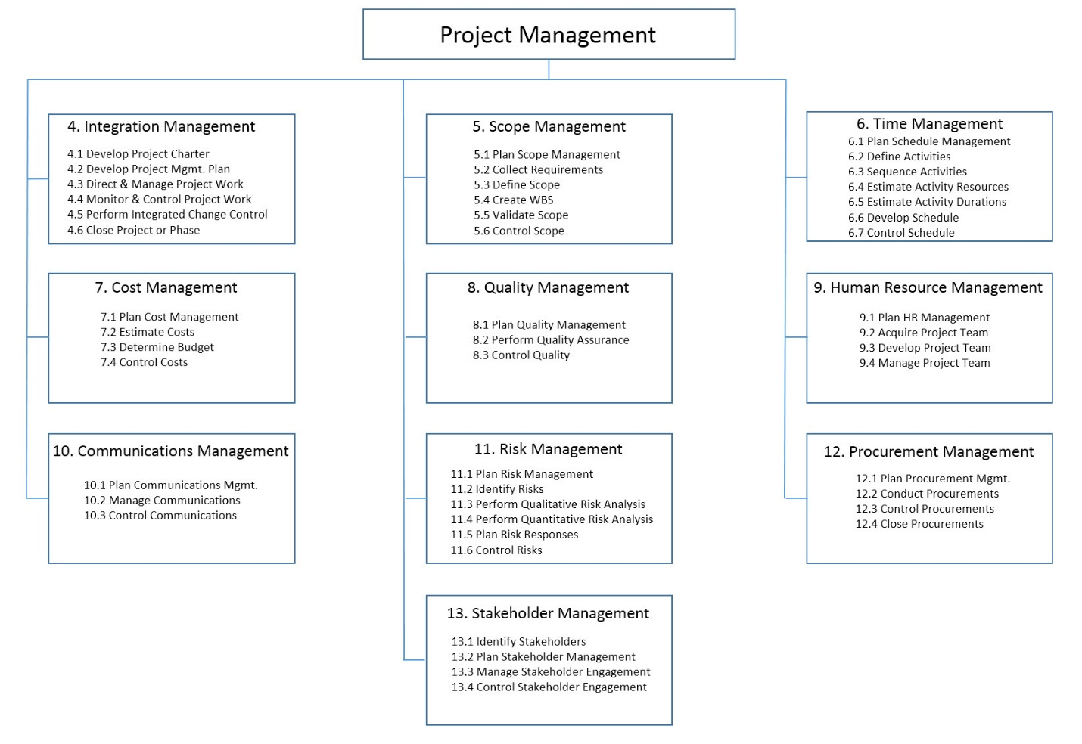

DISCUSSION QUESTIONS

1.1 What are some of the principal reasons why project management has become such a popular business tool in recent years?

In today’s market, the length of product life cycles is shortening. This means businesses are under pressure to produce new or improved products at an increasingly rapid pace. Growing global markets, consumer tastes, and competition demand that products constantly be improved to be better, faster, and sleeker and offer more features. Most organizations are planning their next product or product improvement as their latest innovation is just on its way out the door. Under conventional business practices, keeping up with this demand for innovation can be difficult. Project management offers companies a manner in which to become more innovative and to develop products at a faster pace.

1.2 What do you see as the primary challenges to introducing a project management philosophy to most organizations? That is, why is it difficult to shift to a project-based approach in many companies?

Many companies encounter a resistance to change within their personnel that makes implementing a new approach, such as project based, difficult. Employees have to be trained in the new processes and learn to implement it into their current role. Oftentimes, employees are averse to a large shift in current practices due to uncertainty of the outcome.

1.3 What are the advantages and disadvantages of using project management?

Advantages:
- Innovative, produce new ideas and new products
- Geared toward accomplishing a specific goal
- Aimed at customer satisfaction

Disadvantages:
- Inaccurate cost estimates during initial stages may cause project to fail due to lack of resources
- Low success rate in some industries
- Requires heavy commitment by staff

1.4 What key characteristics do all projects possess?

Projects:
- are temporary operations with a defined life span
- help develop and execute organizational strategies and goals
- are sources of innovation and progress
- stimulate internal collaboration between members of various functional areas
- are limited by resource and time constraints
- end when objectives are successfully reached

1.5 Describe the basic elements of the project life cycle. Why is an understanding of the life cycle relevant for our understanding of projects?

The project life cycle includes the stages of the project’s development. The basic elements of the cycle include:
- conceptualization: outlines project goal, scope of work, identifies required resources and stakeholders
- planning: specifications, timetables and other plans are created, work packages are broken out, assignments are made and process for completion is defined
- execution: actual work of project takes place, majority of teamwork is performed and, characteristically, majority of costs are incurred
- termination: project is completed and passed on to customer, resources are reassigned and team members disbanded

Life cycles provide a guiding point for determining the scope and resource requirements of specific projects. By outlining a project’s life cycle, many challenges and potential pitfalls can be pinpointed. More generally, an understanding of life cycles lends itself to a better understanding of how projects function within an organization and how they differ from conventional forms of corporate process.

1.6 Think of a successful project and an unsuccessful project with which you are familiar. What distinguishes the two, both in terms of the process used to develop them and their outcomes?

This question is intended for classes with students who have had some experience with projects in the past. It seeks to get them to examine the causes of success and failure from their own experience. Instructors should then begin developing a list of the various causes of success and failure as a point of discussion.

1.7 Consider the Expedition Everest case at the end of the chapter: what elements in Disney’s approach to developing its theme rides do you find particularly impressive? How can a firm like Disney balance the need for efficiency and smooth development of projects with the desire to be innovative and creative? Based on this case, what principles appear to guide its development process?

This case lets students comment on the particularly appealing elements in Disney’s project management approach; for example, their attention to detail and willingness not to cut corners in terms of cost or schedule to make sure that the ride offers a memorable experience. The need to balance efficiency and creativity is an interesting one because it gets to the heart of project trade-offs. There are always more trips to be taken, more time to be spent, more artifacts that can be gathered to continuously “tweak” the ride; however, ultimately, they must also adhere to a roll-out schedule that gets the project completed. How much is enough? How much is too much? These form the basis of great in-class discussions. Finally, it is important to get the class to consider other factors that must weigh into project development decisions, like safety and general appeal. For example, creating a ride that is too intense for young children would violate Disney’s “kid friendly” philosophy. Likewise, all new rides must first be completely safe for the passengers, so any design issues always must be subordinated to safety.

1.8 Consider the six criteria for successful IT projects. Why is IT project success often so difficult to assess? Make a case for some factors being more important than others.

IT project success is often difficult to assess because the criteria for success—system quality, information quality, use, user satisfaction, individual impact, and organizational impact—are not easy to accurately measure. Customer feedback related to user satisfaction, system quality, and impact may vary from user to user. For instance, while someone in insurance claims may find the system user friendly and beneficial to everyday tasks, an employee in actuary may find it cumbersome and difficult to navigate. When it comes to IT projects and the criterion above, user background, training, and experience could greatly affect the success rate of the project. These factors may not be fully known during initial planning and implementation stages.

However, criteria such as system/information quality and use may be easier to assess. The team should be able to determine whether the designed system meets the specifications of the customer. All specifications should have been determined from the beginning, so upon completion test runs should determine if the system meets quality standards. In the area of use, following implementation, in most cases, it is possible to track use. Due to their ability to be more concretely measured, these factors, combined with the overall satisfaction of the customer, may be more important in determining success of the project than other more arbitrary measures.

1.9 As organizations seek to become better at managing projects, they often engage in benchmarking with other companies in similar industries. Discuss the concept of benchmarking. What are its goals? How does benchmarking work?

Benchmarking compares the performance of a company to that of industry competitors and in some cases, for instance, where procedures or functions are similar, to that of superior performers in other industries. To set benchmarks for a company, first a leader in the industry is selected. Then, the company gathers data of that leader’s performance measures. The data is analyzed and gaps between the leader/benchmarks and the company are noted. The company then sets goals and strives to meet the benchmarking standards. The goal of benchmarking is, therefore, to seek out weak performance areas within the company and set goals for improvement.

1.10 Explain the concept of a project management maturity model. What purpose does it serve?

Implementing project management occurs in phases over time. Companies evolve through stages of project management. Project management maturity models are a way to help ensure that companies do so in the correct method and at a competitive pace. Maturity models provide a starting point for companies new to project management. Project maturity models offer businesses a way to map out necessary steps to becoming competitive through project-based work. Maturity models assess a specific company’s current practices (related to projects), establish the company’s position in relation to its competitors, and provide guidelines for improvement. They use industry data to establish a series of benchmarks. Based on industry competitors, they can then determine stages required as well as how quickly a company should develop. The company can then follow the model to achieve the highest level of ability in each pertinent project management area.

1.11 Compare and contrast the four project management maturity models shown in Table 1.3. What strengths and weaknesses do you perceive in each of the models?

The four models each use five levels beginning with an initial ad hoc or sporadic use of project management and ending with a fully integrated project management system with emphasis on innovation and continuous improvement. Other similarities among the models include an element of benchmarking or use of industry standards to measure project management performance. The models do vary on the relative pace of innovation. For instance, the ESI’s International Project Framework develops more slowly in early stages than that of Kerzner’s Project Management Maturity Model. In addition, some models focus more on learning while others are more directed at control. Kerzner’s discusses training and curriculum while SEI’s Capability Maturity Model Integration outlines steps for control and assessment of results.

Center for Business Practices

Strengths: It is mapped out at an appropriate pace; there are no broad leaps from one stage to the next. Also, it emphasized the role of project management as corporate processes, which means project management becomes part of the working firm, not just part of the job duties of a specific group or team.

Weaknesses: This model lacks direction in management training. It refers to management awareness and support, but does not mention training or formal training.

Kerzner’s Project Management Maturity Model

Strengths: Kerzner’s does a much better job of designating at what levels managers need to be trained or curriculum developed.

Weaknesses: Benchmarking does not come in until level 4, which maybe a little late. A firm in this model would have already integrated project management processes; trying to make any significant adjustments (in accordance with benchmarking figures) after this integration may be difficult.

ESI International’s Project Framework

Strengths: This model has two strong qualities. The first is its overt emphasis on innovation and continuous improvement. Secondly, the model emphasizes the need for integration and understanding throughout the firm.

Weaknesses: The movement between levels 1 through 3 may cause problems for a firm. In level 1, processes are ill-defined and have little organizational support; this changes little as the corporation moves to level 2, which has no project control processes. Then, in level 3 processes are tailored. Given the undefined nature of processes prior to level 3, it may be hard to reach this goal initially. This may cause companies to become stalled in level 3.

SEI’s Capability Maturity Model Integration

Strengths: Quality is a top concern even in early stages of this model. Analysis and insurance procedures are developed at different stages to ensure standards are met.

Weaknesses: On the other hand, the attention to testing may also hinder project management integration. There may be an overabundance of measures to control, analyze, and qualify in this system. While quality is of importance, the level of time commitment to those procedures may be the crux of this model. Team members may become frustrated with the project process if they (or their work) are constantly being measured, tested, and re-measured.

CASE STUDIES

Case Study 1.1 MegaTech, Inc.

MegaTech, Inc. is designed to highlight some of the reasons why an organization that had operated in a relatively stable and predictable environment would seek to move to an emphasis on project-based work. The trigger event, in this case is the advent of the NAFTA treaty, which opened up competition on a more price-competitive basis.

Questions

1. What is it about project management that offers MegaTech a competitive advantage in its industry?

Project management techniques will allow the firm to combine the advantages of internal efficiency with external (environmental) responsiveness. For example, it was determined that successful firms offer frequent product updates, which MegaTech’s move has allowed them to exploit. It has also promoted a team-based atmosphere that is encouraging cooperation and unity of effort among the different functional departments.

2. What elements of the marketplace in which MegaTech operates led the firm to believe that project management would improve its operations?

The intense, new competitive nature of the marketplace impels companies to find new methods for competitive advantage. With many new competitors and serious price pressure, success will require firms to be fast to market, hold the lid on costs, offer frequent upgrades and new products—all while encouraging an atmosphere of risk taking and cooperation.

Case Study 1.2 The IT Department at Hamelin Hospital

The IT Department case shows the prevalence of projects in settings that are perhaps not as obvious (in this case, a large hospital). The case is designed to get students to understand the ubiquitous nature of project-based work in our modern public and private organizations. It also demonstrates career paths and how successful work on projects is often rewarded with corporate success. Projects are not a distraction or a side-line; they are the principal means by which the IT department’s operations are demonstrated.

Questions

1. What are the benefits and drawbacks of starting most new hires at the help desk function?

Most new hires start at the help desk function, where they can become familiar with the system, learn about problem areas, become sensitive to user’s frustrations and concerns, and understand how the IT department affects all hospital operations. Students may also note that though mundane, working at the help desk forces people to “pay their dues” by demonstrating their commitment to the organization prior to being trusted with enhanced responsibilities.

2. What are the potential problems with requiring project team members to be involved in multiple projects at the same time? What are the potential advantages?

One serious disadvantage is that it stretches departmental resources very thin; people can be involved in multiple projects and are likely to start letting commitments slip if they are not careful. Also, it is often difficult to move from assignment to assignment quickly and seamlessly. Instead, team members experience times when they are not productive as they try and multitask across several projects at once. Among the advantages are that this configuration allows the project team members to work with many different people, including several project managers, experiencing different managerial styles and interpersonal relationships. It also keeps team members interest high because their involvement in multiple teams and projects ensures that they do not become bored by routine.

3. What signals does the department send by making “project manager” the highest position in the department?

The main signal is the idea that the career path for successful IT professionals runs directly through project-based work. They cannot be successful in this organization unless they are competent at first serving in and then running projects.

Case Study 1.3 Disney’s Expedition Everest

The Expedition Everest case is an example of the extreme attention to detail that Disney pays in all of their rides. Their management is a combination of careful planning coupled with the imagination and knack for visual effects for which the company is well known. The case tells the story of the development of the ride, the numerous steps Disney went through to get every detail as accurate as possible, and reflects on their overall approach to project management.

Questions

1. Suppose you were a project manager for Disney. Based on the information in this case, what do you think the company uses when designing a new ride? That is, how would you prioritize the needs for addressing project cost, schedule, quality, and client acceptance? What evidence supports your answer?

The case clearly shows that Disney makes its priorities quality and client acceptance. Given the industry they are in, they must first ensure that all their rides are safe and of the highest quality (customers expect nothing less from the Disney name). Because these issues are paramount, concerns with cost and schedule are secondary considerations. One way to see that this is the case is to consider the multiple trips that Disney Imagineers took to Nepal to gather local artifacts, check the topography, and building styles, and other steps to ensure accuracy. These come at a cost but to Disney, the overall effect is worth it.

2. Why is Disney’s attention to detail in its rides unique? How do they use the “atmosphere” discussed in the case to maximize the experience while minimizing complaints about length of wait for the ride?

Disney is interested in creating more than simply a ride; they seek to provide their customers with an experience. In order to maximize this effect, the attention to detail, including the ancillary buildings they construct and the way in which the grounds are prepared, are all designed to distract the customer from the sometime lengthy wait for the ride. The better able Disney is to develop this sense of overall atmosphere, the more their customers will find the ride memorable and their overall satisfaction with Disney will be that much higher.

Case Study 1.4 “Throwing Good Money after Bad”: the BBC’s Digital Media Initiative

The BBC’s disastrous efforts to digitize their broadcast operations resulted in a loss of millions; a system that was riddled with technical flaws, and resulted in the loss of original material and archived records. This case allows students to explore many of the causes of this disaster, occurring at a well-known organization—the British Broadcasting Corporation. This case can be used to illustrate the wide number of ways in which a project can go wrong—through poor technical support, over-optimistic estimates and the ways in which different stakeholders viewed the project, constantly assuming that the problems were due to other reasons, and not through their missteps. The case is quite comprehensive and addresses both causes of the project disaster as well as outcomes from the aftermath of the failure.

Questions

1. What does the story of the BBC’s failed Digital Media Initiative suggest to you about the importance of carefully managing not only the project, but the “message” of the project? That is, why is “benefits management” critical for project success?

This question is intended to demonstrate to students the way that project management requires us to carefully plan the project front-end, develop a coherent goal or set of goals for the project, and make sure that these goals are widely understood. One of the problems with this project was a lack of understanding of exactly what digitizing the BBC’s system would do. What were the benefits from this project? Without a clear understanding of the goals, it is impossible to craft a coherent message about its benefits, leading to misunderstandings, faulty interpretations, and finger-pointing when problems arise.

2. Successful project management requires clear organization, careful planning, and good execution. How was the absence of each of these traits shown in this example?

The BBC Digital Media case offers great examples of the need to carefully organize a variety of different groups and teams, including contractors and other stakeholders, to ensure that everyone is working toward the same goals. The missteps and technological failures of the project illustrate the need to manage not only the core technologies of the project but all relationships among members of the larger project team. Once the problems started occurring, the project organization also failed to effectively manage the message to the larger public, insisting the technology was fine in the face of multiple examples of failure. All in all, this is a great case example illustrating why project management is such a challenge and the myriad issues and groups that effective leaders must manage for project success.

