CHAPTER
1

Patterns of Motion and Equilibrium

1.1 Aristotle on Motion
1.2 Galileo’s Concept of Inertia
1.3 Mass—A Measure of Inertia
One Kilogram Weighs 10 Newtons
1.4 Net Force
1.5 The Equilibrium Rule
1.6 Support Force
Dynamic Equilbrium
1.7 The Force of Friction
1.8 Speed and Velocity
Instantaneous Speed
Average Speed
Velocity
Motion Is Relative
1.9 Acceleration
Demonstration Equipment
- Coat hanger and clay blobs
- Wooden block stapled to a piece of cloth (to simulate table-cloth pull)
- Tablecloth (without a hem) and a few dishes (for the table-cloth pull)
- Piece of rope for a classroom tug-of-war

Kinematics is the study of motion without regard to the forces that produce it. It is interesting to note that no laws of physics occur in kinematics. When forces are considered, the study is then of dynamics, of which Newton’s laws are central. One of the great follies of physics instruction is overtime on kinematics. Whereas many physics and physical science books begin with a chapter on kinematics, such is downplayed in this book. Only the amount of kinematics that is needed is blended into this and the following chapter. As such, please do not focus undue attention to the concepts of speed, velocity, and acceleration. And please spare your students graphical analysis of these topics, which is better left to a math class or a follow-up physics course. Mastering motion graphs is more of an uphill task than getting a grip on the concepts themselves (but try telling that to a teacher who has a passion for graphical analysis!). The concepts of speed, velocity, and acceleration are introduced in this chapter, and they continue in the following mechanics chapters anyway—when your students are better prepared. Too-early emphasis on these topics can bog a course down at the outset. So lightly treat the sections on speed, velocity, and acceleration—then move as smoothly as you can to where the meat is—the next chapter on Newton’s laws of motion.
Of particular interest is the Paul Hewitt Personal Essay in the chapter, which relates to events that inspired him to pursue a life in physics—his meeting with Burl Grey on the sign-painting stages of Miami, Florida. Relative tensions in supporting cables is what first caught his interest in physics, and he hopes to instill the same interest with your students with this chapter.
So force, rather than kinematics, begins this book. And force vectors, only parallel ones at this point, are the easiest to understand. They underlie the equilibrium rule: ΣF = 0 for systems in equilibrium. These are further developed in the Practice Book. (Not using the Practice Book is like teaching swimming away from water. This is an important book—the authors’ most imaginative and pedagogically useful tool for student learning!)
Note that in introducing force we first use pounds—most familiar to your students. A quick transition, without fanfare, introduces the newton. We don’t make units a big deal and don’t get into the laborious task of unit conversions, which is more appropriate for physics majors.
A brief treatment of units and systems of measurement are provided in the lab manual.
If you get into motion you can consider the Sonic Ranger lab, which uses a sonar ranging device to plot in real time the motion of students, rolling ball, or whatever. This lab can be intriguing, so be careful that it doesn’t swallow too much time. Again, overtime on kinematics is the black hole of physics teaching!

In the Practice Book:
- The Equilibrium Rule: ΣF = 0
- Free Fall Speed
- Acceleration of Free Fall

Next-Time Questions on the IRDVD:
- Pellet in the Spiral
- Ball Swing

In the Lab Manual:
- Walking the Plank
- Go! Go! Go! (experiment on graphing motion)
- Sonic Ranger (activity on graphing motion)

Screencasts:
- Equilibrium Rule
- Equilibrium Problems
- Linear Motion Definitions
- Bikes and Bee Problem
- Unit Conversion
- Velocity Vectors
- Free Fall
SUGGESTED PRESENTATION
Begin by holding up the textbook and remarking on its vast amount of information. A look at the table of contents shows there is much to cover. Whereas some material will be covered in depth, some will not. State that they will come to feel quite comfortable with an understanding of much of the content, but not all. There isn’t time for a thorough treatment of all material. So rather than bogging down at the beginning of your course and end up racing over material at the term’s end, you’re going to do it the other way around, and race through this beginning chapter. Rather than tilling this soil with a deep plow setting, you’re going to skim it and dig in later (this will help you avoid the “black hole” of physics—overtime on kinematics!).
Your first question: What means of motion has done more to change the way cities are built than any other? [Answer: The elevator!]
Explain the importance of simplifying. That motion, for example, is best understood by first neglecting the effects of air resistance, buoyancy, spin, and the shape of the moving object. Beneath these factors are simple relationships that may otherwise be masked. So you’ll concentrate on simple cases and avoid complexities. State that you’re not trying to challenge them, but to teach them some of the physical science that you yourself have learned. Better they understand a simple case than be miffed by a complicated one that less clearly focuses on the main concept being treated.
Aristotle’s Classification of Motion
Briefly discuss Aristotle’s views on motion. His views were a good beginning for his time. They were flawed from the point of view of what we know today, but his efforts to classify all things, motion being one of them, was a boost in human thinking. Perhaps we remember him unfairly much for his errors, when in total, he did much to shape good thinking in his time.
Galileo’s Concept of Inertia
Acknowledge the chief difference with Aristotle’s approach and that of Galileo. The big difference between these two giant intellects, was the role of experiment—emphasized by Galileo. The legendary experiment at the Leaning Tower of Pisa is a good example. Interestingly, legend has it that many people who saw the falling objects fall together continued to teach otherwise. Seeing is not always believing. Ideas that are firmly established in one’s thinking are difficult to change. People in science must be prepared to have their thinking challenged often.
Point to an object in the room and state that if it started moving, one would reasonably look for a cause for its motion. We would say that a force of some kind was responsible, and that would seem reasonable. By force, you mean quite simply, a push or a pull. Tie this idea to the notion of force maintaining motion as Aristotle saw it. State that a cannonball remains at rest in the cannon until a force is applied, and that the force of expanding gases drives the ball out of the barrel when it is fired. But what keeps the cannonball moving when the gases no longer act on it? Galileo wondered about the same question when a ball gained speed in rolling down an incline, but moved at constant speed on a level surface. This leads you into a discussion of inertia. In the everyday sense, inertia refers to a habit or a rut. In physics it’s another word for laziness, or the resistance to change as far as the state of motion of an object is concerned. Inertia was first introduced not by Newton, but by Galileo as a result of his inclined-plane experiments. You’ll return to this concept when Newton’s first law is treated in the following chapter.
How much inertia an object has is related to the amount of mass the object has. Mass is a measure of the amount of material in an object. Weight is the gravitational attraction of the Earth for this amount of material. Whereas mass is basic, weight depends on location. You’d weigh a lot more on Jupiter than on Earth, and a lot less on the surface of the Moon. Mass and weight are proportional, hence they are often confused.
Mass is sometime confused with volume. Comparing an overstuffed fluffy pillow to a small automobile battery should convince anyone that mass and volume are different. The unit of mass is the kilogram, and the unit of volume is cubic meters or liters.
Mass Versus Weight
To distinguish between mass and weight compare the efforts of pushing horizontally on a block of slippery ice on a frozen pond versus lifting it. Or consider the weightlessness of a massive anvil in outer space and how it would be difficult to shake. And if moving toward you, it would be harmful to be in its way because of its great tendency to remain in motion. The following demo (often used to illustrate impulse and momentum) makes the distinction nicely:

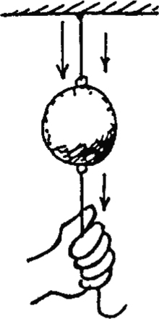
DEMONSTRATION: Hang a massive ball by a string and show that the top string breaks when the bottom is pulled with gradually more force, but the bottom string breaks when the string is jerked. Ask which of these cases illustrates weight. [Interestingly enough, it’s the weight of the ball that makes for the greater tension in the top string.] Then ask which of these cases illustrates inertia. [When jerked, the tendency of the ball to resist the sudden downward acceleration, its inertia, is responsible for the lower string breaking.] This is the best demo we know of for showing the different effects of weight and mass.
One Kilogram Weighs 10 Newtons
Suspend a 1-kilogram mass from a spring scale and show that it weighs about 10 N (which more accurately, in lab perhaps, is 9.8 N).
Units of Force—Newtons
I suggest not making a big deal about the unfamiliar unit of force—the newton. I simply state it is the unit of force used by physicists, and if students find themselves uncomfortable with it, simply think of “pounds” in its place. Relative magnitudes, rather than actual magnitudes, are the emphasis of conceptual physical science anyway. Do as my mentor Burl Grey does in Figure 1.11 and suspend a familiar mass from a spring scale. If the mass is a kilogram and the scale is calibrated in newtons, it will read nearly 10 N. If the scale is calibrated in pounds, it will read 2.2 pounds. State that you’re not going to waste valuable time in unit conversions (students can do enough of that in one of those dull physics courses they’ve heard about).
CHECK YOUR NEIGHBOR: Which has more mass, a 1-kg stone or a 1-lb stone?
[A 1-kg stone has more mass, for it weighs 2.2 lb. But we’re not going to make a fuss about such conversions. If the units newtons bug you, think of it as a unit of force or weight in a foreign language for now!]
Net Force
Discuss the idea of more than one force acting on something, and the resulting net force. Figure 1.10 captures the essence. Here’s where you can introduce vectors. Note the forces in the figure are represented by arrows. Drawn to scale, these are vectors. Briefly distinguish between vector quantities (like force, velocity, and as we shall see, acceleration) and scalar quantities (time, mass, volume).
Equilibrium for Objects at Rest
Cite other static examples, where the net force is zero as evidenced by no changes in motion. Hold the 1-kg mass at rest in your hand and ask how much net force acts on it. Be sure they distinguish between the 10 N gravitational force on the object and the zero net force on it—as evidenced by its state of rest. (The concept of acceleration is introduced shortly.) When suspended by the spring scale, point out that the scale is pulling up on the object, with just as much force as the Earth pulls down on it. Pretend to step on a bathroom scale. Ask how much gravity is pulling on you. This is evident by the scale reading. Then ask what the net force is that acts on you. This is evident by your absence of motion change. Consider two scales, one foot on each, and ask how each scale would read. Then ask how the scales would read if you shifted your weight more on one scale than the other. Ask if there is a rule to guide the answers to these questions. There is: ΣF = 0. For any object in equilibrium, the net force on it must be zero. Before answering, consider the skit in Paul Hewitt Personal Essay.
Signpainter Skit: Draw on the board the sketch below, which shows two painters on a painting rig suspended by two ropes.
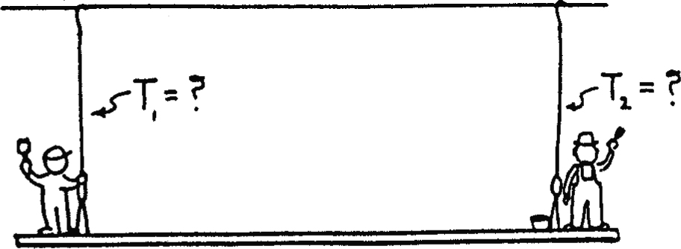
Step 1: If both painters have the same weight and each stands next to a rope, the supporting force in the ropes will be equal. If spring scales were used, one on each rope, the forces in the ropes would be evident. Ask what the scale readings in each rope would be in this case. [The answer is each rope will support the weight of one man + half the weight of the rig—both scales will show equal readings.]
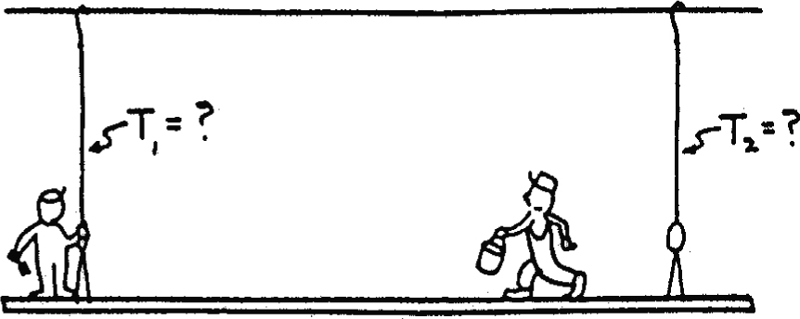
Step 2: Suppose one painter walks toward the other as shown in the sketch, which you draw on the chalkboard (or show via overhead projector). Will the reading in the left rope increase? Will the reading in the right rope decrease? Grand question: Will the reading in the left rope increase exactly as much as the decrease in tension in the right rope? And if so, how does either rope “know” about the change in the other rope? After neighbor discussion, be sure to emphasize that the answers to these questions lie in the framework of the Equilibrium Rule: ΣF = 0. Since there is no change in motion, the net force must be zero, which means the upward support forces supplied by the ropes must add up to the downward force of gravity on the two men and the rig. So a decrease in one rope must necessarily be met with a corresponding increase in the other. (This example is dear to Paul’s heart. Both Burl and Paul didn’t know the answer way back then—because neither Paul nor Burl had a model for analyzing the problem. We didn’t know about Newton’s first law and the Equilibrium Rule. How different one’s thinking is depends on whether there is a model or guidance. If Burl and Paul had been mystical in their thinking, they might have been more concerned with how each rope “knows” about the condition of the other. This is the approach that intrigues many people with a nonscientific view of the world.)
The Support Force (Normal Force)
Ask what forces act on a book at rest on your lecture table. Then discuss Figure 1.13, explaining that the atoms in the table behave like tiny springs. This upward support force is equal and opposite to the weight of the book, as evidenced by the book’s state of rest. The support force is a very real force. Because it is always perpendicular to the surface, it is called a normal force. Without it, the book would be in a state of free fall.
Friction—A Force That Affects Motion
Drag a block at constant velocity across your lecture table. Acknowledge the force of friction, and how it must exactly counter your pulling force. Show the pulling force with a spring balance, keeping it horizontal as you pull horizontally. Now since the block moves without accelerating, ask for the magnitude of the friction force. It must be equal and opposite to your scale reading. Then the net force is zero. While sliding, the block is in dynamic equilibrium. That is, ΣF = 0.
Equilibrium for Moving Things
If you’re in the car of a smoothly moving train and you balance a deck of cards on a table, they are in equilibrium whether the train is in motion or not. If there is no change in motion (acceleration), the cards don’t “know the difference.”
Speed and Velocity
Define speed, writing its equation in longhand form on the board while giving examples—automobile speedometers, etc. Similarly define velocity, citing how a racecar driver is interested in his speed, whereas an airplane pilot is interested in her velocity—speed and direction.
Motion Is Relative
Acknowledge that motion is relative to a frame of reference. When walking down the aisle of a train at 1 m/s, your speed relative to the floor of the train is different than your speed relative to the ground. If the train is moving at 50 m/s, then your speed relative to the ground is 51 m/s if you’re walking forward, or 49 m/s if you’re walking toward the rear of the train. Tell your class that you’re not going to make a big deal about distinguishing between speed and velocity, but you are going to make a big deal of distinguishing between speed or velocity and another concept—acceleration.
Galileo and Acceleration
Define acceleration, identifying it as a vector quantity, and cite the importance of CHANGE. That’s change in speed, or change in direction. Hence both are acknowledged by defining acceleration as a rate of change in velocity rather than speed. Ask your students to identify the three controls in an automobile that enable the vehicle to change its state of motion—that produce acceleration (accelerator, brakes, and steering wheel). State how one lurches in a vehicle that is undergoing acceleration, especially for circular motion, and state why the definition of velocity includes direction to make the definition of acceleration all-encompassing. Talk of how without lurching one cannot sense motion, giving examples of coin flipping in a high-speed aircraft versus doing the same when the same aircraft is at rest on the runway.
Units for Acceleration
Give numerical examples of acceleration in units of kilometers/hour per second to establish the idea of acceleration. Be sure that your students are working on the examples with you. For example, ask them to find the acceleration of a car that goes from rest to 100 km/h in 10 seconds. It is important that you not use examples involving seconds twice until they taste success with the easier kilometers/hour per second examples. Have them check their work with their neighbors as you go along. Only after they get the hang of it, introduce meters/second/second in your examples to develop a sense for the units m/s².
Falling Objects
Round off 9.8 m/s² to 10 m/s² in your discussions and you’ll more easily establish the relationships between velocity and distance. In lab you can then move to the more precise
9.8 m/s², if more precision is wanted.
CHECK YOUR NEIGHBOR: If an object is dropped from an initial position of rest from the top of a cliff, how fast will it be traveling at the end of one second? (You might add, “Write the answer on your notepaper.” And then, “Look at your neighbor’s paper—if your neighbor doesn’t have the right answer, reach over and help him or her—talk about it.”)
After explaining the answer when class discussion dies down, repeat the process asking for the speed at the end of 2 seconds, and then for 10 seconds. This leads you into stating the relationship v = gt, which by now you can express in shorthand notation. After any questions, discussion, and examples, state that you are going to pose a different question—not asking for how fast, but for how far. Ask how far the object falls in one second.
Ask for a written response and then ask if the students could explain to their neighbors why the distance is only 5 m rather than 10 m. After they’ve discussed this for almost a minute or so, ask “If you maintain a speed of 60 km/h for one hour, how far do you go?”—then, “If you maintain a speed of 10 m/s for one second, how far do you go?” Important point: Respect the idea of “wait-time.” You’ll appreciably improve your instruction if you allow some thinking time after you ask a question. Not doing so is the folly of too many teachers. Then continue, “Then why is the answer to the first question not 10 meters?” After a few seconds, stress the idea of average velocity and the relation d = vt.
For accelerating objects that start from a rest position, the average velocity is half the final velocity (average velocity = [initial velocity + final velocity]/2).
CHECK YOUR NEIGHBOR: How far will a freely falling object that is released from rest fall in 2 seconds? In 10 seconds? (When your class is comfortable with this, then ask how far in ½ second.)
Investigate Figure 1.23 and have students complete the speed readings. Ask what odometer readings (that measure distance) would be for the speeds shown. To avoid information overload, we restrict all numerical examples of free fall to cases that begin at rest. Why? Because it’s simpler that way. (We prefer our students understand simple physics than be confused about not-so-simple physics!) We do go this far with them.
Two-Track Demo
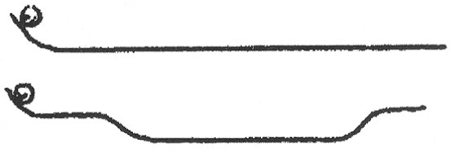
Look ahead at the two tracks shown at the end of the chapter, Discussion Question 107. With your hand hold both balls at the top end of the tracks and ask which will get to the end first. Or you can quip, which will win the race, the slow one or the fast one? Or, the one with the greatest average speed or the one with the smaller average speed? When asked these last two ways, the question guides the answer. But be ready to find that most students will intuitively know the balls will reach the end with the same speed (this is more obvious from a conservation of momentum point of view). But the question is not of speed, but of time—which gets there first. And that’s a challenge—to realize that! The speed gained by the ball on the lower part of the dipped track is lost coming up the other side, so, yes, they reach the end with the same speed. But the gained speed at the bottom of the dip means more average speed overall. You’ll get a lot of discussion on this one. You can make your own tracks quite simply. I got this idea from my friend and colleague, Chelcie Liu, who simply bought a pair of equal length bookcase supports and bent them by hand. They are more easily bent with the aid of a vice.
Hang Time
This fascinating idea completes the chapter. Most students (and other instructors!) are amazed that the best athletes cannot remain airborne for a second in a standing jump. Great class discussion. You can challenge your students by saying you’ll award an A to any student who can do a 1-second standing jump! You’ll have takers; but you’ll award no A’s for this feat.
The Instructor Resource DVD
That you are reading this is evidence that you possess the Instructor Resource DVD for this 6th edition of Conceptual Physical Science. Perchance that you don’t have this very important aid in your teaching, you acquire it via the website: pearsonhighered.com. Click on the button “Find your Rep” and follow the prompts. On this IRDVD is much of “the life” of the authors— PowerPoint Lectures, Test Bank, Next-Time Questions, Clicker Questions, and much much more.

