Chapter 1 Limits and Continuity

1.1 Examples of Velocity, Growth Rate, and Area

1) An object moves along the x-axis so that at time t seconds (where t ≥ 0) it is x = 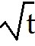 m to the right of the origin. By calculating the average velocity of the object over time intervals [4, 4 + h] for
h = 0.1, h = 0.01, h = 0.001, and h = 0.0001, determine the velocity of the particle at time t = 4s.
A) 0.2499 m/s
B) 0.2498 m/s
C) 0.2485 m/s
D) 0.2000 m/s
E) 0.2501 m/s
Answer: A
Diff: 1

2) An object moves along the x-axis so that its velocity at time t seconds is v(t) = 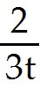 m/s. What is the average acceleration (i.e., average rate of change of the velocity) of the object over the time interval
[2, 2 + h]? What is the acceleration of the object at time t = 2s?
A) - 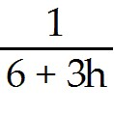 m/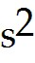, - 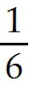 m/
B) 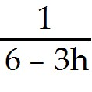 m/, m/
C) 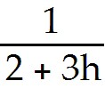 m/, 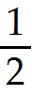 m/
D) - m/, - m/
E) 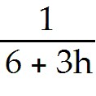 m/, m/
Answer: A
Diff: 1
3) The temperature of an object at time t minutes is 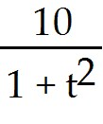 degrees. What is the rate of change of the temperature over the time interval [t, t + h]? How fast is the temperature changing at t = 1?
A) 10 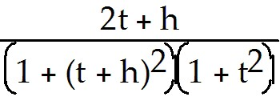 degrees/minute, increasing at 5 degrees/minute
B) -10 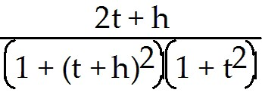 degrees/minute, decreasing at 5 degrees/minute
C) 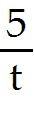 degrees/minute, increasing at 5 degrees/minute
D) -10 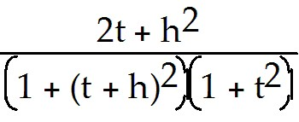 degrees/minute, decreasing at 5 degrees/minute
E) 10 degrees/minute, decreasing at 5 degrees/minute
Answer: B
Diff: 1

4) In the following figure the curve is the graph of a quantity y that is a function of time t. Also shown is its tangent line at t = 100. What is the average rate of change of y from t = 20 to t = 160? What is the approximate rate of change of y with respect to t at t = 100?

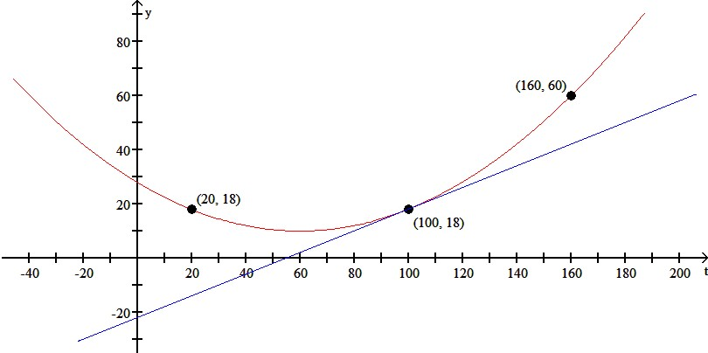
A) 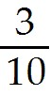, 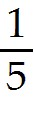
B) , 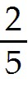
C) 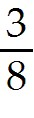,
D) 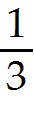, 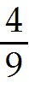
E) none of the above
Answer: B
Diff: 3

1.2 Limits of Functions

1) Evaluate the following limits:
(i) 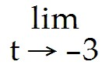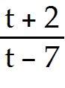
(ii) 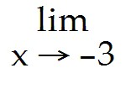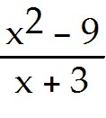
A) (i) 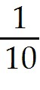 (ii) -6
B) (i) 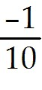 (ii) 6
C) (i) 1 (ii) 1
D) (i) 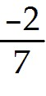 (ii) does not exist
E) (i) (ii) does not exist
Answer: A
Diff: 1

2) Find the limit of f(x) as x approaches 2 if f is defined by
f(x) = 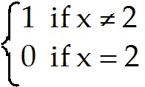
A) 1
B) 2
C) 3
D) 0
E) does not exist
Answer: A
Diff: 1

3) Evaluate 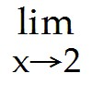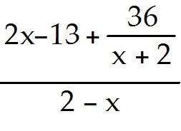.
A) 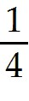
B) 0
C) 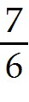
D) -
E) - ∞
Answer: A
Diff: 2

4) Evaluate 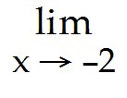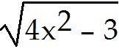.
A) 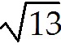
B) 2 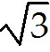
C) 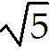
D) 4
E) does not exist
Answer: A
Diff: 1

5) Evaluate 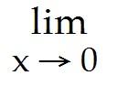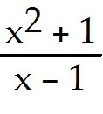.
A) 1
B) 0
C) -1
D) -2
E) does not exist
Answer: C
Diff: 1

6) Evaluate 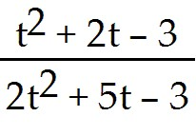.
A) 4/7
B) 2/5
C) 0
D) 1/2
E) does not exist
Answer: A
Diff: 2

7) Evaluate 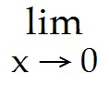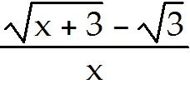.
A) 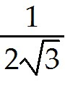
B) 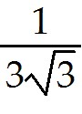
C) 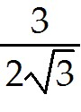
D) 0
E) does not exist
Answer: A
Diff: 2
8) Evaluate 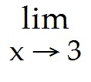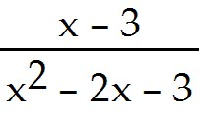.
A)
B) 0
C) 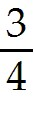
D) -
E) does not exist
Answer: A
Diff: 2

9) If 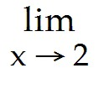 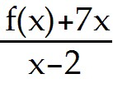 = - 5, find f(x).
A) 14
B) - 14
C) 0
D) ∞
E) - 19
Answer: B
Diff: 2

10) Evaluate 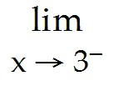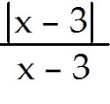.
A) -1
B) -2
C) 1
D) 0
E) does not exist
Answer: A
Diff: 2

11) Let f(x) = 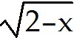 and g(x) =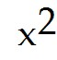 - 2. Which of the following is true?
A) 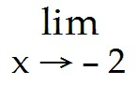f 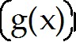 = 0
B) g 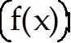 = -2
C) 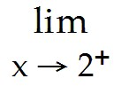f = 0
D) g = -2
E) 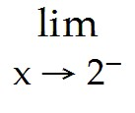g = -2
Answer: E
Diff: 2
12) Evaluate 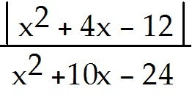.
A) - 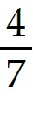
B) -2
C) 1
D)
E)
Answer: A
Diff: 2

13) Evaluate 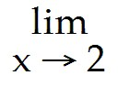 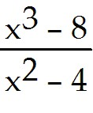.
A) 3
B) 1
C) 4
D) 0
E) does not exist
Answer: A
Diff: 2

14) Evaluate 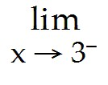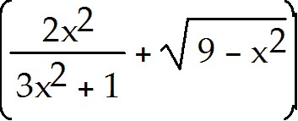.
A) 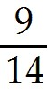
B)
C) 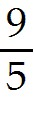
D) ∞
E) does not exist
Answer: A
Diff: 1
15) Find the following limit:
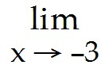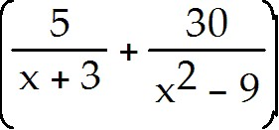.
A) - 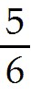
B)
C)
D) -
E) does not exist
Answer: A
Diff: 3

16) Evaluate 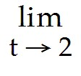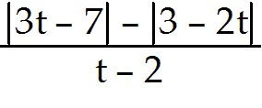.
A) - 5
B) 2
C) 5
D) - ∞
E) - 3
Answer: A
Diff: 2

17) Evaluate 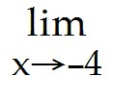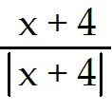.
A) -1
B) 1
C) 4
D) ±1
E) does not exist
Answer: E
Diff: 2

18) Evaluate 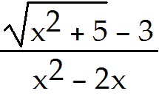.
A)
B)
C) 1
D) 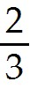
E) does not exist
Answer: A
Diff: 3
19) Let f(x) = 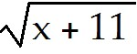 and g(x) = 14 - 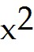. Compute 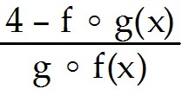.
A) -
B) 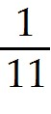
C) - 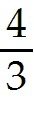
D)
E)
Answer: A
Diff: 3

20) If 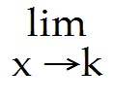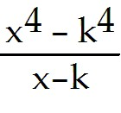 = -32, find k.
Answer: First observe that 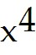 - 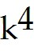 = ( -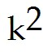 )( + ) = (x - k)(x + k)( + )
Hence,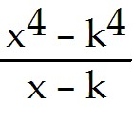 = 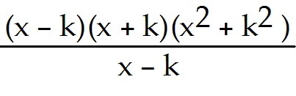 = (x + k)( + ) = (2k)(2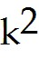) = 4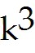
Now 4 = -32 ⇒ = -8 , therefore k = 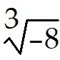 = -2.
Diff: 3

21) Evaluate 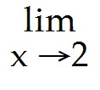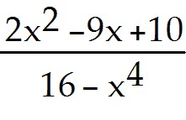.
A) - ∞
B) - 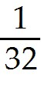
C) 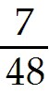
D)
E) 0
Answer: D
Diff: 2
22) Evaluate 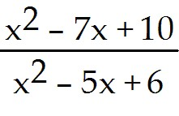.
A) 3
B) -3
C) 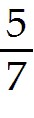
D) 1
E) does not exist
Answer: A
Diff: 2

23) Evaluate the following limit:
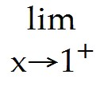x + 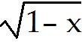.
A) 0
B) 1
C) 2
D) -1
E) does not exist
Answer: E
Diff: 2

24) Evaluate the following limit:
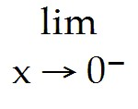x 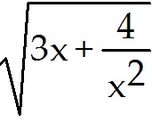.
A) -2
B) 0
C) 2
D) -1
E) does not exist
Answer: A
Diff: 3

25) Compute the following limit: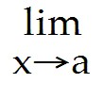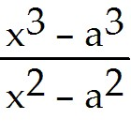.
A) 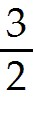a
B) a
C) - a
D)
E) does not exist
Answer: A
Diff: 2
26) True or False: If 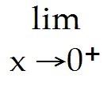f(x) = A and 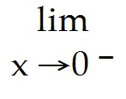f(x) = B, where A ≠ B,
then f 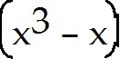 = B.
Answer: FALSE
Diff: 2

27) True or False: If 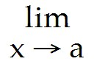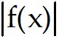 = , then f(x) = L.
Answer: FALSE
Diff: 2

28) True or False: If f(x) = L, then 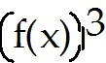 = 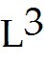.
Answer: TRUE
Diff: 2

29) True or False: If f(x) = L, then 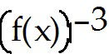 = 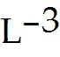.
Answer: FALSE
Diff: 2

1.3 Limits at Infinity and Infinite Limits

1) Evaluate 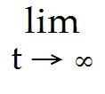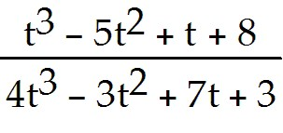.
A)
B) -
C) -
D) 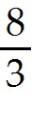
E) does not exist
Answer: A
Diff: 1
2) Evaluate 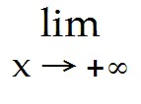(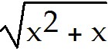 - x).
A)
B)
C) -
D) -
E) does not exist
Answer: A
Diff: 2

3) Evaluate 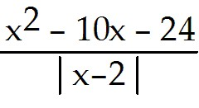.
A) +∞
B) 14
C) -∞
D) -14
E) 0
Answer: C
Diff: 1

4) Let g(x) = 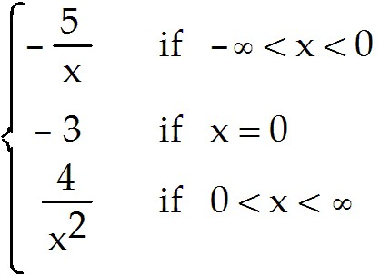 .
Evaluate g(x).
A) ∞
B) -3
C) -∞
D) 1
E) none of the above
Answer: A
Diff: 1

5) Evaluate 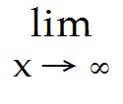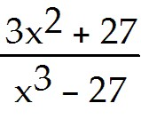.
A) 0
B) 1
C) ∞
D) -1
E) 3
Answer: A
Diff: 2
6) Evaluate 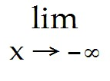(3 -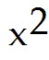 + x - 7).
A) -∞
B) 0
C) 1
D) ∞
E) none of the above
Answer: D
Diff: 2

7) True or False: If f and g are functions such that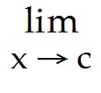f(x) = - ∞ and g(x) = - ∞, then
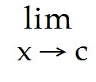[f(x) - g(x)] = 0.
Answer: FALSE
Diff: 1

8) Evaluate 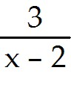.
A) ∞
B) -∞
C) 1
D) 0
E) does not exist
Answer: E
Diff: 2

9) Find all values of the real number k so that 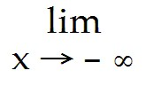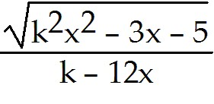 = .
A) 0
B) -
C) ±
D) ± 3
E) -3
Answer: D
Diff: 2
10) Evaluate 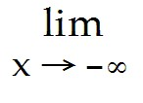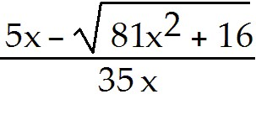.
A)
B) 0
C) +∞
D) -
E) -∞
Answer: A
Diff: 3

11) Find 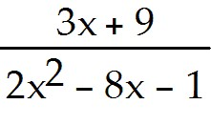.
A) 0
B) ∞
C)
D) 2
E) does not exist
Answer: A
Diff: 2

12) Evaluate 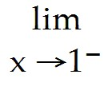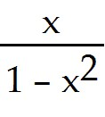.
A) 0
B) 1
C) -1
D) ∞
E) -∞
Answer: D
Diff: 2

13) Let f(x) = 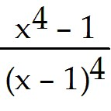. Find 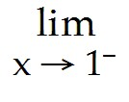f(x).
A) +∞
B) 0
C) 1
D) -∞
E) -1
Answer: D
Diff: 2
14) Find the limit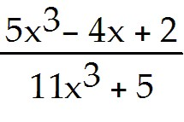.
A) - 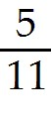
B)
C)
D)
E) does not exist
Answer: D
Diff: 2

15) Evaluate 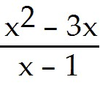.
A) 1
B) -∞
C) ∞
D) 0
E) none of the above
Answer: C
Diff: 3

16) Evaluate 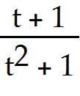.
A) 1
B) 0
C) -1
D) 2
E) does not exist
Answer: B
Diff: 3

17) Evaluate 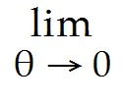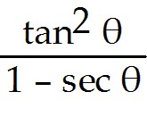.
A) -2
B) -1
C) 0
D) 2
E) does not exist
Answer: A
Diff: 3
18) Evaluate 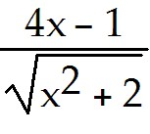.
A) -4
B) 2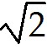
C) 4
D) -2
E) does not exist
Answer: A
Diff: 3

19) Evaluate 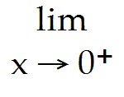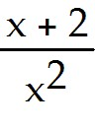.
A) ∞
B) -∞
C) 1
D) -1
E) 2
Answer: A
Diff: 3

20) Evaluate 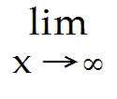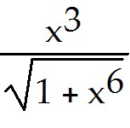.
A) ∞
B) 0
C) 1
D) -1
E) 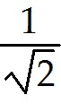
Answer: C
Diff: 3

21) Evaluate 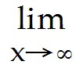 sin x.
A) ∞
B) -∞
C) 0
D) 1
E) does not exist
Answer: E
Diff: 3
22) Evaluate .
A) ∞
B) 1
C) -∞
D) -1
E) 2
Answer: A
Diff: 2

23) Evaluate 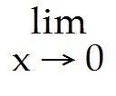.
A) ∞
B) 1
C) 0
D) -∞
E) 2
Answer: A
Diff: 2

24) Evaluate 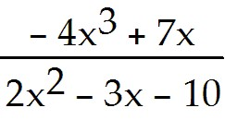.
A) ∞
B) -∞
C) 0
D) -1
E) -2
Answer: A
Diff: 3

25) Evaluate 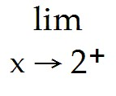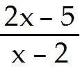.
A) ∞
B) -∞
C) 2
D) - 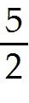
E) none of the above
Answer: B
Diff: 3
26) Evaluate 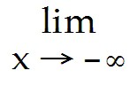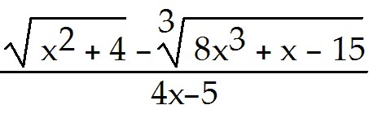.
A) -
B) +∞
C) -
D) 0
E) -
Answer: A
Diff: 3

27) Evaluate 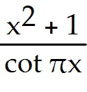.
A) ∞
B) -2
C) 0
D) -∞
E) π
Answer: D
Diff: 2

28) Evaluate 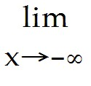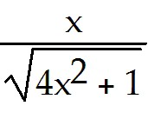.
A) -2
B)
C) 0
D) -
E) does not exist
Answer: D
Diff: 2

29) Evaluate 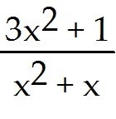.
A) -3
B) 3
C) 1
D) -1
E) does not exist
Answer: B
Diff: 2
30) Evaluate 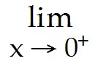(2 tan x + 3 cot x).
A) 3
B) 2
C) ∞
D) -∞
E) 5
Answer: C
Diff: 3

31) Given that 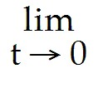 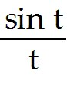 = 1, evaluate (5 + 7x - 3) sin 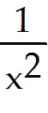.
A) 5
B) 7
C) 0
D) -3
E) does not exist
Answer: A
Diff: 3

32) Given that 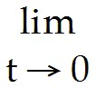 = 1, evaluate 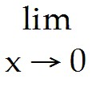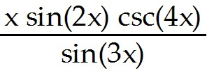.
A)
B) 0
C)
D)
E) does not exist
Answer: A
Diff: 3

33) True or False: If f(x) = ∞, then f(x) does not exist.
Answer: TRUE
Diff: 3

34) True or False: If f(x) = 0, then 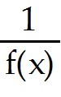 = ∞
Answer: FALSE
Diff: 3

35) True or False: If 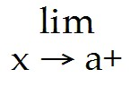f(x) = 0, then 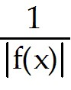 = ∞
Answer: FALSE
Diff: 3
1.4 Continuity

1) Courier rates for delivery of mail up to 200 g are given in the following chart:

Draw the graph of the cost (in dollars) of mailing a letter as a function of its mass (in grams). Where are the discontinuities of this function? Is the cost function right or left continuous at these points?
A) discontinuous at 30, 50, 100; left but not right continuous there
B) discontinuous at 30, 50, 100; right but not left continuous there
C) discontinuous at 30, 50, 100; neither left nor right continuous there
D) There are no discontinuities.
E) discontinuous at 30, 50, 100; right continuous at 30 and 50, left continuous at 100
Answer: A
Diff: 1

2) Let g(x) = 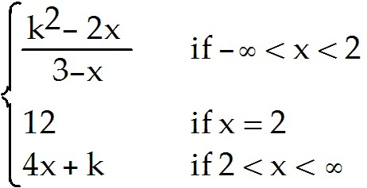

where k is a constant real number. If g has a removable discontinuity at x = 2, then k is equal to:
A) -3
B) 4
C) ±4
D) 3
E) -4 or 3
Answer: A
Diff: 3

3) Let f(x) be defined by

f(x) = 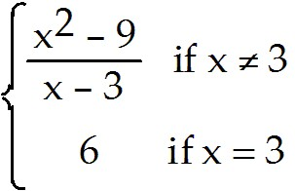 Where, if anywhere, is f discontinuous?
A) at x = 0
B) at x = 3
C) nowhere
D) at x = -3
E) at x = 6
Answer: C
Diff: 2
4) Is the function f(x) = 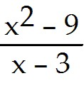 discontinuous at any point of its domain? Would your answer change if we also define f(3) = 6?
A) no, yes
B) yes, yes
C) no, no
D) yes, no
E) none of the above
Answer: B
Diff: 2

5) True or False: If h(x) = 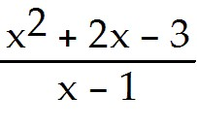 if x ≠ 1 and h(1) = 4, then h is continuous at every x.
Answer: TRUE
Diff: 2

6) Let f(x) have values

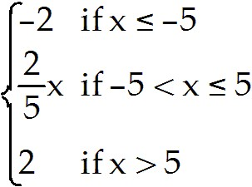

Where is f discontinuous?
A) nowhere
B) at x = -5 only
C) at x = 5 only
D) at both x = -5 and x = 5
E) none of the above
Answer: A
Diff: 2

7) True or False: If 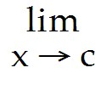f(x) exists and is finite, then either f is continuous at x = c or f has a continuous extension to x = c.
Answer: TRUE
Diff: 1

8) True or False: The polynomial function P(x) = + 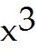 - 7 - 2x + 10 has a zero in the closed interval [1 , 2].
Answer: TRUE
Diff: 2
9) In which of the intervals (-2, -1), (-1, 0), (0, 1), and (1, 2) does the intermediate value theorem imply that f(x) = 2 - 4 + 5x - 4 must have a zero?
A) (1, 2)
B) (0, 1)
C) (-1, 0)
D) (-2, -1)
E) none of the above
Answer: A
Diff: 2

10) For what value of the constant c is the function f(x) = 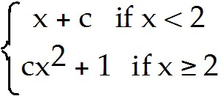
continuous everywhere?
A)
B)
C) 1
D) 0
E) none of the above
Answer: A
Diff: 3

11) Given f(x) =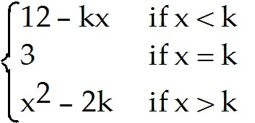
find the value of the constant real number k such that f is continuous at x = k.
A) - 1
B) -3
C) 3
D) -2
E) 1
Answer: C
Diff: 2

12) Let f(x) = 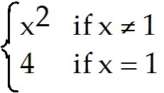
Which of the following statements, I, II, or III, are true?
I. 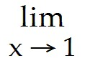f(x) exists
II. f(1) exists
III. f is continuous at x = 1.
A) only I
B) only II
C) only I and II
D) only II and III
E) I, II, and III
Answer: C
Diff: 3
13) If f(x) is a function defined on the closed interval [a , b] such that f(a) < 0 and f(b) > 0 , then the function f must have at least one zero in the interval [a , b].
Answer: FALSE
Diff: 1

14) Let f and g be continuous functions on the interval ( -∞ , ∞ ) such that f has a zero on the closed interval I, and g has a zero on the closed interval.
Which of the following functions must have at least one zero on the closed interval I ?
A) f ∘ g , g ∘ f
B) f + g , f - g
C) f g , g f
D) 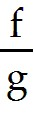 , 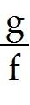
E) none of the above.
Answer: C
Diff: 3

15) Let f(x) = 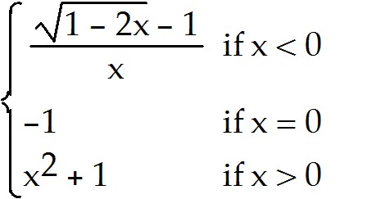
Which of the following statements is true?
A) The function f is continuous at x = 0.
B) The function f is continuous from the left at x = 0.
C) The function f is continuous from the right at x = 0.
D) The function f has continuous extension to x = 0.
E) The function f has a removable discontinuity at x = 0.
Answer: B
Diff: 2

16) A function is continuous on the interval [3, 5] and takes the values f(3) = 0 and f(5) = π - 2. Which of the numbers 1, 2, 3, 4, or 5 must belong to the range of f?
A) only 1
B) only 4
C) only 1 and 2
D) only 3, 4, and 5
E) only 3 and 5
Answer: A
Diff: 2
17) For what values of the constants c and k is the function
f(x) = 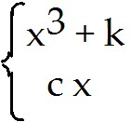 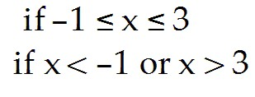
continuous at all x?
A) c = 7, k = -6
B) c = -6, k = 7
C) c = 6, k = 7
D) c = -6, k = -7
E) c = -7, k = 6
Answer: A
Diff: 2

1.5 The Formal Definition of Limit

1) To the nearest 1/1,000, how close need x be chosen to 1 to ensure that | - 1| < ?
A) within distance 0.032
B) within distance 0.033
C) within distance 0.034
D) within distance 0.040
E) within distance 0.031
Answer: A
Diff: 1

2) Given f(x) = 4x + 7 and a number ε > 0, find the largest value of δ for which 0 < 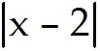 < δ will imply that 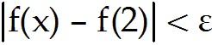.
A) δ = 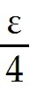
B) δ = 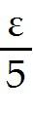
C) δ = 4ε
D) δ = 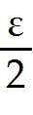
E) δ = ε
Answer: A
Diff: 1
3) In order to prove that = 4, we need to find, for any given ε > 0, a corresponding number 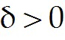 such that if 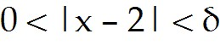, then | - 4| < ε. Which of the following values of δ will do that for a given ε?
A) δ =
B) δ = 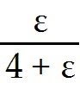
C) δ =
D) δ = min{1, ε}
E) δ = 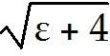 - 2
Answer: E
Diff: 2

4) Which of the following conditions will guarantee that 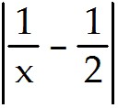 < 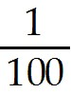?
A) - 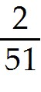 < x - 2 < 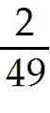
B) |x - 2| < 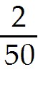
C) |x - 2| <
D) all of the above
E) none of the above
Answer: A
Diff: 2

5) Use the formal definition of the limit to verify the addition property of limits:

If 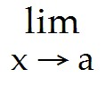f(x) = L and g(x) = K, then [f(x) + g(x)] = L + K.
Answer: Let ε > 0. Since f(x) = L, there exists 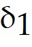 such that if 0 < |x - a| < , then
|f(x) - L| < . Since g(x) = K, there exists 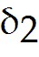 such that if 0 < |x - a| < , then
|g(x) - K| < . If 0 < |x - a| < δ = min{, }, then
|(f(x) + g(x)) - (L + K)| ≤ |f(x) - L| + |g(x) - K| < + = ε. Thus (f(x) + g(x)) = L + K.
Diff: 3
6) Complete the following definition: We say 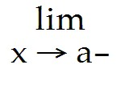 f(x) = L if for every ε > 0 there exists δ > 0 depending on ε such that
A) if a - δ < x < a, then |f(x) - L| < ε
B) if |x - a| < δ, then |f(x) - L| < ε
C) if |x - a| < δ, then f(x) - L < ε
D) if a < x < a + δ, then |f(x) - L| < ε
E) none of the above
Answer: A
Diff: 3

7) Use the formal definition of limit to verify that (x-a) = 0.
Answer: Let ε > 0 be given. We must find δ > 0 so that:
0 < 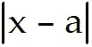 < δ implies 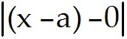 <ε
That is to say: we must find δ > 0 so that
0 < < δ implies <ε
We can simply take δ = ε, and the statement above will be true.
Diff: 1

