Chapter 1
Management Accounting and the Business Environment
1-1 Management accounting is concerned with providing information to managers for their use internally in the organisation. Financial accounting is concerned with providing information to stockholders, creditors, and others outside of the organisation.
1-2 Essentially, the manager carries out three major activities in an organisation: planning, directing and motivating, and controlling. All three activities involve decision making.
1-3 The Planning and Control Cycle involves the following steps: formulating plans, implementing plans, measuring performance, and evaluating differences between planned and actual performance.
1-4 The manager relies on feedback to assure that activities are under control; that is, to assure that things are going according to plan.
1-5 A line position is one that is directly related to the achievement of the basic objectives of the organisation. A staff position is not directly related to the achievement of those objectives; rather, it is supportive in nature, providing services and assistance to other parts of the organisation.
1-6 In contrast to financial accounting, management accounting: (1) focuses on the needs of the manager; (2) places more emphasis on the future; (3) emphasises relevance and flexibility, rather than precision; (4) emphasises the segments of an organisation; (5) is not governed by UK GAAP; and (6) is not mandatory.

1-7 Companies use budgets to translate plans into formal quantitative terms. Budgets are used for various purposes, such as forcing managers to plan ahead, allocating resources across departments, coordinating activities across departments, establishing goals that motivate people, and evaluating and rewarding employees. These various purposes often conflict with one another, which makes budgeting one of management’s most challenging activities.
1-8 The introduction of new technology, globalisation and deregulation has a huge impact on management accounting practices. In response to these changes, new management accounting techniques like, JIT, TQM and process re-engineering etc. can enhance quality, reduce cost, increase output, eliminate delays in responding to customers and ultimately increase profits.
1-9 In comparison with traditional manufacturing, where the product is easy to see and touch, products in service industries are less tangible. Services cannot be stored in inventory so that managers in service industries may be less interested in product cost but, rather, which customers are profitable and which customers are not.

Managers of service companies require accurate and timely information from management accounting systems. They need this for improving the quality, timeliness, and efficiency of the activities they perform and to make decisions about their individual products, services, and customers.
1-10 First, there is a compliance motive – companies may find that they are forced through regulation and green taxes to manage environmental resources more carefully. Second, eco-efficiency not only may save the planet but reduce the business costs. Finally, there may be strategic reasons – companies may have customers who demand green business policies and who are increasingly suspicious of ‘environmental window dressing’ through environmental reporting.
1-11 If ethical standards were not generally adhered to, there would be undesirable consequences for everyone. Essentially, abandoning ethical standards would lead to a lower standard of living with lower quality goods and services, less to choose from, and higher prices. In short, following ethical rules is not just a matter of being ‘nice’; it is absolutely essential for the smooth functioning of an advanced market economy.

Exercise 1-1 (10 minutes)
- Line
- Directing and motivating
3. Budgets
4. Planning
5. Staff
6. Decentralisation
7. Precision; Nonmonetary data
8. Management accounting; Financial accounting
9. Feedback
10. Chief Accountant
11. Performance report

Problem 1-2 (30 minutes)
1. 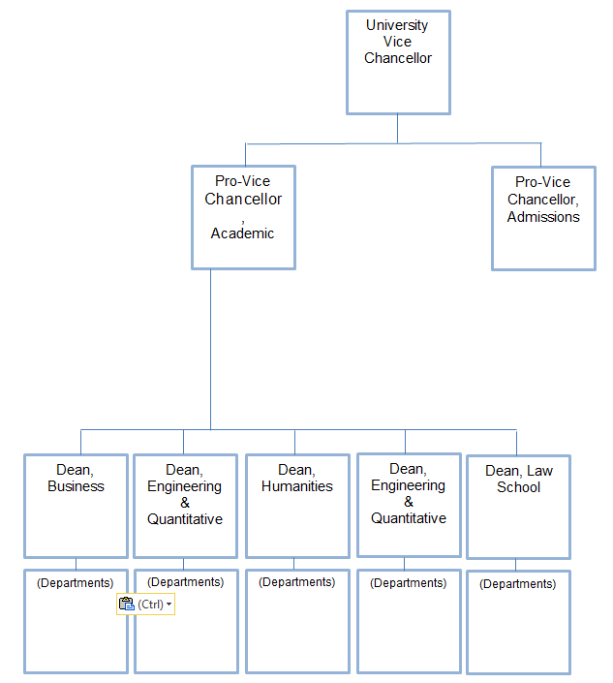
2. Line positions would include the university vice chancellor, pro vice-chancellors, the deans of the four colleges, and the dean of the law school. In addition, the department heads (as well as the faculty) would be in line positions. The reason is that their positions are directly related to the basic purpose of the university, which is education.
All other positions on the organisation chart are staff positions. The reason is that these positions are indirectly related to the educational process, and exist only to provide service or support to the line positions.
3. All positions would have need for accounting information of some type. For example, the manager of central purchasing would need to know the level of current inventories and budgeted allowances in various areas before doing any purchasing; the vice-chancellor for admissions and records would need to know the status of scholarship funds as students are admitted to the university; the dean of the business college would need to know his/her budget allowances in various areas, as well as information on cost per student credit hour; and so forth.

Problem 1-3 (20 minutes)

- Failure to report the obsolete nature of the inventory would violate the ethical conduct as follows:

Competence
- Perform duties in accordance with relevant technical standards.
- Prepare complete reports using reliable information.
By failing to write down the value of the obsolete inventory, Potter would not be preparing a complete report using reliable information. In addition, generally accepted accounting principles (GAAP) require the write-down of obsolete inventory.

Integrity
- Avoid conflicts of interest.
- Refrain from activities that prejudice the ability to perform duties ethically.
- Refrain from subverting the legitimate goals of the organisation.
- Refrain from discrediting the profession.
Members of the management team, of which Potter is a part, are responsible for both operations and recording the results of operations. Since the team will benefit from a bonus, increasing earnings by ignoring the obsolete inventory is clearly a conflict of interest. Potter would also be concealing unfavorable information and subverting the goals of the organisation. Furthermore, such behaviour is a discredit to the profession.

Objectivity
- Communicate information fairly and objectively.
- Disclose all relevant information.
Hiding the obsolete inventory impairs the objectivity and relevance of financial statements.
2. As discussed above, the ethical course of action would be for Potter to insist on writing down the obsolete inventory. This would not, however, be an easy thing to do. Apart from adversely affecting her own compensation, the ethical action may anger her colleagues and make her very unpopular. Taking the ethical action would require considerable courage and self-assurance.

Problem 1-4 (20 minutes)

1. If all garages shops routinely tried to sell customers parts and services they didn’t really need, most customers would eventually figure this out. They would then be reluctant to accept the word of the service representative that a particular problem needs to be corrected—even when there is a legitimate problem. Either the work would not be done, or customers would learn to diagnose and repair problems themselves, or customers would hire an independent expert to verify that the work is really needed. All three of these alternatives impose costs and hassle on customers.
2. As argued above, if customers could not trust their service representatives, they would be reluctant to follow the service representative’s advice. They would be inclined not to order the work done even when it is really necessary. And, more customers would learn to do repairs and maintenance themselves. Moreover, customers would be unwilling to pay as much for work that is done since customers would have reason to believe that the work may be unnecessary.
3. These two effects would reduce demand for repair services. The reduced demand would reduce employment in the industry and would lead to lower overall profits.

