SOLUTIONS TO EXERCISES - SERIES A - CHAPTER 1

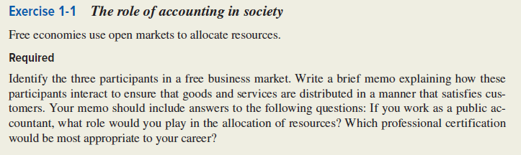

EXERCISE 1-1 Solution

The three participants in the free business market are:
- Resource owners

3.

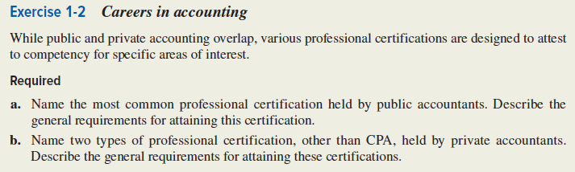

EXERCISE 1-2 Solution

a. Professional certifications and requirements for public accountants:

b. Prof. certifications and requirements for private accountants:

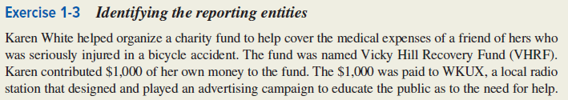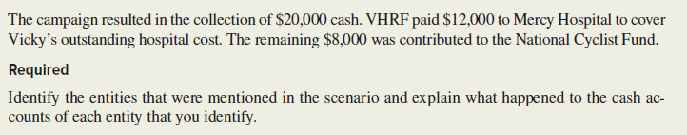

EXERCISE 1-3 Solution

Entities mentioned: | Effect on cash:
Vicky Hill Recovery Fund | Increase for cash contributions, $21,000  Decrease for  Decrease for  Decrease for
Karen White
WKUX
Public
Mercy Hospital
National Cyclist Fund

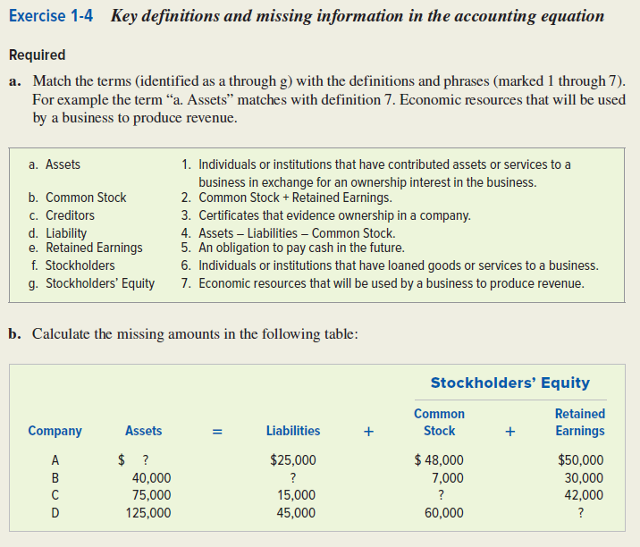

EXERCISE 1-4 Solution

a.
 | Term |  | Definition
a. | Assets | 7. | Economic resources that will be used by a business to produce revenue.
b. | Common Stock
c. | Creditors
d. | Liability
e. | Retained Earnings
f. | Stockholders
g. | Stockholders’ Equity

b.

Accounting Equation
 |  |  |  |  | Stockholders’ Equity
 |  |  |  |  | Common |  | Retained
Company | Assets | = | Liabilities | + | Stock | + | Earnings
A |  | = | 25,000 | + | 48,000 | + | 50,000
B | 40,000 | = |  |  | 7,000 | + | 30,000
C | 75,000 | = | 15,000 | + |  | + | 42,000
D | 125,000 | = | 45,000 | + | 60,000 | +

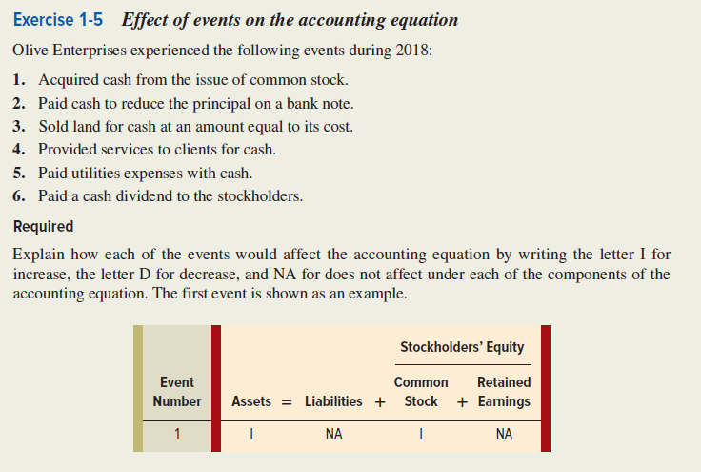

EXERCISE 1-5 Solution

Olive Enterprises
Accounting Equation
Stockholders’
Equity
Event  Number | Assets | = | Liabilities |  | + | Common Stock | Retained Earnings
1. | I |  | NA |  |  | I | NA
2.
3.
4.
5.
6.

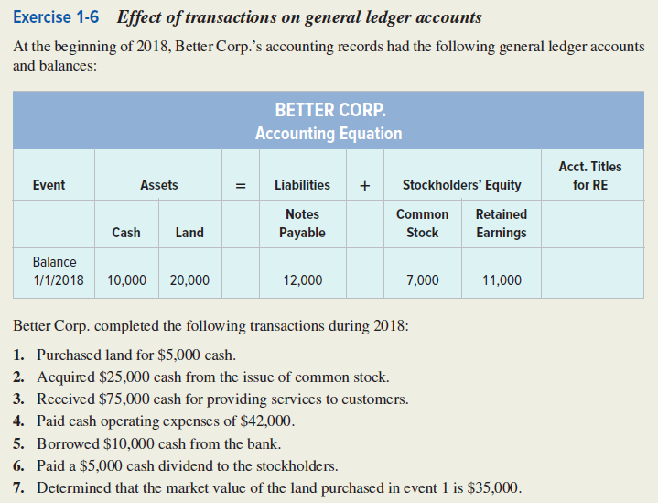
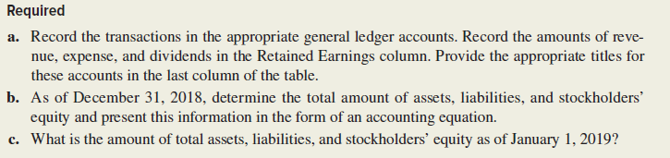

EXERCISE 1-6 (cont.) Solution

a.
Better Corporation
Accounting Equation for 2018
 |  | Assets |  |  | = | Liabilities |  | + | Stockholders’ Equity
Event |  | Cash | + | Land | = | Notes  Payable | + |  | Com.  Stock | + | Retained Earnings | Acct.  Title/RE
Bal. 1/1/18 |  | 10,000 |  | 20,000 |  | 12,000 |  |  | 7,000 |  | 11,000
1. Pur. Land |  | (5,000) |  | 5,000 |  | NA |  |  | NA |  | NA | NA
2. Issued stk.
3. Provide Svc.
4. Paid Exp.
5. Loan
6. Paid Div.
7. Land Value
Totals |  |  | +

b.

Assets | = | Liabilities | + | Stockholders’ Equity
 | = |  | +

c. Assets Liabs. S. Eq.

1/1/2019 ______ ______ ______

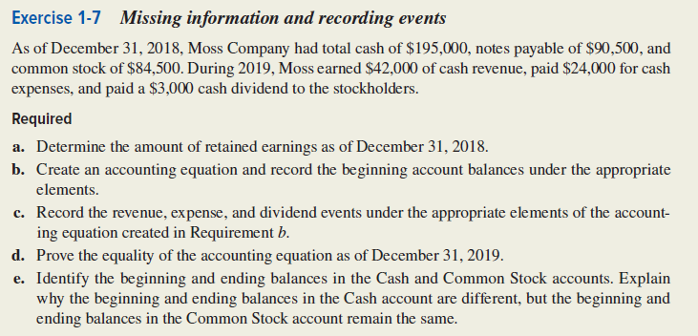

EXERCISE 1-7 Solution

a.
Assets | = | Liabilities | + | Stockholders’ Equity
Cash | = | Note Payable | + | Common Stock | + | Retained Earnings
 | = |  | + |  | + | ?

b. & c.
Moss Company
Effect of 2019 Transactions on the Accounting Equation
 | Assets | = | Liabilities | + | Stockholders’ Equity
 |  |  | Notes |  | Common |  | Retained
Event | Cash | = | Payable | + | Stock | + | Earnings
Beginning Balances
1. Earned Revenue
2. Paid expenses
3. Paid dividend
Ending Balance | 210,000 | = |  |  |  | + | 35,000

EXERCISE 1-7 (cont.)

d.
Cash | = | Note Payable | + | Common Stock | + | Retained Earnings

Liabilities + Stockholders’ Equity =__________

Assets = Liabilities + Stockholders’ Equity
_________ =__________+__________

e. Cash Common Stock

Beg. Bal. ___________ ___________
End. Bal.

Explaination:

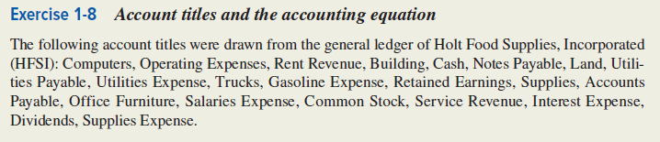
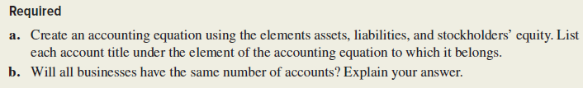

EXERCISE 1-8 Solution

a.

 | Assets | = | Liabilities | + | Stockholders’ Equity
 | Computers |  | Notes Payable |  | Operating Expenses

b. Will all businesses have the same account?

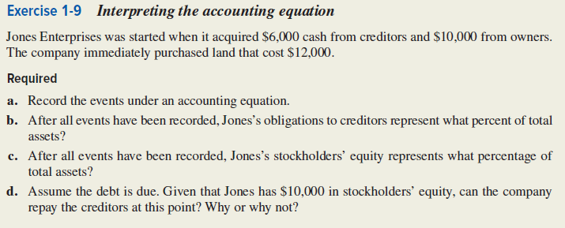

EXERCISE 1-9 Solution

a.
 | Cash | + | Land | = | Creditors | + | Stockholders’  Equity
Bal. |  | + |  | = |  | +

b. Creditor’s Claim ÷ __________= Percent of Total

c.

d. Can the company pay its creditors and Why?

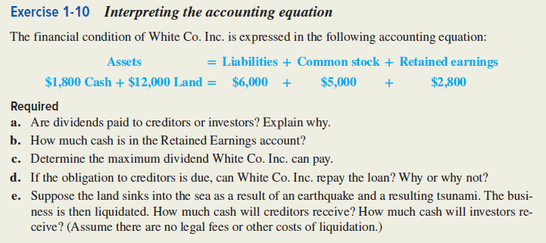

EXERCISE 1-10 Solution

a. Are dividends are paid to investors? Explain:.

b. Cash in Retained Earnings:.

c. Maximum dividend:

d. Can White repay the loan:

e.. Cash creditors receive:

Cash investors receive:

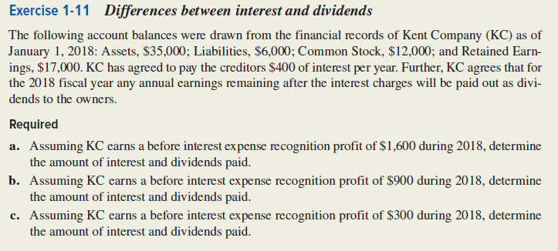

EXERCISE 1-11 Solution

a. Creditors receive __________interest payment.
Investors receive __________dividends.

b. Interest paid__________.
Dividends paid__________.

c. Interest paid__________.
Dividends paid__________

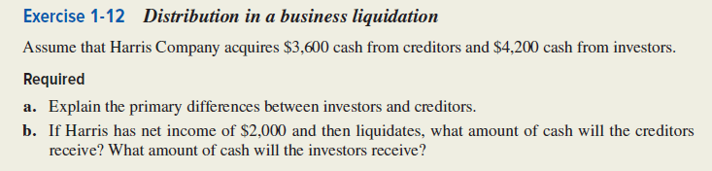
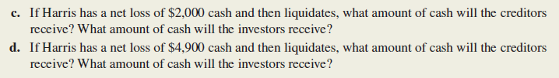

EXERCISE 1-12 Solution

a. Differences between investors and creditors:

b
Harris Company
Accounting Equation
Event | Assets | = | Liabilities | + | Stockholders’ Equity
Acquired assets
Earned income
Balance
Investors:
Creditors:

c
Harris Company
Accounting Equation
Event | Assets | = | Liabilities | + | Stockholders’ Equity
Acquired assets
Incurred loss
Balance
Investors:
Creditors:
EXERCISE 1-12 Solution (cont.)

d.
Harris Company
Accounting Equation
Event | Assets | = | Liabilities | + | Stockholders’ Equity
Acquired assets
Incurred loss
Balance
Investors:
Creditors:

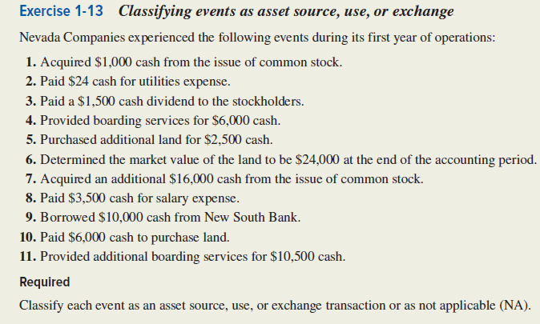

EXERCISE 1-13 Solution

Event | Classification
1. | Asset Source
2.
3.
4.
5.
6.
7.
8.
9.
10.
11.

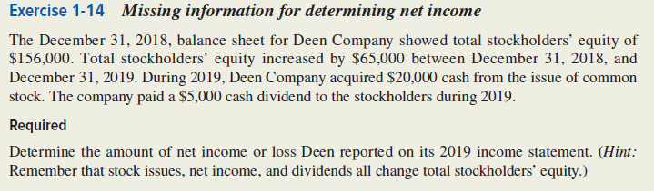

EXERCISE 1-14 Solution

Steps:
1.
Common Stock Issued = Change in Common Stock
$20,000 (given) = ____________

2.
Change in Stk. Equity = Change in Com. Stock + Change in Ret. Earn.
$65,000 (given) = ____________________+__________________

3.
Increase in Ret. Earn. = Net Income − Dividends
________________ = ___________ − __________(given)

EXERCISE 1-14 Solution (cont.)

Alternate Solution:
From the Statement of Changes in Stockholders’ Equity we know (with minor modifications):

Beginning Total Stk. Equity, 1/1/2018
(Common Stock + Retained Earnings)
Plus:
Plus:
Less:
Change in Stockholders’ Equity
Ending Total Stk. Equity, 12/31/2018

Working backwards from the change in equity we can solve for net income:

Change in Stockholders’ Equity, 2018
Plus:
Less:
Net Income, 2018

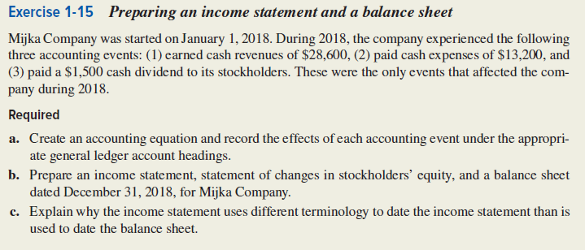

EXERCISE 1-15 Solution

a.
Mijka Company
Accounting Equation for 2018
 | Assets | = | Liabilities | + | Stockholders’ Equity
 |  |  |  |  | Common |  | Retained
Event | Cash | = |  | + | Stock | + | Earnings
1. Cash revenues
2. Paid expenses
3. Paid dividend
Ending Balance |  | = |  | + |  | +
b.
Mijka Company
Income Statement
For the Year Ended December 31, 2018
Revenue
Expense
Net Income

EXERCISE 1-15 Solution (cont.)

Mijka Company
Statement of Changes in Stockholders’ Equity
For the Year Ended December 31, 2018
Beginning Common Stock
Plus:
Ending Common Stock
Beginning Retained Earnings
Plus:
Less:
Ending Retained Earnings
Total Stockholders’ Equity

Mijka Company
Balance Sheet
As of December 31, 2018
 | Assets
 | Liabilities |  | $ -0-
 | Stockholders’ Equity
 |  | $ -0-
 | Total Stockholders’ Equity
 | Total Liabilities and Stockholders’ Equity

c. Explanation for differences in terminology:

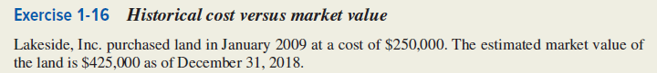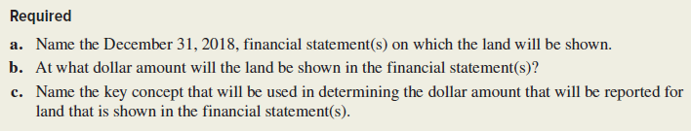

EXERCISE 1-16 Solution

a. Financial Statement:

b. Dollar Amount of Land:

c. Key Concept:

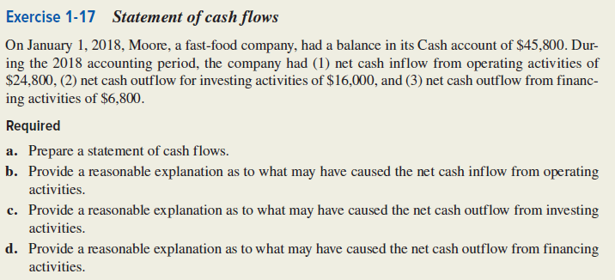

EXERCISE 1-17 Solution

a.
Moore Company
Statement of Cash Flows
For the Year Ended December 31, 2018
Cash Flows From Operating Activities:
Net Cash Inflow from Operating Activities
Cash Flows From Investing Activities:
Net Cash Outflow from Investing Activities
Cash Flows From Financing Activities:
Net Cash Outflow from Financing Activities
Net Increase in Cash
Plus: Beginning Cash Balance
Ending Cash Balance

EXERCISE 1-17 Solution (cont.)

b. Causes of Operating Activity Cash Flows:

c. Causes of Investing Activity Cash Flows:

d. Causes of Financing Activity Cash Flows

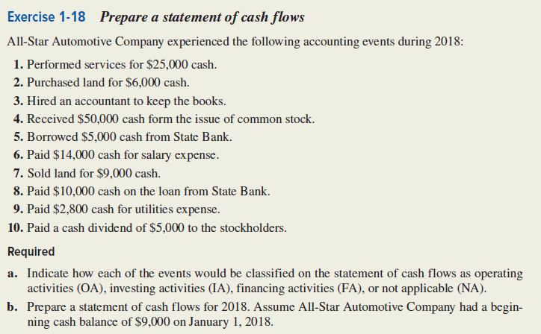

EXERCISE 1-18 Solution

a.
Event | Statement of Cash Flow Classification
1. | OA
2.
3.
4.
5.
6.
7.
8.
9.
10.

EXERCISE 1-18 Solution (cont.)

b.
All-Star Automotive Company
Statement of Cash Flows
For the Year Ended December 31, 2018
 | Cash Flows From Operating Activities:
 | Net Cash Flow from Operating Activities |  | $8,200
 | Cash Flows From Investing Activities
 | Net Cash Flow from Investing Activities |  | 3,000
 | Cash Flows From Financing Activities:
 | Net Cash Flow from Financing Activities |  | 40,000
 | Net Increase in Cash
 | Plus: Beginning Cash Balance
 | Ending Cash Balance
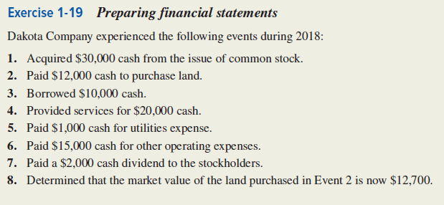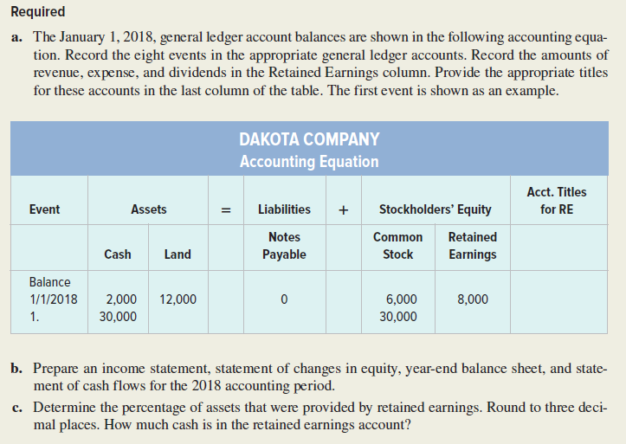

EXERCISE 1-19 (cont.) Solution

a.
Dakota Company
Accounting Equation for 2018
 |  | Assets |  |  | = | Liabilities | + | Stockholders’ Equity
Event |  | Cash | + | Land | = | Notes  Payable | + | Com.  Stock | + | Retained Earnings | Acct.  Title/RE
Bal. 1/1/18 |  | 2,000 |  | 12,000 |  | -0- |  | 6,000 |  | 8,000
1. Issued stk. |  | 30,000 |  | NA |  | NA |  | 30,000 |  | NA | NA
2. Pur. Land
3. Loan
4. Provide Svc.
5. Paid Utilities
6. Pd. Op. Exp.
7. Paid Div.
8. Land Value
Totals |  |  | + |  | = |  | + |  | +

b.

Dakota Company
Income Statement
For the Year Ended December 31, 2018
Service Revenue
Utilities Expense
Operating Expense
Net Income

EXERCISE 1-19 b. Solution (cont.)

Dakota Company
Statement of Changes in Stockholders’ Equity
For the Year Ended December 31, 2018
Beginning Common Stock
Plus: Common Stock Issued
Ending Common Stock
Beginning Retained Earnings
Plus: Net Income
Less: Dividends
Ending Retained Earnings
Total Stockholders’ Equity

Dakota Company
Balance Sheet
As of December 31, 2018
Assets
Total Assets
Liabilities
Total Liabilities
Stockholders’ Equity
Total Stockholders’ Equity
Total Liabilities and Stockholders’ Equity
EXERCISE 1-19 b. Solution (cont.)

Dakota Company
Statement of Cash Flows
For the Year Ended December 31, 2018
 | Cash Flows From Operating Activities:
 | Net Cash Flow from Operating Activities |  | $ 4,000
 | Cash Flows From Investing Activities:
 | Net Cash Flow from Investing Activities
 | Cash Flows From Financing Activities:
 | Net Cash Flow from Financing Activities |  | 38,000
 | Net Increase in Cash
 | Plus: Beginning Cash Balance
 | Ending Cash Balance

c. Percentage of assets provided by retained earnings:

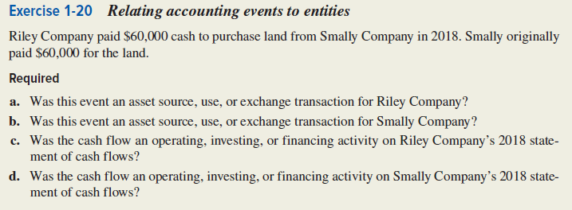

EXERCISE 1-20 Solution
a.
a. | Riley Company:
b. | Smally Company:
c. | Riley Company:
d. | Smally Company:

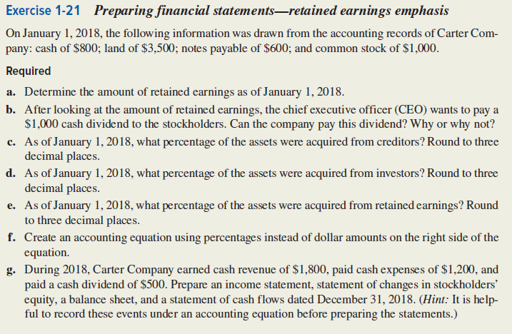
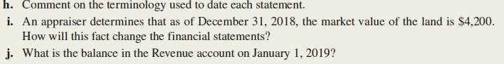

EXERCISE 1-21 Solution
a.
Carter Company
Accounting Equation as of January 1, 2018
Assets |  |  | = | Liabilities | + | Stockholders’ Equity
 |  |  |  | Notes |  | Common |  | Retained
Cash | + | Land | = | Payable | + | Stock | + | Earnings
 |  |  |  |  |  |  |  | ?

EXERCISE 1-21 Solution (cont.)

b. Can the company pay a dividend?
Why:

c. Percentage of Assets from Creditors:
Total Assets =

Creditor’s Loans ÷ Total Assets =

d. Percentage of Assets from Investors:

e. Percentage of Assets from Retained Earnings:

EXERCISE 1-21 Solution (cont.)

f.
Carter Company
Accounting Equation as of January 1, 2018
Assets |  |  | = | Liabilities | + | Stockholders’ Equity
 |  |  |  | Notes |  | Common |  | Retained
Cash | + | Land | = | Payable | + | Stock | + | Earnings

g.
Carter Company
Accounting Equation as of December 31, 2018
Assets |  |  |  |  | = |  | Liabilities |  | + |  | Stockholders’ Equity
 |  |  |  |  |  | Notes |  |  |  | Common |  |  | Retained
 | Cash | + | Land | = |  | Payable |  | + |  | Stock |  | + | Earnings

Carter Company
Income Statement
For the Year Ended December 31, 2018
Revenue
Expenses
Net Income

EXERCISE 1-21 g. Solution (cont,)

Carter Company
Statement of Changes in Stockholders’ Equity
For the Year Ended December 31, 2018
Beginning Common Stock
Plus: Common Stock Issued
Ending Common Stock
Beginning Retained Earnings
Plus: Net Income
Less: Dividends
Ending Retained Earnings
Total Stockholders’ Equity

Carter Company
Balance Sheet
As of December 31, 2018
Assets
Cash
Land
Total Assets
Liabilities
Notes Payable
Total Liabilities
Stockholders’ Equity
Common Stock
Retained Earnings
Total Stockholders’ Equity
Total Liabilities and Stockholders’ Equity
EXERCISE 1-21 g. Solution (cont.)

Carter Company
Statement of Cash Flows
For the Year Ended December 31, 2018
Cash Flows From Operating Activities:
Cash Receipts from Customers
Cash Payments for Expenses
Net Cash Flow from Operating Activities
Cash Flows From Investing Activities:
Cash Flows From Financing Activities:
Cash Payments for Dividends
Net Cash Flow from Financing Activities
Net Increase in Cash
Plus: Beginning Cash Balance
Ending Cash Balance

h. Comment on Terminology:

i. How will change in value of land affect financial statements?

j. Balance in revenue Jan. 1, 2019:

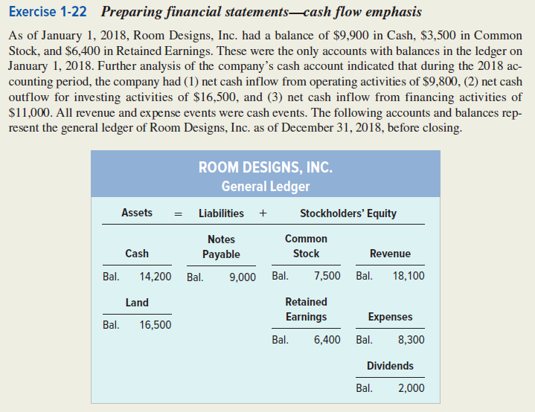
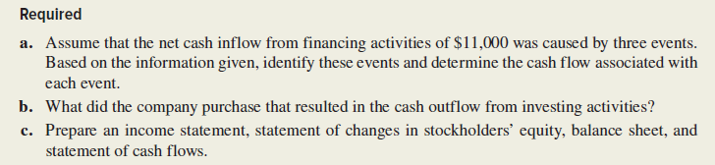

EXERCISE 1-22 (cont.) Solution

a.
Cash Flows From Financing Activities:
Cash Receipts from Loan
Cash Receipts from Stock Issue
Cash Payments for Dividends
Net Cash Flow from Financing Activities

b. Cash outflow under Investing Activities:

c.
Room Designs, Inc.
Income Statement
For the Year Ended December 31, 2018
Revenue
Expenses
Net Income

EXERCISE 1-22 c. Solution (cont.)

Room Designs, Inc.
Statement of Changes in Stockholders’ Equity
For the Year Ended December 31, 2018
Beginning Common Stock
Plus: Common Stock Issued
Ending Common Stock
Beginning Retained Earnings
Plus: Net Income
Less: Dividends
Ending Retained Earnings
Total Stockholders’ Equity

Room Designs, Inc.
Balance Sheet
As of December 31, 2018
Assets
Total Assets
Liabilities
Notes Payable
Total Liabilities
Stockholders’ Equity
Total Stockholders’ Equity
Total Liabilities and Stockholders’ Equity
EXERCISE 1-22 c. Solution (cont.)

Room, Designs, Inc.
Statement of Cash Flows
For the Year Ended December 31, 2018
Cash Flows From Operating Activities:
Net Cash Flow from Operating Activities
Cash Flows From Investing Activities:
Net Cash Flow from Investing Activities
Cash Flows From Financing Activities:
Net Cash Flow from Financing Activities
Net Increase in Cash
Plus: Beginning Cash Balance
Ending Cash Balance

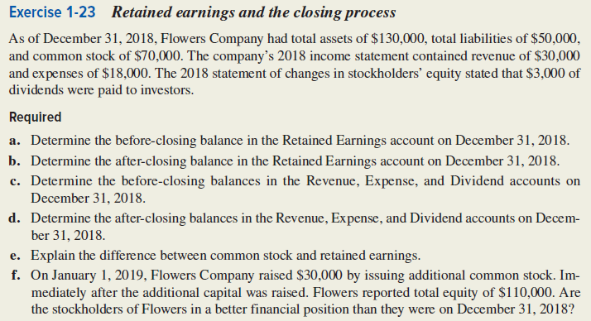

EXERCISE 1-23 Solution

a.
Flowers Company
Accounting Equation as of December 31, 2018
Assets | = | Liabilities | + | Common Stock | + | Retained Earnings
 |  |  |  |  |  | ?

b.
Retained Earnings after closing: | ?
Less, Revenue
Add, Expenses
Add, Dividends
Retained Earnings before closing

EXERCISE 1-23 Solution (cont.)

c. The balances in revenue, expenses, and dividends before closing are:

Revenue
Expenses
Dividends

d. The balances in revenue, expenses, and dividends after closing are:

e. Difference between common stock and retained earnings:

f. Better or worse financial condition after additional capital:

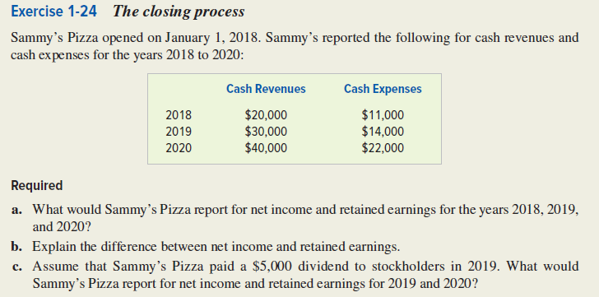

EXERCISE 1-24 Solution

a.
Year |  | Cash  Revenues |  | Cash  Expenses |  | Net  Income |  | Retained  Earnings
2018
2019
2020

b. Difference between net income and retained earnings:

c.
Year |  | Cash  Revenues |  | Cash  Expenses |  | Net  Income |  | Retained  Earnings
2018
2019
2020

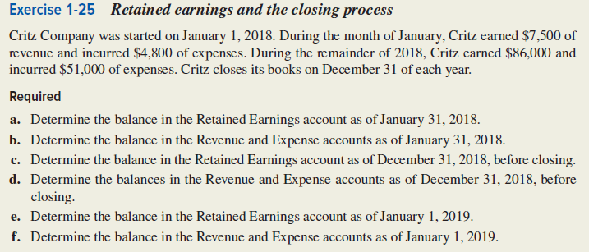

EXERCISE 1-25 Solution

a. The balance in the Retained Earnings account as of January 31, 2018 is_______________.

b. The balance in the Revenue account as of January 31, 2018 is______________. The balance in the Expense accounts as of January 31, 2018 is_____________.

c. The before closing balance in the Retained Earnings account as of December 31, 2018 is_____________.

d. The December 31, 2018 before closing balance in the Revenue account is ______________. The December 31, 2018 before closing balance in the Expense accounts is ______________.

e. The January 1, 2019 balance in the Retained Earnings account is ________________.

f. The January 1, 2019 balance in the Revenue and Expense accounts is ________________.

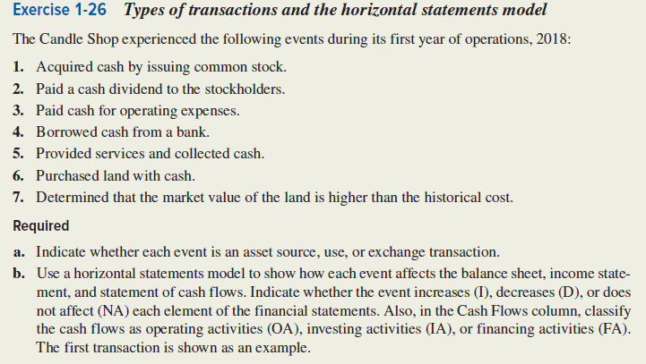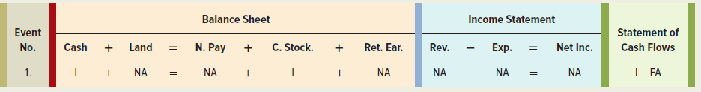

EXERCISE 1-26 (cont.) Solution

a.
Event
1. | Asset Source
2.
3.
4.
5.
6.
7.

b.
The Candle Shop
Horizontal Statements Model for 2018
 |  | Balance Sheet |  |  |  |  |  |  |  |  |  |  | Income Statement |  |  |  |  |  | Statement of
 |  | Assets |  |  | = |  | Liab. | + | Stockholders’ Equity |  |  |  | Revenue | − | Expense | = | Net Inc. |  | Cash Flows
Event  No. |  | Cash | + | Land | = | Notes  Payable |  | + | Common  Stock | + | Retained  Earnings
1 |  | I | + | NA | = | NA |  | + | I | + | NA |  | NA | − | NA | = | NA |  | I FA
2
3
4
5
6
7
.
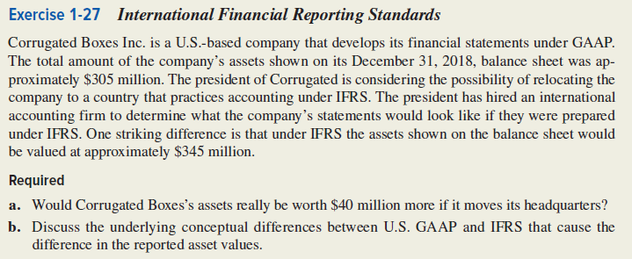

EXERCISE 1-27 Solution

a. Would assets be worth $40 million:

b. Conceptual Differences in asset values:

U.S. GAAP IFRS

SOLUTIONS TO PROBLEMS - CHAPTER 1

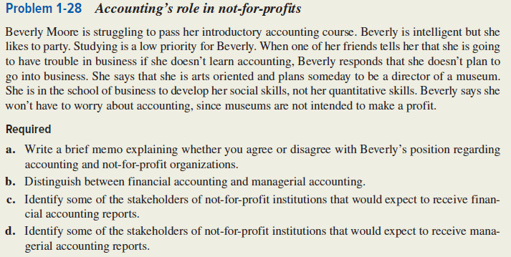

PROBLEM 1-28 Solution

a. Memo: (include information on the of use of assets)

PROBLEM 1-28 Solution (cont.)

b. Financial Accounting Managerial Accounting

c. Identify stakeholders for not-for-profit:

d. Stakeholders that may want managerial accounting reports would include:

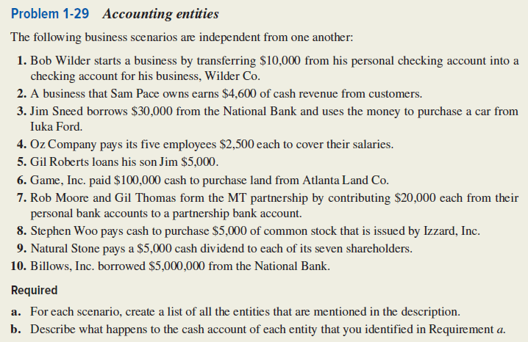

PROBLEM 1-29 (cont.) Solution

a. & b.
a. Entities mentioned: | b. Effect on the cash account:
1. Bob Wilder | Decrease
Wilder Co. | Increase
2.
3.
4.
5.
6.
7.
8.
9.
10.
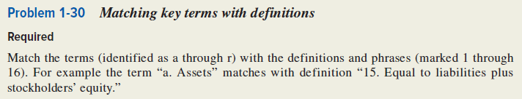
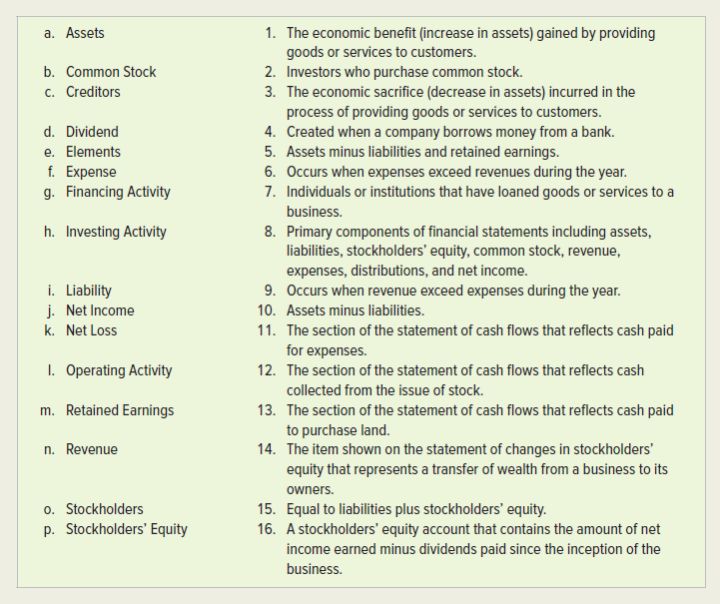

PROBLEM 1-30 (cont.) Solution

 | Term |  | Definition/Phrase
a. | Assets | 15. | Equal to liabilities plus stockholders’ equity.
b.
c.
d.
e.
f.
g.
h.
i.
j.
k.
l.
m.
n.
o.
p.
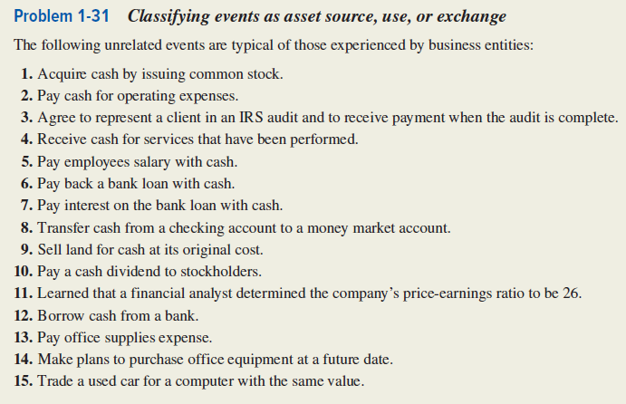
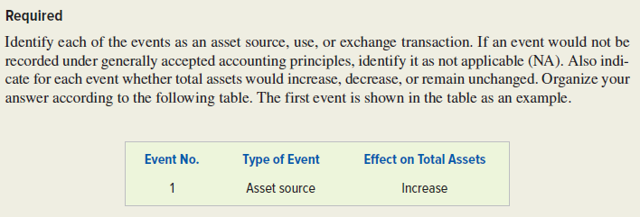

PROBLEM 1-31 (cont.) Solution

Event No. | Type of Event | Effect on Total Assets
1. | Asset Source | Increase
2.
3.
4.
5.
6.
7.
8.
9.
10.
11.
12.
13.
14.
15.

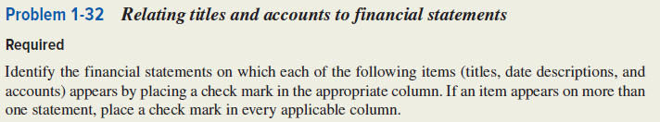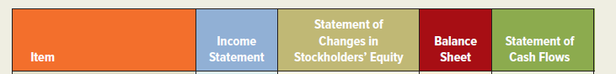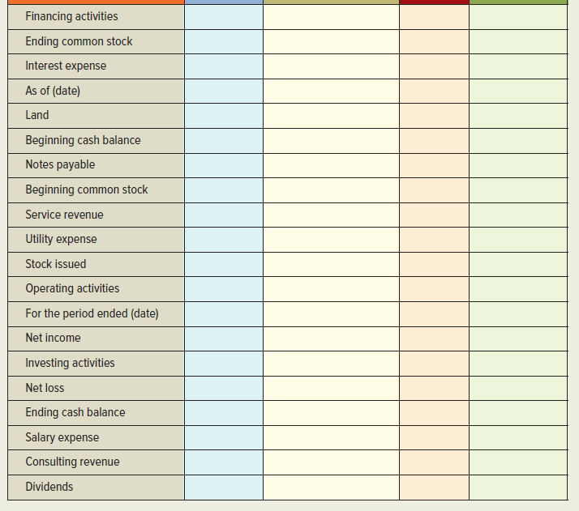
PROBLEM 1-32 (cont.) Solution

Item | Income Statement | Statement of Changes in Stk. Equity | Balance Sheet | Statement of Cash Flows
Financing activities |  |  |  | 
Ending common stock |  |  | 
Interest expense
As of (date)
Land
Beginning cash balance
Notes payable
Beginning common stock
Service revenue
Utility expense
Stock issued
Operating activities
For the Period Ended (Date)
Net income
Investing activities
Net loss
Ending cash balance
Salary expense
Consulting revenue
Dividends

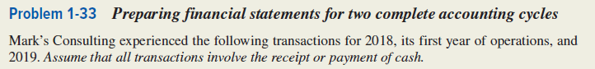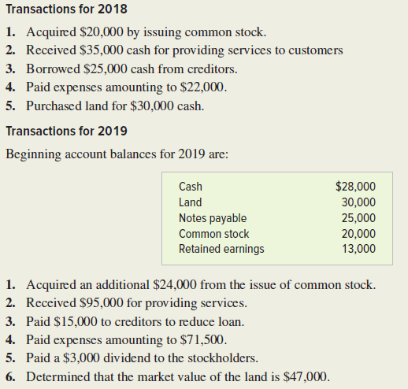
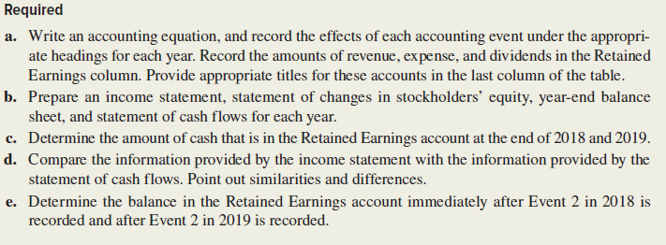

PROBLEM 1-33 (cont.) Solution

a.
Mark’s Consulting
Accounting Equation for 2018
 |  | Assets |  |  | = | Liabilities | + | Stockholders’ Equity
Event |  | Cash | + | Land | = | Notes  Payable | + | Com. Stock | + | Retained Earnings | Acct.  Title/RE
1. Issued stk
2. Revenue
3. Loan
4. Paid Exp.
5. Pur. Land
Totals

Mark’s Consulting
Accounting Equation for 2019
 |  | Assets |  |  | = | Liabilities |  | + |  | Stockholders’ Equity
Event |  | Cash | + | Land | = | Notes  Payable | + |  | Com.  Stock |  | + | Retained Earnings | Acct.  Title/RE
Beg. Bal.
1. Issued stk
2. Revenue
3. Paid Loan
4. Paid Exp.
5. Paid Div.
6. Land Val.
Totals
PROBLEM 1-33 Solution (cont.)

b.
Mark’s Consulting
Income Statement
For the Period Ended December 31, 2018
Service Revenue
Expenses
Net Income

Mark’s Consulting
Statement of Changes in Stockholders’ Equity
For the Period Ended December 31, 2018
Beginning Common Stock
Plus: Common Stock Issued
Ending Common Stock
Beginning Retained Earnings
Plus: Net Income
Ending Retained Earnings
Total Stockholders’ Equity

PROBLEM 1-33 b. Solution (cont.)

Mark’s Consulting
Balance Sheet
As of December 31, 2018
Assets
Total Assets
Liabilities
Notes Payable
Stockholders’ Equity
Total Stockholders’ Equity
Total Liabilities and Stockholders’ Equity

PROBLEM 1-33 b. Solution (cont.)

Mark’s Consulting
Statement of Cash Flows
For the Year Ended December 31, 2018
Cash Flows From Operating Activities:
Net Cash Flow from Operating Activities
Cash Flows From Investing Activities:
Net Cash Flow from Investing Activities
Cash Flows From Financing Activities:
Net Cash Flow from Financing Activities
Net Increase in Cash
Plus: Beginning Cash Balance
Ending Cash Balance

PROBLEM 1-33 b. Solution (cont.)

Mark’s Consulting
Income Statement
For the Period Ended December 31, 2019
Service Revenue
Expenses
Net Income

Mark’s Consulting
Statement of Changes in Stockholders’ Equity
For the Period Ended December 31, 2019
Beginning Common Stock
Plus: Common Stock Issued
Ending Common Stock
Beginning Retained Earnings
Plus: Net Income
Less: Dividends
Ending Retained Earnings
Total Stockholders’ Equity

PROBLEM 1-33 b. Solution (cont.)

Mark’s Consulting
Balance Sheet
As of December 31, 2019
Assets
Cash
Land
Total Assets
Liabilities
Notes Payable
Stockholders’ Equity
Common Stock
Retained Earnings
Total Stockholders’ Equity
Total Liabilities and Stockholders’ Equity

PROBLEM 1-33 b. Solution (cont.)

Mark’s Consulting
Statement of Cash Flows
For the Year Ended December 31, 2019
Cash Flows From Operating Activities:
Net Cash Flow from Operating Activities
Cash Flows From Investing Activities
Cash Flows From Financing Activities:
Net Cash Flow from Financing Activities
Net Increase in Cash
Plus: Beginning Cash Balance
Ending Cash Balance

c. 2018 2019
Amount of cash in Ret. Earnings:

d. Income Stat. Cash Flow Stat.
Similarities:

Differences:

e. 2018 2019
Bal. in Ret Earnings
After Event 2: ___________ __________
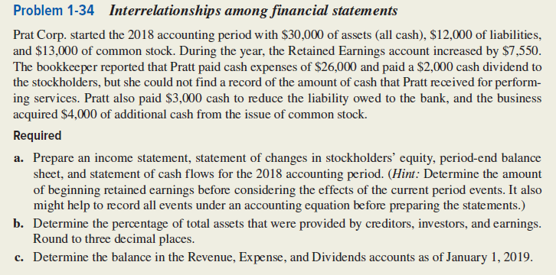

PROBLEM 1-34 Solution
a.
Prat Corp.
Accounting Equation
 |  |  |  |  | Stockholders’ Equity
 |  |  |  |  | Common |  | Retained
Event | Assets | = | Liabilities | + | Stock | + | Earnings
Beginning Balances | 30,000 | = | 12,000 | + | 13,000 | + | ?
1. Paid Expense
3. Revenue
4.
5.
6.
Ending Balance

PROBLEM 1-34 a Solution (cont.)

Prat Corp.
Income Statement
For the Year Ended December 31, 2018
Revenue
Expense
Net Income

Prat Corp.
Statement of Changes in Stockholders’ Equity
For the Year Ended December 31, 2018
Beginning Common Stock
Plus: Common Stock Issued
Ending Common Stock
Beginning Retained Earnings
Plus: Net Income
Less: Dividends
Ending Retained Earnings
Total Stockholders’ Equity

PROBLEM 1-34 a Solution (cont.)

Prat Corp.
Balance Sheet
As of December 31, 2018
Assets
Liabilities
Stockholders’ Equity
Total Stockholders’ Equity
Total Liabilities and Stockholders’ Equity

PROBLEM 1-34 a Solution (cont.)

Prat Corp.
Statement of Cash Flows
For the Year Ended December 31, 2018
 | Cash Flows From Operating Activities:
 | Net Cash Flow from Operating Activities
 | Cash Flows From Investing Activities
 | Cash Flows From Financing Activities:
 | Net Cash Flow from Financing Activities
 | Net Increase in Cash
 | Plus: Beginning Cash Balance*
 | Ending Cash Balance |  | $38,550
*Assumes all assets are cash.

b. Percentage of assets provided by:
Creditors =

Investors =

Earnings =

c. Revenue Expense Dividends
Balance on
Jan.1,1019: ________ ________ _________

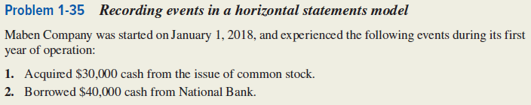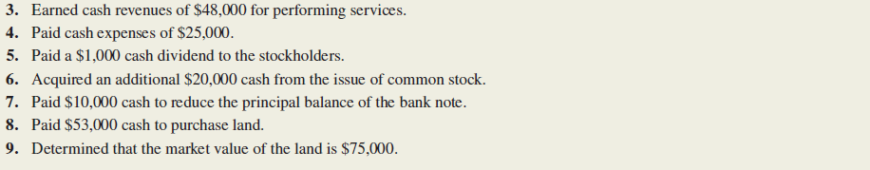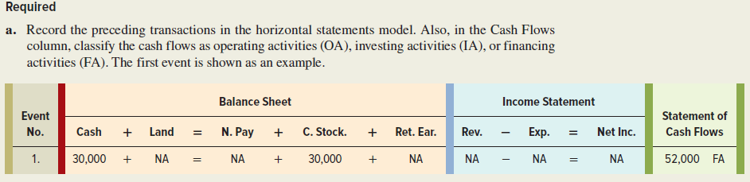

PROBLEM 1-35 (cont.)
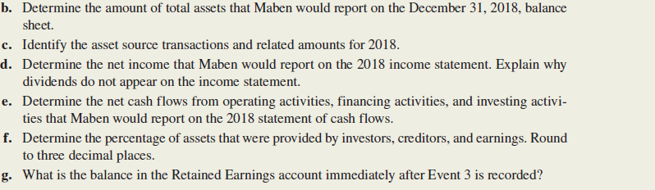

PROBLEM 1-35 (cont.) Solution

a.
Maben Company
Horizontal Statements Model for 2018
 |  | Balance Sheet |  |  |  |  |  |  |  |  |  | Income Statement |  |  |  |  |  | Statement of
 |  | Assets |  |  | = | Liab. | + | Stockholders’ Equity |  |  |  | Revenue | − | Expense | = | Net Inc. |  | Cash Flows
Event  No. |  | Cash | + | Land | = | Notes  Payable | + | Common Stock | + | Retained  Earnings
1 |  | 30,000 | + | NA | = | NA | + | 30,000 | + | NA |  | NA | − | NA | = | NA |  | 30,000 FA
2
3
4
5.
6.
7.
8.
9.
Total |  | 49,000 | + |  |  |  |  |  | + | 22,000 |  |  |  |  |  | 23,000 |  | 49,000 NC

Problem 1-35 Solution (cont.)

- Total Assets 2018 Bal. Sheet =

c.
Sources of Assets
Total Sources of Assets | $138,000

d. Net Income on 2018 Income Stat.=

Why dividends are not on the Income Statement:

e.
Operating Activities:
Cash from
Cash paid for
Net Cash Flow from Operating Activities

Investing Activities:
Cash paid to purchase land
Net Cash Flow from Investing Activities

Problem 1-35 e Solution (cont.)

Financing Activities:
Cash from stock issue
Cash from
Paid cash
Cash paid on
Net Cash Flow from Financing Activities

f. Percentage of assets provided as follows:

Investors:

Creditors:

Earnings:

g. Bal. in Ret. Earnings after Event 3=

