Instructor’s Resource Manual

Donna McGovern

**Horngren’s Cost Accounting**

*17th Edition*

Srikant M. Datar

*Harvard University*

Madhav V. Rajan

*Stanford University*

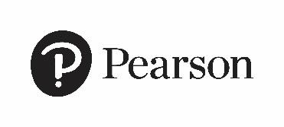

**This work is protected by United States copyright laws and is provided solely for the use of instructors in teaching their courses and assessing student learning. Dissemination or sale of any part of this work (including on the World Wide Web) will destroy the integrity of the work and is not permitted. The work and materials from it should never be made available to students except by instructors using the accompanying text in their classes. All recipients of this work are expected to abide by these restrictions and to honor the intended pedagogical purposes and the needs of other instructors who rely on these materials.**

Copyright © 2021 by Pearson Education, Inc. or its affiliates. All Rights Reserved. Manufactured in the United States of America. This publication is protected by copyright, and permission should be obtained from the publisher prior to any prohibited reproduction, storage in a retrieval system, or transmission in any form or by any means, electronic, mechanical, photocopying, recording, or otherwise. For information regarding permissions, request forms, and the appropriate contacts within the Pearson Education Global Rights and Permissions department, please visit [www.pearsoned.com/permissions/](http://www.pearsoned.com/permissions/).

PEARSON, ALWAYS LEARNING, and REVEL are exclusive trademarks owned by Pearson Education, Inc. or its affiliates in the U.S. and/or other countries.

Unless otherwise indicated herein, any third-party trademarks, logos, or icons that may appear in this work are the property of their respective owners, and any references to third-party trademarks, logos, icons, or other trade dress are for demonstrative or descriptive purposes only. Such references are not intended to imply any sponsorship, endorsement, authorization, or promotion of Pearson’s products by the owners of such marks, or any relationship between the owner and Pearson Education, Inc., or its affiliates, authors, licensees, or distributors.

